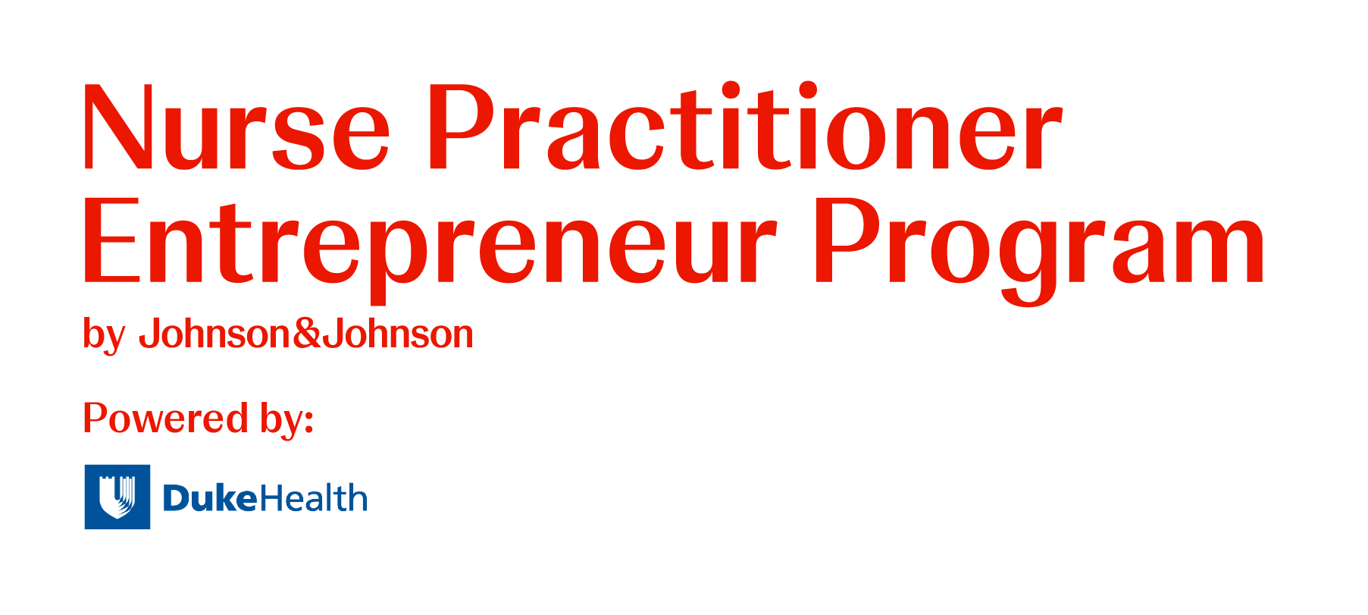
2025-2026 Participant Letter of Commitment

1. Attendance Requirement - All participants are required to attend the following events:

- On-site Leadership Retreats in Durham, NC
O February 22-25, 2026
O December 11-13, 2026

- Virtual Leadership Conferences via Zoom
O June 6-7, 2026
O October 3-4, 2026

- Virtual Business Consultative Panel via Zoom
All participants are required to present on ONE date and attend ONE additional date. Specific dates will be assigned early in the program based on participant availability:
O August 22-23, 2026
O August 29-30, 2026

- Virtual NPBO Learning Sessions via Zoom at 7 pm CT
O March 5 and 19, 2026
O April 2, 16, and 30, 2026
O May 14 and 28, 2026
O June 11, 2026

Educational sessions may vary in length and format, including seminars, salon circles, discussion groups, and group exercises. Some activities may take place during evenings or weekends. I will ensure my schedule allows for full participation without late arrivals, early departures, or competing obligations.

2. Business Plan Requirements – All participants are required to develop and evaluate a business All participants must develop and present a business plan and marketing plan for an NP-led enterprise serving a limited-resource community. Required deliverables (with deadlines provided at program start) include:
- Consultative Panel Presentation (participating on TWO dates):
  - August 22–23, 2026 or August 29–30, 2026
- Submission of Comprehensive Business Plan
- Slide Presentation of Business Plan
- Final Oral Presentation: December 11–13, 2026
Extensions may be granted only for extenuating circumstances and must be approved prior to the original deadline. Missed deadlines allow a one-week grace period for submission.

3. Entrepreneur Salon Participation – All participants are expected to participate in virtual, monthly entrepreneur salon circle meetings.
- Sessions are led by a salon mentor and include both mentor guidance and peer-to-peer feedback.
- Meeting times will be set collaboratively by each salon group.
- Missed sessions require follow-up with the mentor and fellow participants.
Repeated lack of engagement, as determined by the salon mentor and program leadership, could result in dismissal from the program.

4. Distance Learning Education Sessions – Participants are strongly encouraged to engage in online learning activities that supplement the program’s focus on leadership and business training.
These include:
- 1–2 recurring sessions per month
- A mix of live webinars and asynchronous self-directed activities
- Opportunities to earn continuing education hours

5. Executive Leadership & Business Coaching – All participants are strongly encouraged to engage in:
- One-on-one executive leadership coaching with a PhD-trained, nationally certified executive coach to focus on self-discovery, goal setting, and strategic action on topics of their choice.
- Group business coaching sessions offered through NPBO™

6. Professionalism Expectations
Participants must:
- Communicate respectfully with staff, mentors, coaches, and peers
- Respond to program correspondence within 24–48 hours
- Provide constructive, courteous feedback to peers
- Complete required program components and evaluations on time
If a participant consistently misses sessions or deliverables, a meeting will be held to develop an Individual Engagement Plan (IEP) with the salon mentor, program director, and coordinator.
Failure to meet IEP expectations may result in dismissal.

7. Program Standing
I understand that failure to meet program requirements may result in dismissal and that I may not represent myself as a NP Entrepreneur Program participant or graduate if dismissed.

By signing below, I confirm that I have read, understand, and agree to the expectations outlined in this Letter of Commitment.

Participant’s Signature: __________________________________Date: ___________________

Participant’s Name: _____________________________________

