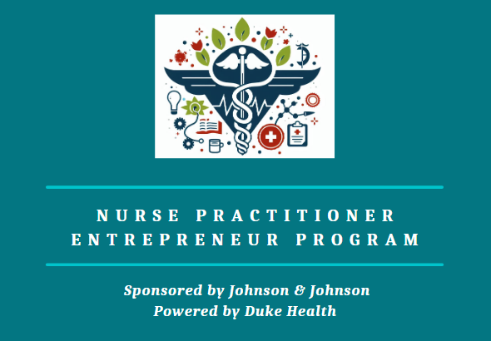
2024-2025 Participant Letter of Commitment
If accepted to participate in the Duke-Johnson & Johnson NP Entrepreneur Program, I understand and will comply with the following expectations set forth for all program participants:

- Retreats & Web-Conferences – I will attend the following events:
  - All participants are required to attend two on-site leadership conferences in Durham, North Carolina:
O October 5-9, 2024
O September 26-28, 2025
  - All participants are required to attend three virtual leadership conferences on Zoom:
O January 18-19, 2025
O April 26-27, 2025
O July 12, 2025

  - All participants are required to attend ONE 3-hour business consultative panel (virtual) on one of the four dates shown below. Each participant’s specific date will be determined early in the program and based on the participant's availability.
O March 8-9, 2025
O March 15-16, 2025
All educational sessions will involve full-day learning experiences, such as seminars, learning circles, discussion groups, and group exercises, with some evening and weekend activities. These leadership and business development opportunities provide a unique intensive immersion experience, and full engagement is required. I understand that it is essential that I thoughtfully plan my personal and professional schedules accordingly in order to avoid: late arrival to and/or early departures from leadership retreats and web-conferences; and personal/professional distractions that would pull me away from daily retreat activities.

- Business & Marketing Plans – All participants are required to develop and evaluate a business plan and a marketing plan for a NP healthcare enterprise focused on providing primary care and behavioral health services in a limited resource setting. It is mandatory that participants complete, by the specified deadlines shared at the beginning of the program year, key components related to the business and marketing plan’s development and progress:
- Q1 Business Report: December 31, 2024
- Consultative Panel Presentation on ONE of these dates: March 8-9 OR March 15-16, 2025.
- Q2 Business Report: March 31, 2025
- Q3 Business Report: June 30, 2025
- Final Business Report: September 13, 2025
- Slide Set of Business and Marketing Plan Presentation: Sep 20, 2025
- Oral Presentation of Business and Marketing Plan: Sep 26-28, 2025
For program deliverables, a deadline extension may be granted due to extenuating circumstances; however, this must be agreed upon before the original deadline. If a participant misses a deadline, they have a one-week grace period to submit the deliverable.
- Entrepreneur Salons – All participants are expected to participate in virtual, monthly entrepreneur salon meetings. Meetings will be led by a salon mentor that will offer guidance, feedback and encouragement throughout all stages of the business development process. Participants will also partake in peer-to-peer feedback with one another during these meetings. These meetings are crucial for professional development, tackling challenges, and ensuring program commitment. The meeting dates and times will be determined collectively by the salon participants. Attendance is expected, with missed sessions requiring follow-up with the mentor and team.
Repeated failure to engage in entrepreneur salon activities, as determined by the salon mentor and program leadership, could result in dismissal from the program.
- Distance Learning Education Sessions – All participants are strongly encouraged to engage in monthly distance-based online learning activities that supplement the program’s focus on leadership and business training. There will be one to two distance-based sessions scheduled at reoccurring time intervals per month. Some sessions will be live webinars while other sessions will involve asynchronous, self-directed activities. A portion of these distance education sessions will provide an opportunity to earn continuing education hours for participation.
- Personalized Executive Leadership and Business Coaching – All participants are strongly encouraged to participate in one-on-one leadership coaching with a PhD trained, nationally certified executive coach to focus on self-discovery, goal setting and strategic action on topics of their choice. All participants are also offered an opportunity to participate in one-on-one business coaching sessions as well with NPBOTM.
- Professionalism – All participants are expected to engage with program staff, other participants, mentors, coaches and other collaborators in a professional and respectful manner. This includes, but is not limited to, replying to correspondences in a timely manner (within 24-48 hours), demonstrating courtesy and consideration when providing feedback to other participants, and completing program components and evaluations as requested.
- If a participant continuously fails to attend and fully participate in key program sessions and submit deliverables, a meeting will be held to discuss and develop an individual engagement plan (IEP) with the salon mentor, program director, and coordinator. Failure to successfully complete the IEP may result in dismissal from the program.
I understand that if I do not engage in the required components of the program in a timely manner, I may be subject to dismissal from the program and will not be able to refer to myself, in any capacity, as a NP Entrepreneur Program Participant or graduate.
The signature below indicates that I have reviewed, understand and agree to the content of this Letter of Commitment:

Participant’s Signature: __________________________________Date: ___________________

Participant’s Name: _____________________________________

