Notes: Acids and Bases Name: ___________________________

_________________: compounds that ____________________________________________________ when they’re dissolved in water.
- Examples from investigation:

_______________: compounds that ___________________________________________ when they’re dissolved in water.
- Examples from investigation:

_______________: compounds that _____________________________________________________ when they’re dissolved in water.
- Examples from investigation:
- Water already has some H+ ions to start with, which is why neutral solutions have “some” H+ ions in them
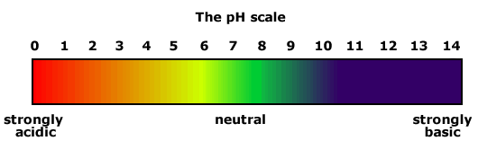
Dissociation of Water
- Pure water is in a state of ______________________________with its ions:

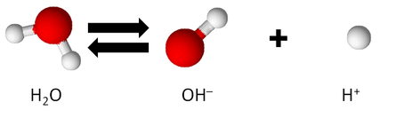
- It’s mostly H₂O, with 10⁻⁷ M H⁺ and 10⁻⁷ M OH⁻

You dissolve the following compounds in water. Write the dissociation reaction that occurs and identify if the compound is an acid or base:
- HF
- KOH
- Mg(OH)₂
- H₂SO₄
pH Scale
- pH =
- In water, the concentration of H+ ions is 10⁻⁷ M. What is the pH of water?

Every solution has H+ and OH- ions in it
- Acidic solutions =
- Basic solutions =
- [H+] and [OH-] have an ____________________________________
  - [H+] x [OH-] =
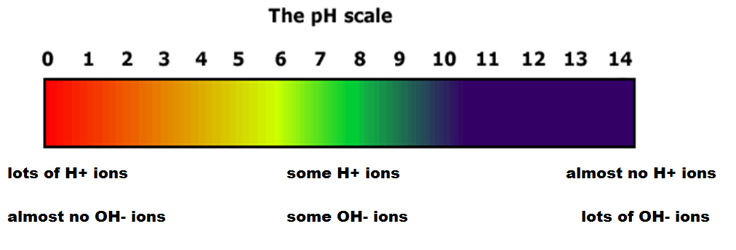
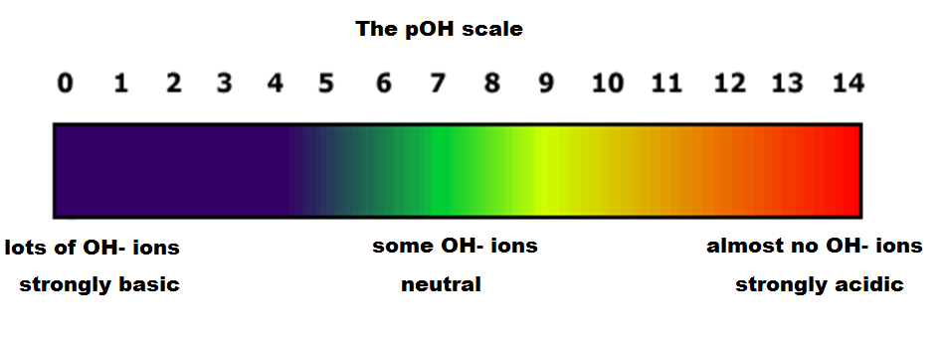
pOH Scale
pOH =
[H+] x [OH-] =
pH + pOH =

If [OH-] = 10⁻³ M, what is the pOH? What is the pH?
Practice:
- [H+] = 10⁻⁴ M. What is the pH? What is the pOH?
- [OH-] = 10⁻² M. What is the pOH? What is the pH?
- [H+] = 3.5 x 10⁻⁷ M. What is the pH? What is the pOH?
- Challenge: the pH of a solution is 3. What is the concentration of H+ ions?
Strength of an acid:
- Strong acids/bases:
  - HCl
  - NaOH
- Weak acids/bases:
  - RCOOH
  - NH₃

- Most drugs (medicine or recreational) are weak acids or bases
  - The ability of weak acids/bases to go back and forth between charged and uncharged forms allows it to move throughout our bodies!
- In aqueous environments, ___________________ molecules are more easily dissolved.

- It’s easier for a molecule to pass through the lipid membranes of our cells if it is ____________________

