Working Through Multiple True/False Questions

Working through multiple True/False questions can be challenging and it’s easy to second guess yourself when an answer choice could go either way. Here are some tips that may help you feel more confident answering questions like this. Remember, practice with these questions is important so you become more familiar with the style of question and the best approaches that work for you when answering them.

Tip #1 Gather the Information: Before reading the question, COVER the multiple choice answer choices so you focus first on the information that is being provided to you in the prompt

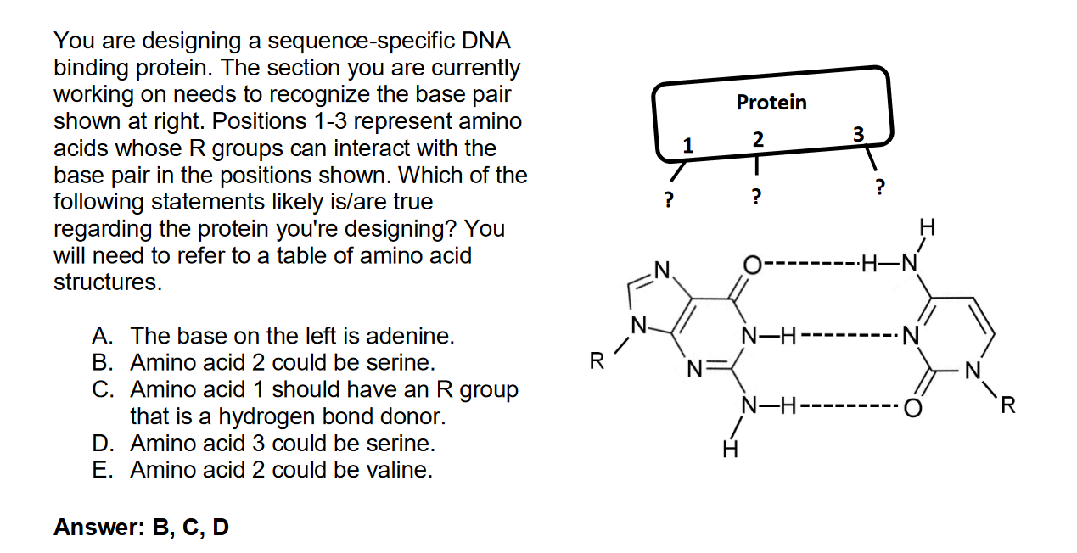

Tip #2 Focus on the Prompt: Carefully read all of the information provided to you in the question prompt. Keep in mind that it’s possible not all of it will be useful for answering the question. Identify what materials on your 1-page reference sheet or supplementary material you might need. In the case of this question, you need the table of amino acid structures.

Tip #3 Develop a Possible Answer: If there is a diagram, and many Bio 201 questions have a diagram, table, or image of some kind, determine what is going on in the figure. Ask yourself, what information do I have? What information am I missing? You are able to write on your quizzes and exams, so mark-up the diagram with all of the information you have!
Information I have and am missing: There are 3 hydrogen bonds between the two bases. So, this has to be a C-G pair rather than an A-T pair, which has 2 hydrogen bonds. The base on the right has two rings (purine), thus, that one has to be guanine and the one on the right has one ring (pyrimidine), so that one is cytosine. (If you are having a hard time remember purine vs. pyrimidine, think of the phrase “pure as gold.” When you think gold, think, two rings. And pure purine, “as gold,” the “a” for adenine and “g” for guanine). You do not know what the 3 R-groups are on the mystery protein, but you do know that they have to interact with N, O, and NH₂. N and O are hydrogen bond acceptors, and NH₂ is a hydrogen bond donor. As such, 1, 2 and 3 should be complimentary to this pattern, donor, donor, acceptor, respectively.
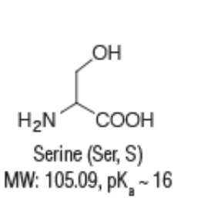
Tip #4 Review Your Choices: Look at the answer choices and eliminate the ones that you know for sure are incorrect.
G
C
Donor
Acceptor
Acceptor
Acceptor
Donor
Donor

A is wrong since you identified this base pairing was between G-C rather than A-T since there are 3 hydrogen bonds rather than 2.

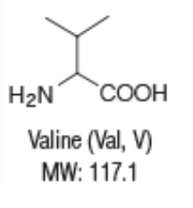
Serine has an -OH group, which can be either a donor or an acceptor, so amino acid 2 could be a serine, thus B is correct.

C is correct since you identified that amino acid one would interact with the N and therefore had to be a hydrogen donor.

For the same reason as answer choice B, serine could be amino acid 3, with its ability to act as a donor or an acceptor, so D is correct.

Valine is hydrophobic and does not hydrogen bond well at all, so E is incorrect.

Are you second guessing yourself? Think about what evidence you have to support choosing or not choosing something as True. If you completely aren’t sure, check your one-page reference sheet or pause from the question to return to later, just don’t forget to come back to it!

