Teacher: | Subject/Grade: 6th grade
Objective/Standard: Teach students what invasive species are and why they’re threatening to ecosystems | Materials: art materials for final project ( can include poster paper, markers, color pencils)
Length of Lesson: 1 hour and a half | Goal: ( What do you want students to know/create)  Students at the end of the lesson must be able to understand and define what are invasive species, why they occur and why them harm the environment. At the end of the lesson, students must research an invasive species from their area and create a poster.

Engage: Video/ present problem/ questions to hook students.
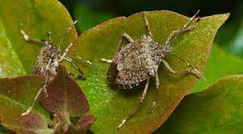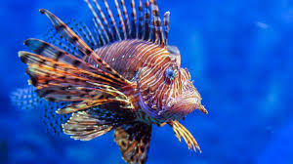

- Show students different pictures of invasive species
- -Ask students what they think all these different animals have in common
Explore: Ask question to gather student knowledge- hands on activity students can do to activate prior knowledge and begint to connect to new learning
- Reveal that all the animals in the pictures above are all invasive species/
- Ask students questions to see what they already know about invasive species:
  - What are invasive species?
    - What does it mean to be “invasive”?
  - Are these species beneficial or harmful to the environment? What do you think?
  - Why are there invasive species? What are the causes and effects?
Explain: Meat of the lesson- where you teach what you want them to learn
This should include activities for students/ Vocabulary
- Introduce vocabulary:
  - An invasive species is an introduced organism that negatively alters its new environment. Species that grow and reproduce quickly, and spread aggressively, with potential to cause harm, are given the label “invasive.” (www.nwf.org)
  - Species: A species is often defined as a group of individuals that actually or potentially interbreed in nature
  - Ecosystem: a biological community of interacting organisms and their physical environment.
- Key points from the lesson:
  - Emphasize how invasive species are often introduced to environments due to human activities, unintentionally
  - Emphasize why invasive species are threatening to an ecosystem: (www.nwf.org)
    - “The direct threats of invasive species include preying on native species, outcompeting native species for food or other resources, causing or carrying disease, and preventing native species from reproducing or killing a native species' young.”
    - “When a new and aggressive species is introduced into an ecosystem, it may not have any natural predators or controls. It can breed and spread quickly, taking over an area. Native wildlife may not have evolved defenses against the invader, or they may not be able to compete with a species that has no predators.”
    - “Invasive species can change the food web in an ecosystem by destroying or replacing native food sources.”

Elaborate: Connect to real world- where or how will they see this concept in life
- Begin a class discussion and ask the following essential questions:
  - What can humans do to reduce the occurrence of invasive species?
  - Why are invasive species so harming?
  - What can be done to increase awareness of invasive species issues?

Evaluate: How will you assess that they learned it- project- quiz- daily question to gather that they are making progress
- Research project:
  - Students will select an invasive species found in their state or country. They will then prepare an outreach media project that will raise awareness about this species and its potential dangers to the environment and possible solutions.
  - The project can be done in a multitude of mediums including a paper brochure, a poster, a Powerpoint, etc. Students are allowed to choose whichever they’re the most comfortable with.
  - Students must cite sources at the end

Created by: Sofia Silvosa

