SCAR presents….
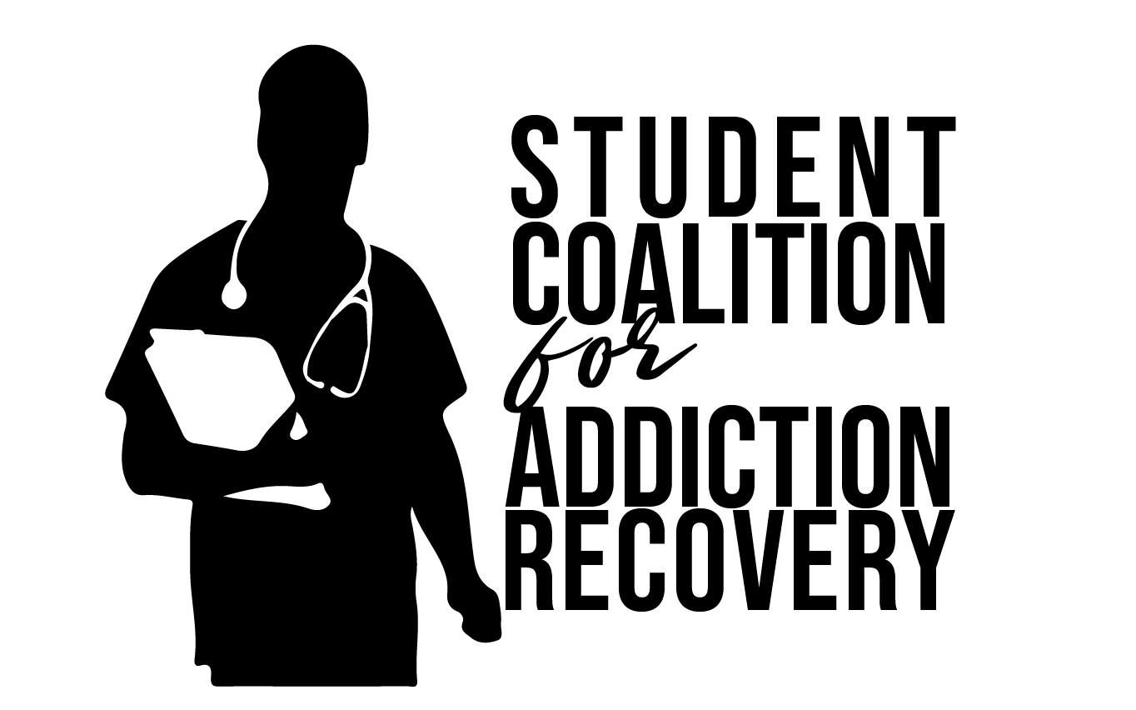

Addiction in Media Series

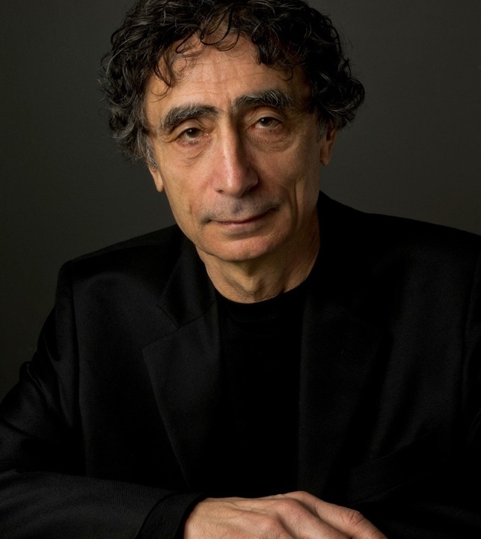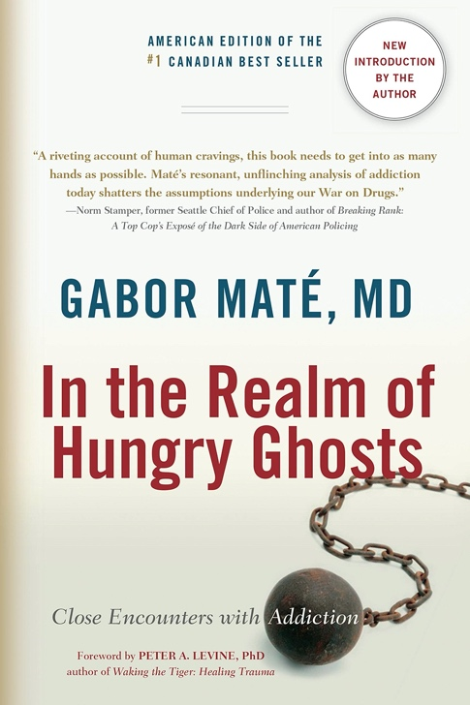

Wednesday May 11th, 5:30-7:00PM @Trent-Semans Center

Join the Student Coalition for Addiction Recovery (SCAR) for a reading group dinner and discussion on Canadian-Hungarian physician Dr. Gabor Maté’s In the Realm of Hungry Ghosts.

We will read and discuss selections from this best-selling book on Dr. Mate’s perspective and reflections on addiction.

A faculty moderator from the School of Medicine will be present to help facilitate the discussion. Open to all graduate and medical students. Copies of the book will be provided to discussion participants!

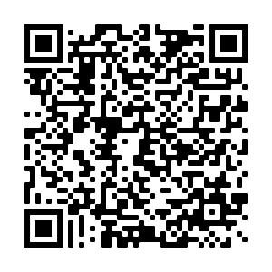
Sign up if interested:
Details to follow!

This Diversity and Inclusion event is a joint collaborative effort between the Duke Graduate School and the Duke School of Medicine, with the generous support of Dean McClain of the Graduate School.
