**Future Space Settlements: Lessons from History**

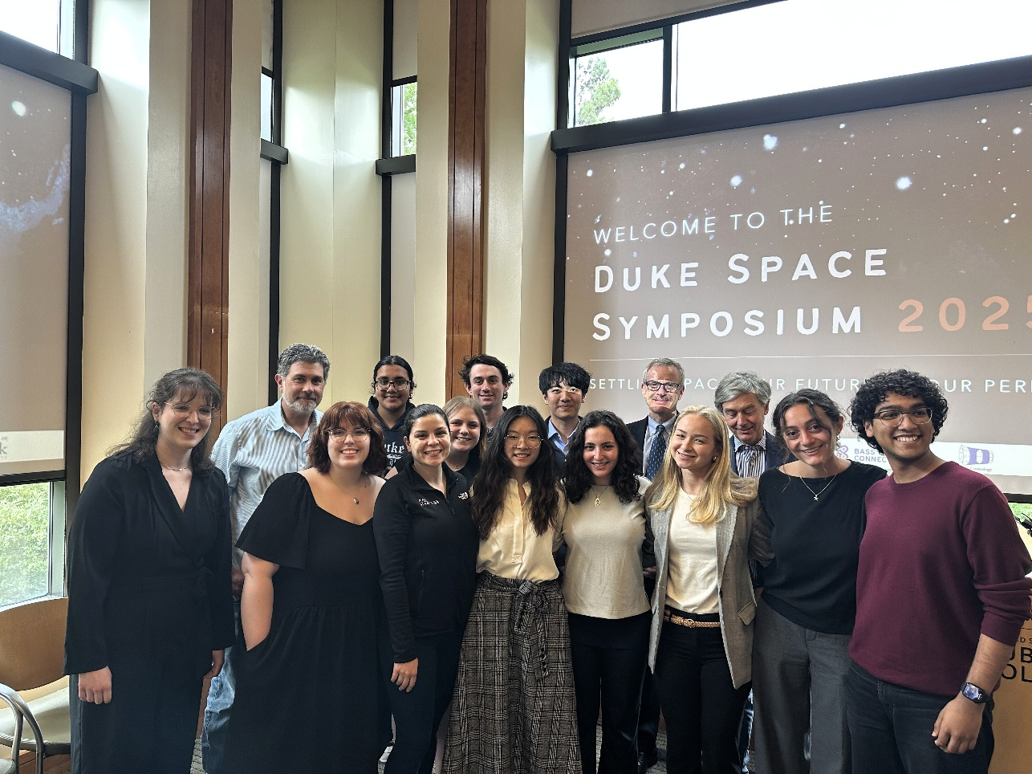Bass Connections Team Profile | 2024–2025

*The team celebrates its work at the inaugural Duke Space Symposium.*

What can centuries of terrestrial settlement teach us about building human communities beyond Earth? This year, our Bass Connections team, *Future Space Settlements: Lessons from History*, examined how historical examples of exploration, colonization, and governance can inform the design of sustainable, equitable, and resilient space settlements.

As exploration shifts from short-term missions to permanent settlement, our team asked what the past can tell us about what might enable communities to thrive—or fail—in the extreme, isolated environments of space. Our interdisciplinary team included undergraduate and graduate students studying history, public policy, law, environmental science, and engineering. They collaborated across three sub-teams:

* The Technology & Innovation team studied how infrastructure, health systems, and other technologies influenced settlement outcomes.
* The Company Towns team examined the labor, social, and environmental dynamics of corporate-led settlements to understand what we might expect of privately-governed expansion into space.
* The Legal Systems team studied how legal systems and international governance in remote regions can inform the structure and oversight of space settlements.

Students undertook extensive research in archival, primary, and scholarly sources across numerous disciplines and ranging back centuries. They also engaged with leaders in medicine, aerospace, public history, and genetics. Guests included [Dr. Dan Buckland,](https://scholars.duke.edu/person/Daniel.Buckland) [Provost Alec Gallimore](https://provost.duke.edu/about/provost-alec-d-gallimore/), [Dr. Emily Margolis](https://airandspace.si.edu/people/staff/emily-margolis), and [Executive Vice Provost Mohamed Noor](https://duke.edu/about/leadership/noor/). Team members also participated in the event “From the Antarctic to the Moon” hosted by the Rethinking Diplomacy Program and attended Astronomy Day at the NC Museum of Natural Sciences. These experiences enriched our understanding of how space exploration intersects with science communication, governance models, and public engagement.

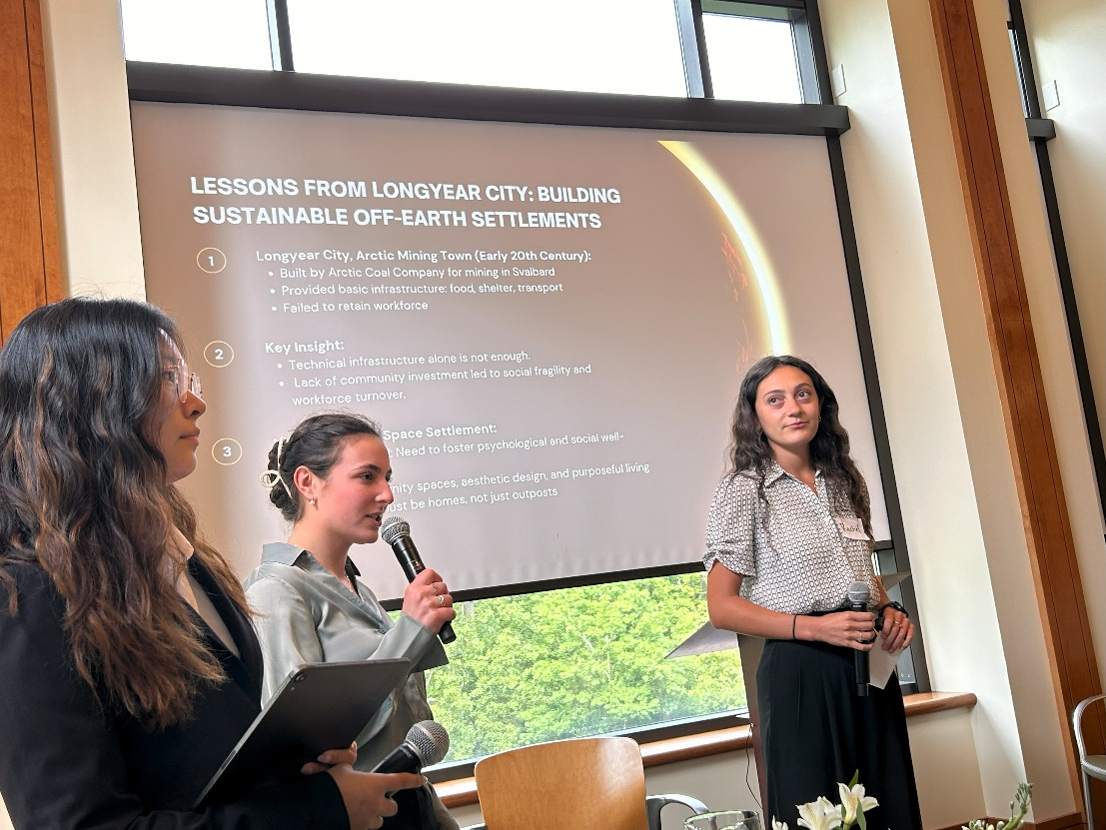 Armed with their sub-teams' research, students collaboratively developed a suite of research outputs—including an [open-source archive](https://docs.google.com/spreadsheets/d/1obktHZYg-EzZiapocdJIoNFtovHw6-FW-_ngzEqCG6c/edit#gid=0), [team website](https://sites.duke.edu/futurespacesettlements), and imagined future settlement designs (including a space “constitution”) informed by cautionary lessons from history. A major highlight of the year was our role in organizing and presenting at the inaugural Duke Space Symposium. This two-day event featured expert panels, student presentations, and a keynote address by space ethicist Dr. Erika Nesvold. Our team helped develop the agenda, moderated discussions, and presented across multiple sessions, contributing to a broader university conversation about space governance, ethics, and commercialization.

*Karina Lu, Romy Greenwald, and Rachel Christ presenting on potential environmental issues related to the commercialization of space at the Duke Space Symposium.*

We also had several opportunities to share our work with broader audiences. The Bass Connections Showcase allowed us to present our research to the wider Duke community, sparking conversations across disciplines. In addition to presenting at the Showcase, the Technology & Innovation sub-team was selected to present their work at the NC Space Symposium, where they explored how history and emerging technologies can inform AI-assisted healthcare in space.

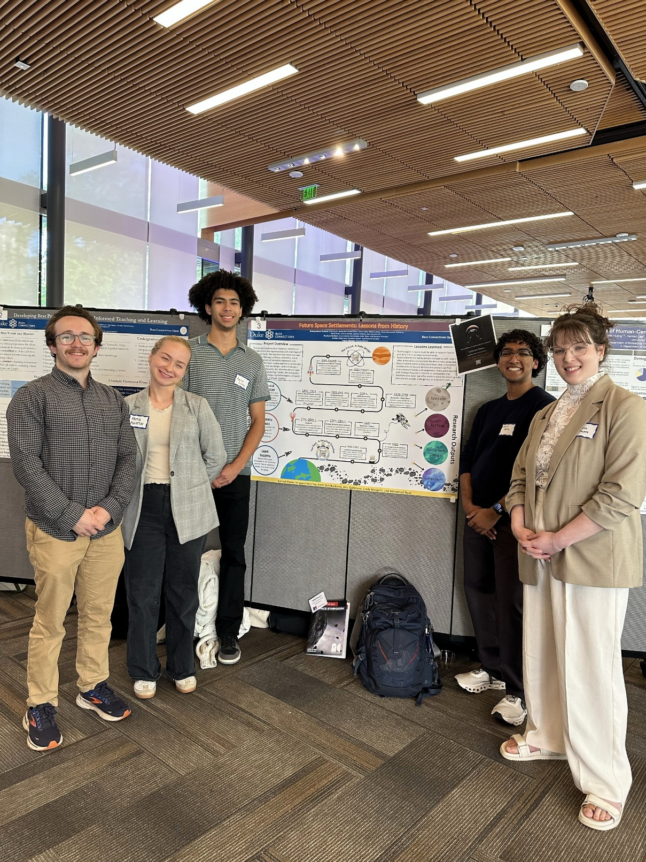*Harrison Schreiber, Faith Austin, Aaron Coley, Nikhil Methi, and Anna Mallard presenting at the Bass Connections Showcase.*

Reflecting on the year, our biggest challenge was narrowing the scope of such a wide-ranging topic. By organizing into sub-teams and holding regular cross-cutting discussions, we developed a shared framework for evaluating historical lessons and applying them to contemporary space policy questions.

*This project fundamentally reshaped how I think about the future of spacefaring and space governance. I’ve come to realize that nothing is new under or around the Sun. Just as maritime law can guide how we imagine space governance, historical analogs of isolated settlements offer universal wisdom for shaping space-based communities. This Bass Connections team encouraged me to shoot for the stars in my research like never before!*

*— Faith Austin*

Looking ahead, several team members plan to build on their research in future projects, and some are preparing for careers in the space sector. We also hope to use the success of this Bass Connections project and the Duke Space Symposium as a launchpad for bringing together space research and teaching across campus, so students, faculty, and outside experts can explore interdisciplinary questions in space technology, history, governance, and ethics.

*Sic itur ad astra*.