Economic Racism: A Look at Rental Prices in 1930

Basel Fakhoury

Professor Patrick Bayer, Faculty Advisor

Honors thesis submitted in partial fulfillment of the requirement for Graduation with Distinction
in Economics in Trinity College of Duke University

Duke University
Durham, North Carolina
2012
Acknowledgments

I would like to thank my advisors Professor Patrick Bayer and Professor Marjorie McElroy for helping me write this paper. Professor Bayer regularly helped me interpret my results and helped guide the direction of my paper. Professor McElroy’s weekly classes helped me learn what economics research entails, and I am grateful for the hours she has spent looking over my multiple drafts.
I would also like to thank Professor Seth Sanders who was instrumental in helping me choose the topic and on teaching me how to begin my research, which was invaluable.
I have also had a number of other students and friends edit this paper and give me valuable feedback, including Michael Ge, Ryan Lipes, Jon Palgon, Sam Zimmerman, and Matt LaSardo.

Abstract
The Great Migration caused massive demographic changes in Northeastern and Midwestern cities as African Americans moved from the South to the North. These changes led to economic discrimination and segregation within northern cities. This paper compares African American and white rental prices in four major cities: Chicago, Detroit, New York City, and Philadelphia in an effort to see how this discrimination and segregation affected rental prices. The results consistently show that in the most precise geographic area, prices rise as the concentration of blacks in those neighborhoods rise, which I believe is a result of overcrowding.

JEL Codes: J1, J11, J15, R31

Keywords: The Great Migration; Economic Discrimination; Housing Markets; Segregation

Table of Contents

- Introduction…………………………………………………………………………........5

- History of the Great Migration and Restrictive Covenants………………………...…6

- Literature Review……………………………………………………………………..…9

- Description of Data……………..………………………………………………………11

- Economic Theory and Methodology…………………………………………………..16

- Empirical Results………………………………………………………………………23

- Analysis…………………………………………………………………………………28

- Conclusion………………………………………………………………………….…33

I. Introduction
During the first part of the Great Migration, which lasted from 1910 to 1930, almost two million African Americans moved from the American South to cities in the Northeast and Midwest. Increasing racism in the South and the opportunity for new jobs in the newly industrialized North caused this mass exodus. The African Americans ended up competing for land and work with the white population already in the North as well as new European immigrants. This competition led to friction between the white and the African American populations (Lemann, 1991). Consequently, the white residents attempted to prevent the integration through several means, including forms of collective action racism, which limited the housing available to African Americans (Cutler, Glaeser, Vigdor, 1999). This paper examines how segregation affected rental prices for African Americans in 1930.
This paper aims to first see if there are rental price differences between white households and African American households at different levels of geographic precision in Chicago, Detroit, New York City and Philadelphia. It then attempts to identify what is driving this difference by controlling for the racial makeup of different geographic areas. My results find that households in enumeration districts, the most precise geographic area, with a higher proportion of black residents paid higher rental prices. However, the opposite is true in a less precise geographic area, wards. The rest of this paper shows how these were found, how they fit into the existing research, and the conclusions that can be drawn from them.
Section 2 reviews the history of The Great Migration and of segregation during it. Section 3 reviews some of the existing literature about segregation and differences in housing prices among races. Section 4 describes the Census data used, including the variables and the limitations of the data. Section 5 lays out the measures used and the economic theory underlying them. Section 6 shows the empirical results from the regression. Section 7 then analyzes those results and Section 8 concludes the paper.
II. History of the Great Migration
The first wave of The Great Migration took place between 1910 and 1930 as black Americans moved “out of the terror of Jim Crow to an uncertain existence in the North and Midwest” (Wilkerson, 2010). The following table shows the increase of African Americans in four major US cities (data taken from 1910 and 1930 Censuses):
Table 1: African American Population

 | 1910 | 1930 | Percent Change
Detroit | 8642 | 125229 | 1349.07
Chicago | 54389 | 225177 | 314.01
NYC | 83030 | 318221 | 283.26
Philadelphia | 87625 | 225044 | 156.83

As can be seen from Table 1, The Great Migration severely changed the demographic makeup of Northern cities. The main factors that led to this migration were the rise of Jim Crow laws and racism in the South, and new job opportunities in the newly industrialized North. Before The Great Migration nine out of every ten black Americans lived in the South and three out of four lived in farms (Mintz, 2007). However, during the late 19th century and early 20th century, racism in the South was continuously increasing. This racism took many forms, from laws to lynching. One of the most notorious examples of such racism was the Tulsa Race Riot in 1921 where one of the wealthiest African American communities was burned down, killing at least 300 African Americans in a single day (Hirsch, 2002). In addition to the lynching, de jure racism also existed under the Jim Crow laws. These laws arose after the Reconstruction period in the South, especially between 1890 and 1910, when ten of the eleven Confederate states rewrote their constitutions in ways that would disenfranchise African Americans. The laws pretended to promote separate but equal statuses for blacks and whites but in reality just systematically disadvantaged African Americans (Perman, 2001).
While Jim Crow laws were rising in the South, the Northeast and Midwest offered new opportunities for black Americans. One example of such opportunities was the industrial jobs opening to African Americans due to expanding industrialization. Additionally, World War I stopped the mass immigration of European workers who used to work in these industrial jobs and also caused an increase in the demand for products made in these factories (Miller, 1984). All of these factors led to many economic opportunities in the North for previously rurally-based African Americans.
This increase in African Americans led to large demographic changes, such as the rise of black neighborhoods in northern cities. This influx of blacks also led to friction and hostility between the new black immigrants and the white American working class in the northern cities. These two groups were competing both for jobs and for housing in the new cities. Additionally, the white Americans felt that the increased competition would lower their ability to negotiate their salaries, leading them to resent the black immigrants. This resentment led to discrimination against blacks and de facto segregation in the North, limiting areas where African Americans could live. For example, African Americans were banned from some skilled occupations and forced to live in overcrowded communities with poor health standards and high death rates (Harrison, 1992).
Cutler, Glaeser and Vigdor’s “The Rise and Decline of the American Ghetto” (1992) argues that there are three main drivers of segregation among races: ports of entry, collective action racism, and decentralized racism. Collective action racism is using “legal, quasi-legal, or violent, illegal barriers to keep blacks out of white neighborhoods” (p. 20). Segregation through ports of entry is the idea that primarily black areas were developed by black immigrants to help them assimilate into their new environment (p. 18). Decentralized Racism claims that segregation is caused by individual whites choosing to live with other whites, but not actually excluding blacks (p. 21).
Racial restrictive covenants are an example of collective action racism as a response to The Great Migration. They are private agreements that prohibit non-Caucasians from living in or owning property. These agreements, which reached their peak between 1920 and 1940, usually appeared as appendices or articles in the deed. They were heavily supported by the National Association of Real Estate Boards as a means to promote segregation (Jones-Correa, 2000). A typical racial restrictive covenant follows:
“In consideration of the premises and the sum of five dollars ($5.00) each to the
other in hand paid, the parties hereto do hereby mutually covenant, promise, and
agree each to the other, and for their respective heirs and assigns, that no part of
the land now owned by the parties hereto, a more detailed description of said prop-
erty, being given after the respective signatures hereto, shall ever be used or occu-
pied by, or sold, conveyed, leased, rented, or given to, Negroes, or any person or
persons of the Negro race or blood. This covenant shall run with the land and bind
the respective heirs and assigns of the parties hereto for the period of twenty-one
(21) years from and after the date of these presents” (Jones-Correa, 2000, p. 544).

In 1926 the Supreme Court case Corrigan v. Buckley upheld enforcement of a racial restrictive covenant legalizing them until 1948 when the Supreme Court changed their verdict.
It is clear that during the early 20th there was a large increase of African Americans living in northern cities. Additionally, in response to this demographic shift, collective action racism increased as seen through restrictive racial covenants. This paper will examine if this increased demand and artificially-decreased supply of housing led to African Americans paying more money for equal housing than their white counterparts.
III. Literature Review
There is a substantial amount of literature that focuses on segregation in the housing market throughout American history. In the 1960s, the married couple Alma and Karl Taeuber contributed to some of the most important developments in this literature. In their 1965 book, Negroes in the City, they created a segregation index and ranked 207 U.S. cities on their levels of dissimilarities, and concluded there was a “high degree of racial residential segregation” in American cities (p 2).
“The Rise and Decline of the American Ghetto,” by Vigdor, Cutler and Glaeser, attempts to measure segregation in the United States from 1890 to 1999. They divide the history of segregation into three periods, first one being from 1890 to 1940, which coincides with the first wave of The Great Migration. One of the two ways they measure segregation is through this dissimilarity index, which measures if “blacks disproportionately reside in some areas of a city relative to whites” (p. 458):
$$Index of Dissimilarity=\frac{1}{2}*\sum_{i=1}^{N}{\left|\frac{black_{i}}{black_{total}}-\frac{nonblack_{i}}{nonblack_{total}}\right|}$$
Black_{i} is the number of African Americans in ward i, while black_{total} is the number of African Americans in the city on the whole, and the nonblack variable is analogous for non-blacks in the city. The data showed that large cities in the Midwest/Northeast had the highest index of dissimilarity, which grew over 30% between 1890 and 1930. The authors title this time period the “birth of the ghetto” (p. 462) due to the increase in segregation. They also look at rental costs and show that as cities become more segregated the relative rental payment for blacks increased compared to that of whites.
Along this line two papers in the 1970s, Ronald Wienk’s “Measuring Racial Discrimination in American Housing Markets” (1979) and A. Thomas King and Peter Mieszkowski’s paper “Racial Discrimination, Segregation and the Price of Housing,” (1973) which demonstrated that black house seekers were discriminated against when buying homes. They both argued that in the 1970s black headed households paid more for a similar level of housing than white headed households did.
Currently a well known wealth gap between African American and white households exists. William Gales’ “Intergenerational Transfers and the Accumulation of Wealth” (1994) shows that part of this wealth differential can be attributed to differences in intergenerational wealth transfers. If African Americans did have to pay more for housing in the 1930s it would have decreased their savings and thus the amount of money they bequeathed to their heirs. This could still be having an effect on the black-white wealth gap today.
Much of modern literature focuses on how living in ghettos and other segregated areas affected the residents. Additionally, a substantial amount of data exists about wealth differences between black and white households. These articles, coupled with research above gives an overview of segregation in American cities. Additionally, they show the effects segregation and poverty can have on future generations. The Vigdor, Cutler Glaeser paper even shows that segregation at the ward level increases rental price differences. However, there is no article that I have found that looks at how this segregation actually affects the rental prices. By focusing on four major cities down to the enumeration district level, this paper will be able to look within the cities to get a better idea if there are rental price differences and if so what is driving them in these segregated cities.
IV. Data
This research uses 1930 United States Census data for a number of reasons. First of all, it is the most recent Census for which all data is publicly available. This is due to the 72 year rule, which does not give access to Census data until 72 years after it was taken. Additionally, as mentioned previously, the first wave of the Great Migration is generally thought to have taken place between 1910 and 1930, so the 1930 Census should capture many of its effects. The variables I will use are listed here using the variable names from the Integrated Public Use Microdata Series (IPUMS), the source of the majority of my data.
- Rent30: The amount the landlord expected to rent the unit in 1930.
- Enumdist: The enumeration district in which the household is located.
- Ward: The ward in which the household is located.
- City: The city the household lives in. These cities were Chicago, Detroit, New York City, and Philadelphia.
- Occscore: An estimation of income based on the worker’s occupation. This variable was constructed by taking the median income of workers in different occupations and applying it to all workers in that occupation.
- Race: An indicator for what race the head of the household is. I use a dummy variable that is 1 if the head of the household is black and 0 if white. Also, there were extremely few households who were a race other than African American or white. I did not include them as I was focusing on the difference between African American and white households.
- Radio30: An indicator for whether the household has a radio or not. It is 1 if the household does have a radio, and 0 if it does not.
- Numperhh: The number of people who live in the household.
In addition to the above variables, from IPUMS, I also created the following variables using the IPUMS data:
- Enumeration District Dummy Variables: A dummy variable for each enumeration district in each of the 4 cities, to control for enumeration district fixed effects.
- Ward Dummy Variables: A dummy variable for each ward in each of the 4 cities, to control for ward fixed effects
- AAPercentED: A variable showing the percent of the population in each enumeration district that was African American.
- AAPercentward: A variable showing the percent of the population in each ward that was African American.
All of these data are provided by the aforementioned IPUMS, which is a compilation of United States Census data. I will focus on Chicago, New York City, Philadelphia, and Detroit as they were the four biggest cities in America in 1930. As Table 1 in Section II shows they all received a large influx of African Americans between 1910 and 1930. The data from IPUMS is extremely detailed and the data from 1930 allows us to be as precise as an enumeration district. Enumeration districts were defined as an area that was small enough that a single Census taker could cover the area in 2-4 weeks in 1930; however actual size varied depending on population densities. For most urban areas they encompassed only a few city blocks. I also looked at wards which are larger sub-city geographic areas. Image 1 at the end of this section shows how Chicago in 1930 was split into fifty wards and Image 2 shows how Ward 1 was split into 41 different enumeration districts.
It should be noted that the Census contains very limited information on the quality of the homes. For example, the only variable given about amenities within these homes is if they had a radio, and there is no information on the size of the property. This lack of information limits the results that can be obtained from the research. In spite of this, the geographic precision can still lead to useful results even without the quality measures. Additionally, if I do find a difference that African Americans pay more, this means that difference would only not matter if they lived in higher quality of homes than white people in the same area, which is counterintuitive. Thus home quality would only strengthen the evidence for discrimination causing higher rental prices for African Americans.
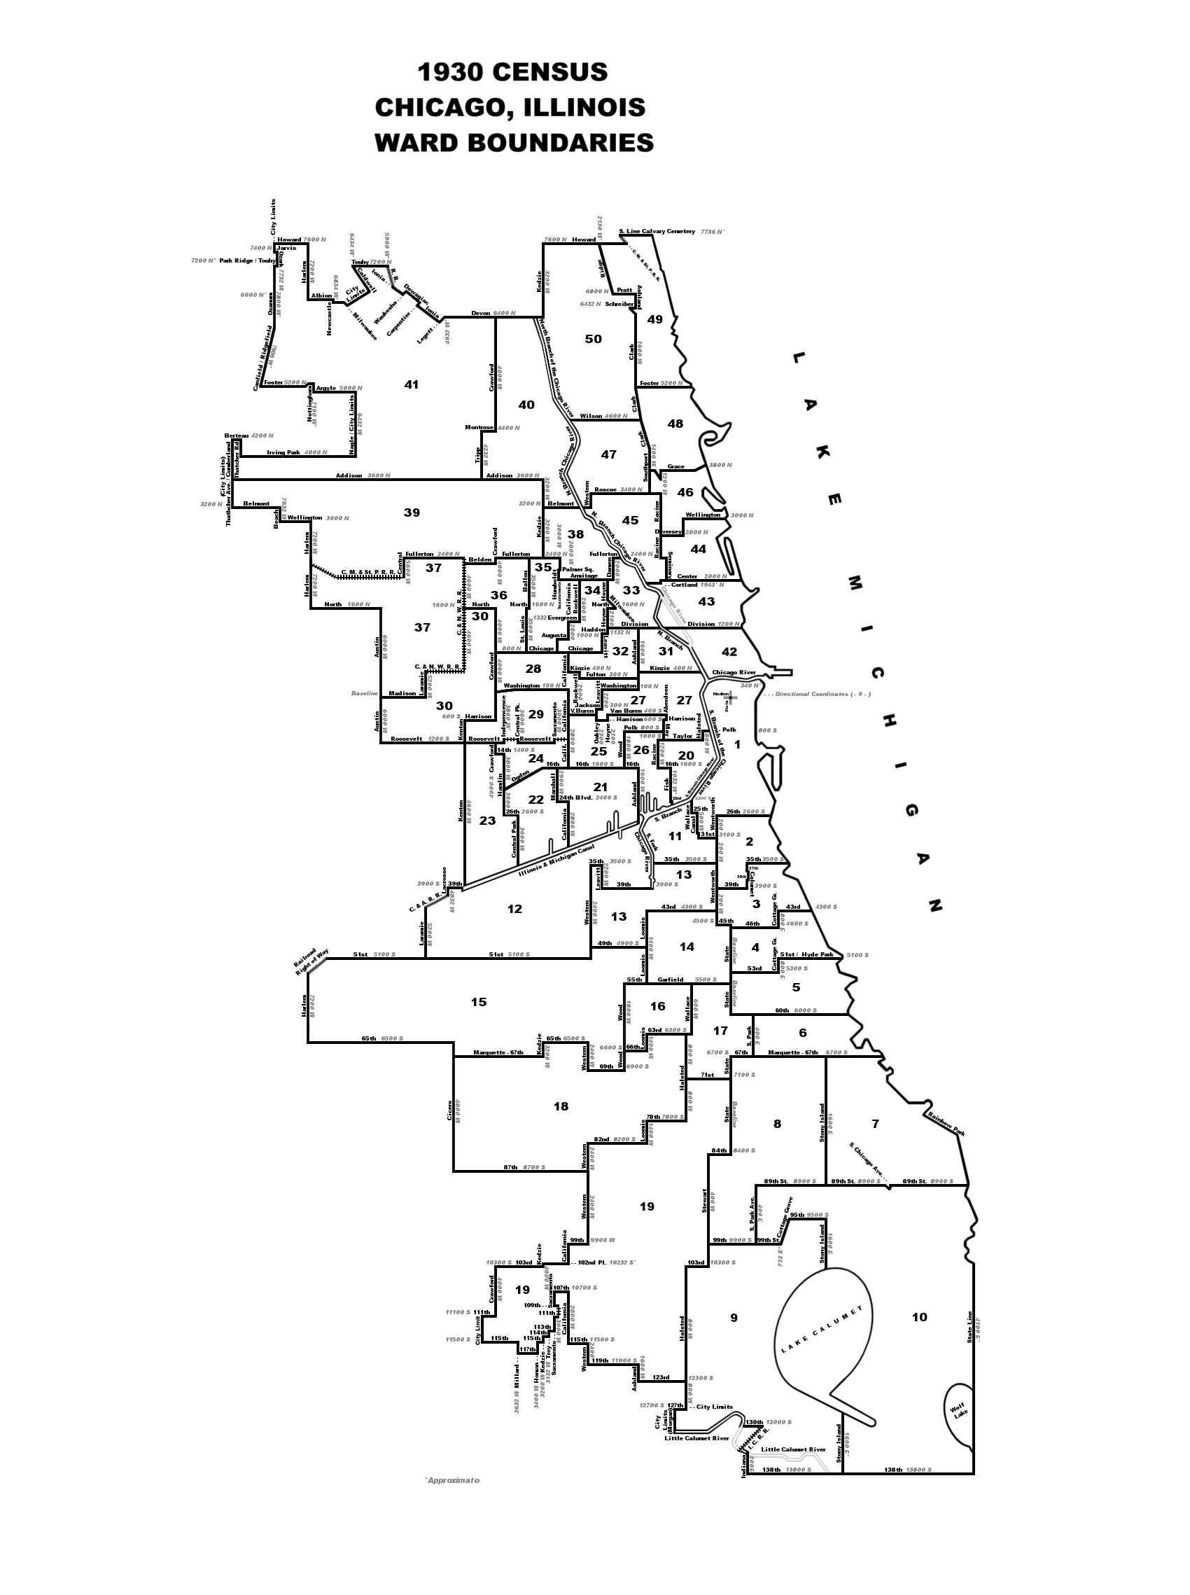
Image 1
(Image from http://www.alookatcook.com/1930/hypermap.htm)
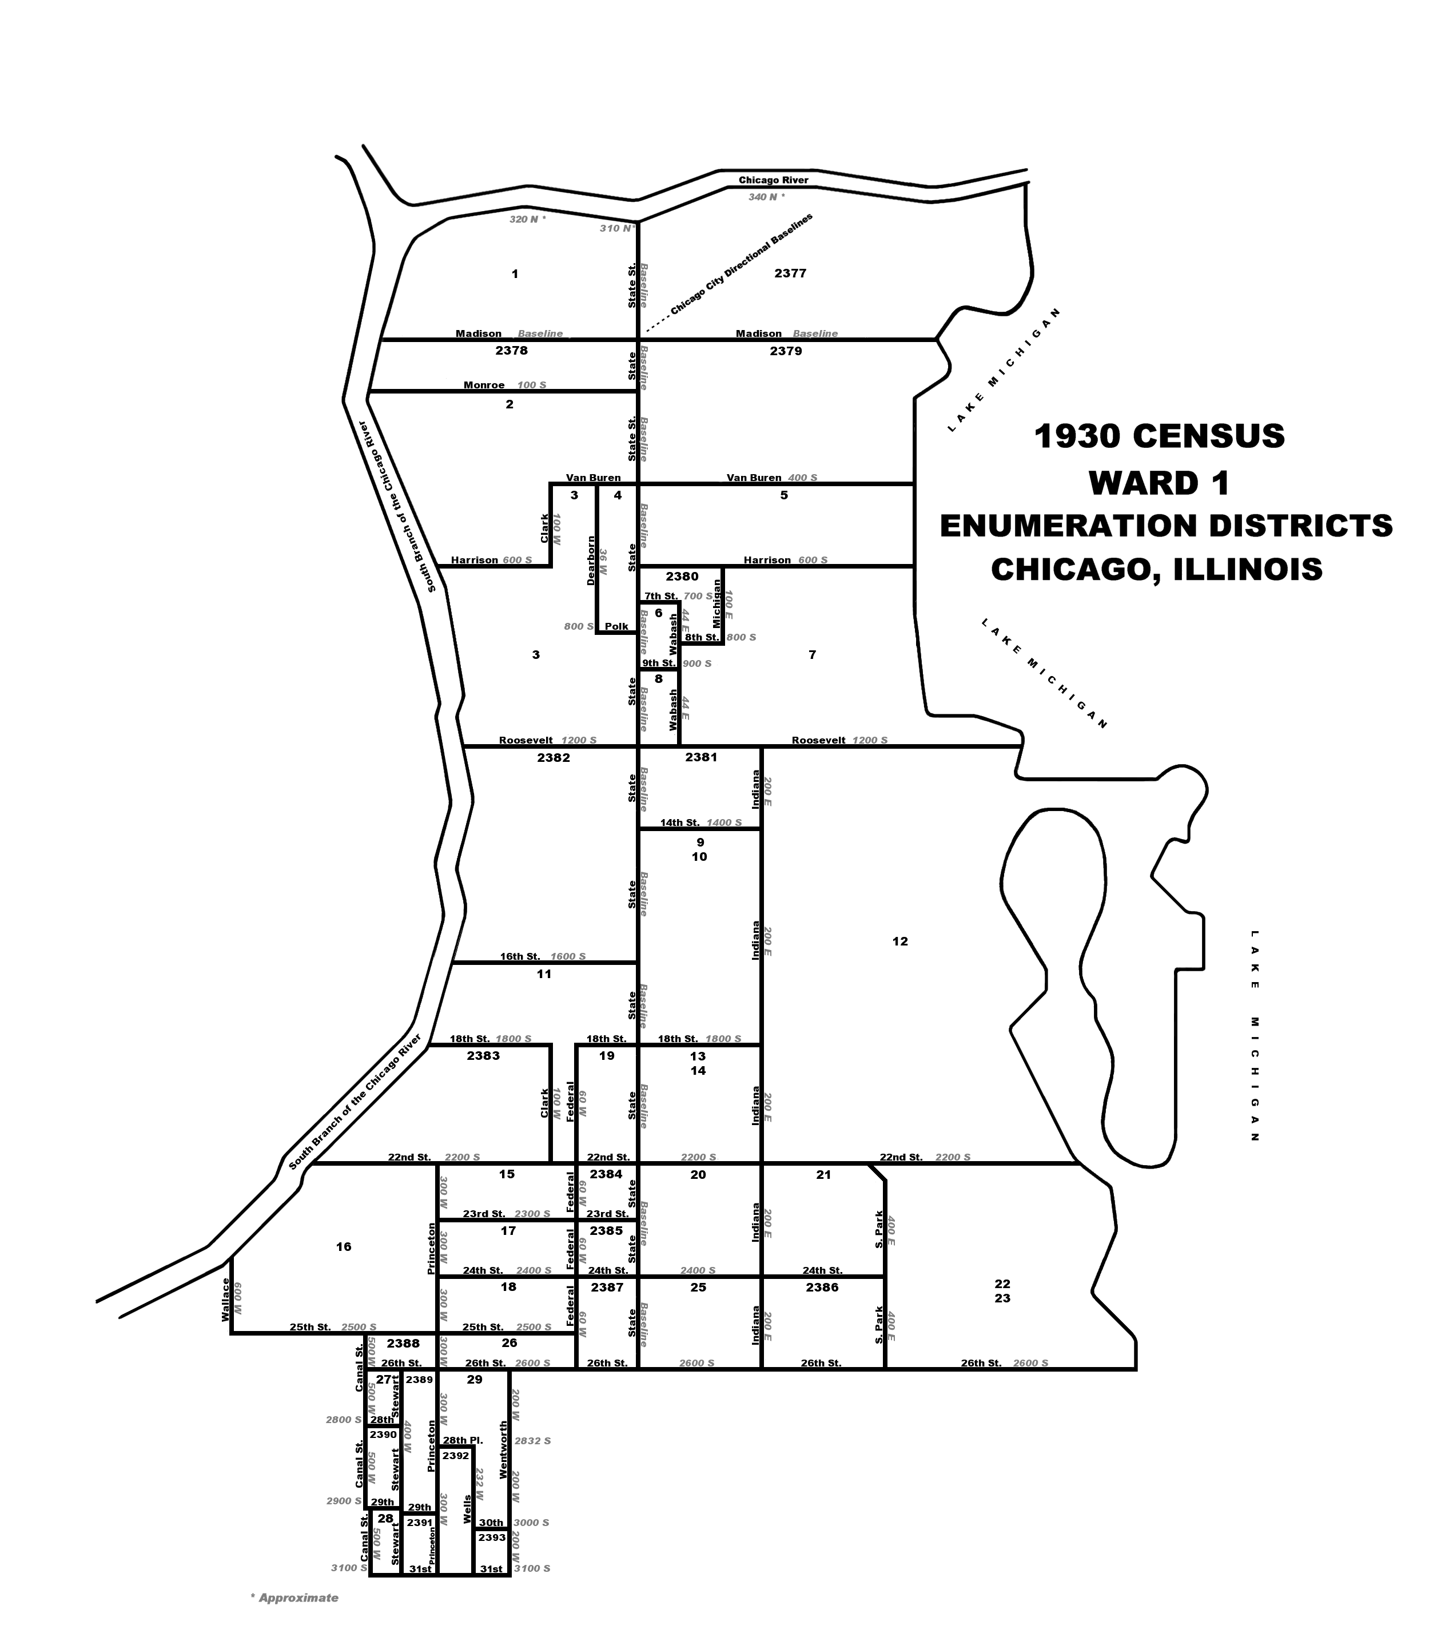
Image 2

(Image from http://www.alookatcook.com/1930/c1930wd01mapptif.gif)
V. Economic Theory and Methodology
Housing is a unique commodity due to many characteristics, including its necessity, and the heterogeneity of its supply. Additionally, housing supply does not respond to changes in demand in the short run because of lags in the construction process as well as the finite amount of land available for use. This price inelasticity is why the supply curves are vertical in following charts. However, at the basic level, price is still based on the economic supply and demand curves, with a lower supply as well as higher demand leading to higher rent prices such as in the following charts (Mills and Nijkamp, 2002).

Chart 1: Decrease in Supply
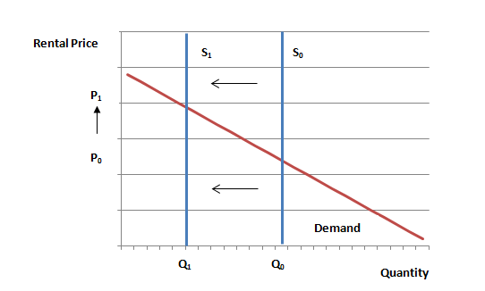

Chart 2: Increase in Demand
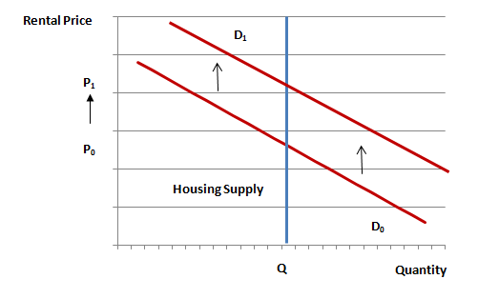

As can be seen from Chart 1, a decrease in the supply of housing will cause prices to rise. One hypothesis is that the discrimination against black housing caused the supply of housing for African American households to decrease. This decrease effectively creates two supply curves, one for African American households and one for white households. Chart 2 shows what this hypothesis predicts, with S_{black} representing the supply of housing available to African American households, and S_{white} representing the supply of housing available to white households. The demand function cannot be split up as easily, due to overlapping yet not homothetic preferences between the two races. Thus this first hypothesis represents the difference as a supply shift with no change in demand.

Chart 3: Supply Shift from White Households to Black Households
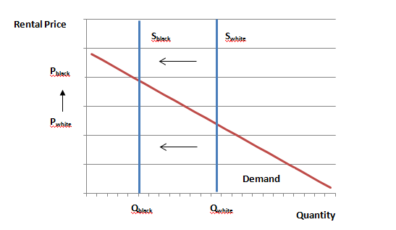

In the above chart there is an ambiguous change in demand curves between white households and black households. There is a definite decrease in supply from black households to white households, causing black households to pay higher rental prices for a similar quality of house.
Another important aspect of housing is that it has the dual property of being both a use and as an investment asset. Thus, both investors looking to make a return on an investment and people looking for living space drive housing markets. This makes it more complicated than the supply and demand curves as there are really two markets for real estate. Since houses are an asset, their price reflects both the user cost as well as expectations of future appreciation. Alternatively, rent reflects only user cost which is the aspect that makes up cost of living (DiPasquale 1995). This paper’s focus is on whether African American households had a higher cost of living than white households and thus it only uses rental costs.
Due to the heterogeneity of housing it is not possible to see what a black household would pay for the same exact unit as a white household. As such, the measurements were created with the intent of seeing which variables affect rent. To start off I use a simple measure of the gap between rents paid by black and white households, which is the average difference in mean rent as a percent of white rents such as in the following equation:
$$Y=\sum_{i=1}^{n}{((B_{i}}-W_{i })/W_{i })/n$$
B_{i=} mean rent of black-headed households in geographic area i
W_{i}= mean rent of white-headed households in geographic area i
n= number of geographic areas
Y gives the average percent difference of black households and white households in a geographic area. I can use this simple equation for cities, wards, and enumeration districts. If smaller geographic areas contain more homogenous quality housing units than larger ones, then one would expect y to be bigger for wards than for the city as a whole and bigger still for enumeration districts. It should be noted that I only used enumeration districts and wards that had information for both black and white households’ rental prices.
The equation above is a good starting place to see overall differences among the four cities, but does not take into account many drivers of rental pricing. Classical economic theory has focused on location being a major driving factor on rent since the days of David Ricardo. Because the Census data from 1930 has geographical precision to the enumeration districts, which are very small, this factor can be controlled for.
However, the geographic precision does not control for the structural quality of the house. This variable includes the size of the house, quality of the upkeep, and amenities within the house. Because of the heterogeneity of housing and the limitations of the data from the 1930 Census, I am not able to fully control for this variable. To try to account for this limitation I do create a proxy for quality effects using three variables listed in the above section: radio, occscore, and numperhh. These respectively show whether the household owns a radio, the median income of a person with the head of the households’ job, and the number of people living within the household. Radios are a good proxy because in 1930 approximately 40% of households owned one. This is a good way to stratify between lower quality and higher quality homes as it was a relatively common luxury good. Occupation score controls for income to an extent, which is useful because it can be assumed that households with higher income on average will spend more on rent regardless of any other factors. Finally, the number of people in a household helps differentiate between household make ups, for example between people who live alone and families.
Taking into account the above discussion I then created the second measure I use, which is a linear regression with rent paid by the household as the dependent variable and race and the quality proxy variables as independent variables. This gives the following equation:
$$Rent=a+β_{1}*Race+β_{2}*Radio+β_{3}*Occscore+β_{4}*Numperhh$$
In the above regression the most important coefficient is β₁ as it tells us the difference in rental prices if you control for all the other variables. From now on, β_{2*}Radio + β_{3*}Occscore + β_{4*}Numperhh will be referred to as “quality effects.”
Location is one of the other major factors driving rental prices, so I integrate that into the next equation by creating geographic area fixed effects variables. These fixed effects were created by making dummy variables for every geographic area used. For example, I created a dummy variable for every ward which had a 1 if the household was in that ward and 0 otherwise, and for ward fixed effects incorporated all of the wards into the equation. Doing this gives the following equations:
$$Rent=a+β_{1}*Race+Quality Effects+Ward Fixed Effects$$
And
$$Rent=a+β_{1}*Race+Quality Effects+Enumeration District Fixed Effects$$
As with the first equation I assumed that controlling for the more precise enumeration district fixed effects would cause $β_{1}$ to be larger than when I controlled for ward fixed effects. These results, shown and discussed in later sections, did not conform to my first hypothesis.
After looking at the results from the above equation I created a new variable, AApercent, which controlled for the percent of the population that was black in the geographic area a household was in. AApercentWard used ward as the geographic area, and AApercentED used enumeration districts. The next regressions used the same controls for quality and rent still as the dependent variable, while also stipulating the AApercent variables as an independent variable. The regressions do not combine the AApercent variables and the geographic fixed effects. The reason is that the AApercent variables are proxies for other underlying drivers, and these drivers would be controlled for with the fixed effects. Using AApercent is a way to measure those effects which are correlated with it, but cannot be directly measured with the available data. These following regressions were the first step in seeing whether prices were systematically different in areas with different demographics.
$$Rent=a+β_{1}*AApercentWard+Quality Effects$$
And
$$Rent=a+β_{1}*AApercentED+Quality Effects$$
I then combined the above equations with race as an independent variable. This was useful because the results showed whether segregation was affecting the rental prices in specific areas, or of specific households. This gave the following equations:
$$Rent=a+β_{1}*Race+β_{2}*AApercentWard+Quality Effects$$
And
$$Rent=a+β_{1}*Race+β_{2}*AApercentED+Quality Effects$$
The final equation, which provides the primary results for this analysis, combines both AApercentWard and AApercentED in addition to race. This measures the effects of different levels of geographic precision. This equation is:
$$Rent=a+β_{1}*Race+β_{2}*AApercentWard+β_{3}AApercentED$$
$$+ Quality Effects$$
Adding the two AApercent variables allows us to compare whether segregation is affecting prices for specific areas or specific households – I believe this idea is worth focusing on. The original theory proposed focused on individual buyers and due to a decrease in supply of housing for black households assumed they would pay more rent. There is, however, an alternative scenario, which focuses on a different way economic discrimination took place. It posits that the houses African Americans were prevented from buying were not randomly scattered throughout all the neighborhoods in the cities. Instead, as mentioned above, they were used as a way to increase segregation.
If this is true then we have to think of the supply and demand curves from a different perspective. Now instead of having the supply curve represent the amount of housing for white households or black households, it represents the amount of housing in primarily black or primarily white enumeration districts. The demand analogously represents the demand within these districts. With this idea, due to African Americans being pushed into these areas, the demand in their districts increases, causing prices to be higher in primarily African American districts than in primarily white districts. This idea can be seen in the following chart, where D_{black} represents the demand for housing in primarily black enumeration districts, and D_{white} represents the demand for housing in primarily white enumeration districts.
Chart 4: Results of Overcrowding in Enumeration Districts
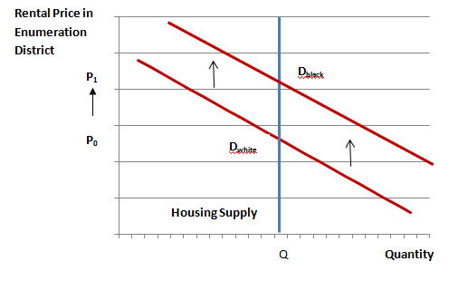
In addition to these effects the results will give an insight into how the demographics of one enumeration district affect the prices of the enumeration districts around them. The results show that the segregated areas were much smaller than wards, as well as closer to enumeration district sizes. Thus, being able to examine both of these types of areas will help answer these questions.
VI. Empirical Results
The first results come from the first equation, which looks at the average percent difference of black household rents and white household rents. The results look at the difference for the average enumeration district of each city, the average ward of each city, and each as a whole. These results can be seen in Table 2. A positive rental gap means African Americans paid more, on average, than whites, a negative rental gap means they paid less. The numbers in parentheses are n, the number of geographic units on which the average is taken.
Table 2: ∑((B_{i}-W_{i})/W_{i} )/n

 | Chicago | Detroit | New York City | Philadelphia
City | 84.5%  (1) | -6.1%  (1) | -17.1%  (1) | -7%  (1)
Ward | 194.7%  (24) | -24.6%  (18) | -28%  (21) | 49.7%  (35)
Enumeration District | -6.6%  (46) | -7.16%  (53) | 9%  (264) | 49.1%  (130)

The results from the first equation are not consistent across the four cities as five of the twelve averages indicate Black households pay more and seven show the reverse. Chicago’s results tell the most interesting story because as the city on the whole African Americans paid a significant 84.5% higher average rent than white residents. Then when the same measure is used at the ward level the average difference is an even larger 194.7%. This increase was actually what I expected as I thought narrowing down the geographic areas would help control for quality differences. The most interesting result comes at the enumeration district level, because then it the price difference reverses direction and falls to black households paying an insignificant 6.6% less than white households.
The results from the other cities do not have the same pattern. The pattern for Detroit and New York City are similar to each other, as they both have relatively small differences on the city level with Black households having lower rental payments than white households. This difference gets larger at the ward level, and then with both of them goes up at the enumeration district. In New York it even becomes positive implying that black households pay more than white household, which is the exact opposite pattern that Chicago has. Philadelphia, on the other hand, had an insignificant difference at the city level, which then shot up at the ward level, and stayed the same around the enumeration district level. It should be noted that there was one outlier enumeration district for Philadelphia, which if taken out makes the enumeration district difference insignificant and results in Philadelphia have a similar pattern as Chicago.
The results for the first equation do not control for anything but geographic areas so they are merely useful to get a broad overview. I do not believe any strong conclusions can be drawn from them except for the fact that there are differences in rental pricing among races, and these differences depend on the level of geographic area used in the calculation. The next measures will help dig deeper into the differences among the races’ rental prices, and can help compare the cities to each other.
The next regression controls for fixed effects at different geographic levels. Table 3b controls for ward fixed effects, and Table 3c for enumeration district fixed effects. The numbers in parentheses are the standard errors.
Table 3a: Rent=α + β_{1*}Race + Quality Effects

 | Chicago | Detroit | New York City | Philadelphia
Race | 63.48***  (15.04) | -4.5  (16.9) | -2.76  (9.81) | 9.19  (22.78)
Prob>F | 0.000 | .9631 | 0.000 | .0164
***significant at the 1% level

Table 3b: Rent=α + β_{1*}Race + Quality Effects + Ward Fixed Effects

 | Chicago | Detroit | New York City | Philadelphia
Race | 121.3***  (24.16) | 0.59  (21.13) | -4.36  (11.95) | 4.52  (25.6)
Prob>F | 0.000 | .68 | 0.000 | 0.000
***significant at the 1% level
Table 3c: Rent=α + β_{1*}Race + Quality Effects + Enumeration District Fixed Effects
 | Chicago | Detroit | New York City | Philadelphia
Race | -2.84  (47.5) | -76.5***  (26.6) | -15.41  (11.94) | -25.34  (26.6)
Prob>F | 0.000 | 0.000 | 0.000 | 0.000
***significant at the 1% level
The regressions in Tables 3a, 3b, and 3c give slightly different results for the cities than those in Table 2. The results actually show that all four of them align more closely with the original Chicago results. They all have either black households paying higher rents than whites or having an insignificant difference on the city level, this difference then increases when ward fixed effects are controlled for (except for Philadelphia). However, when enumeration district fixed effects are controlled for the estimates indicate that black households pay less than white households. This is an interesting result as it implies in small geographic areas black households are not forced to pay higher rents than whites.
At the same time, ward level black households do pay more leading to the possibility that if in smaller geographic areas African Americans do not pay more, then they must be more likely to live in higher priced areas. This would then be an example of Simpson’s paradox as the correlation in different groups (the enumeration districts) is reversed when groups are combined (the wards).
To test this I created the AApercent variables mentioned above and regressed rental prices on them to get the results in Table 4a and Table 4b. As can be seen all the AApercentED coefficients are positive, meaning that the higher the percent of African Americans in an enumeration district the higher the rental price. While at the same time the AApercentWard coefficients are all less.

Table 4a: Rent=α + β₁*AApercentWard + Quality Effects

 | Chicago | Detroit | New York City | Philadelphia
AApercentWard | 25.26  (26.7) | -21.02  (35.58) | -34.86  (29.41) | 9.26  (55.69)
Prob>F | .0024 | .9273 | 0.000 | 0.0175

Table 4b: Rent=α + β₁*AApercentED+ Quality Effects

 | Chicago | Detroit | New York City | Philadelphia
AApercentED | 73.02***  (16.01) | 10.09  (20.26) | 24.99  (16.13) | 47.84  (30.71)
Prob>F | 0.000 | 0.9415 | 0.000 | 0.0061
***significant at the 1% level
Controlling for race gives the even stronger results shown in Table 5a and Table 5b. As mentioned above controlling for both race and the demographics of geographic areas is the first step in seeing whether segregation is affecting specific households, or if it affecting the areas they are forced to live in.
Table 5a: α + β_{1*} Race β₂*AApercentWard+ Quality Effects

 | Chicago | Detroit | New York City | Philadelphia
Race | 115.94***  (32.9) | 2.11  (21.06) | -4.34  (12) | 9.59  (25.5)
AApercentWard | -91.34**  (35.98) | -23.57  (43.69) | -30.38  (31.92) | -1.44  (62.66)
Prob>F | 0.000 | .9709 | 0.000 | .0332
**significant at the 5% level
***significant at the 1% level

Table 5b: Rent=α + β_{1*} Race β₂*AApercentED+ Quality Effects

 | Chicago | Detroit | New York City | Philadelphia
Race | -11.28  (45.32) | -39.81  (31.32) | -21.05*  (12.74) | -40.83  (34.70)
AApercentED | 84.34*  (48.24) | 50.27  (37.54) | 47.12**  (20.97) | 89.40*  (46.8)
Prob>F | 0.000 | 0.7925 | 0.000 | 0.0075
*significant at the 10% level
**significant at the 5% level

To try to understand the opposite signs of AApercentWard and AApercentED, I created a final regression that had both of them as independent variables in addition to race and the quality control proxies. These results solidify the previous results of having the percent of households that are African American in each enumeration district having a large positive effect on rental prices, while having a high percentage of African Americans in wards having the opposite effect. The AApercent variables also make the race of the household statistically insignificant.
Table 6: Rent=α + β_{1*} Race β₂*AApercentWard+ β₃*AApercentED+ Quality Effects

 | Chicago | Detroit | New York City | Philadelphia
Race | -24.89  (53.34) | -35.8  (31.98) | -20.94  (14.40) | -40.51  (34.77)
AApercentWard | -130.98***  (38.38) | -46  (45.93) | -41.21  (32.33) | -68.24  (69.96)
AApercentED | 180.12***  (60.93) | 63.04  (40.02) | 49.12**  (23.54) | 112.04**  (52.38)
Prob>F | 0.000 | .7608 | 0.000 | 0.0105
**significant at the 5% level
***significant at the 1% level

VII. Analysis
A quick hypothetical scenario can help understand the results in table 6. Since the results between the cities are similar I will only focus on Chicago so as not to be redundant. First, assume there are three wards. One is 100% white, one is 50% white and 50% black, and the third one is 100% black. Also use a white household, in an all white enumeration district that is in an all white ward as the base household.
With those requirements a black household in an all black enumeration district will pay about $24 more per month on rent than the base household as it pays $180 more for being in the enumeration district but about $25 less for being a black headed household, and $131 less for being in an all black ward. If this same household were in the 50% white ward it would pay about $90 more. If it were in a 50% white enumeration district in the 50% ward then it would pay about the same as the base household.
A white household in an analogous all white enumeration district and a 50% white ward would pay $65 less than the base. However, if it were in an enumeration district that was only 50% white in the same ward it would pay $25 more than the base. This gives one the idea the interaction between the percentage of the ward that is African American and the percentage of the enumeration district that is affects rental prices. This gives something close to the following chart with the z axis is the white households’ difference from the base household, (the chart for black households would be the same except shifted down by 24.89). In this chart the x axis is AApercentWard and the y axis is AApercentED. As can be seen from the chart, the highest rents are paid in primarily black enumeration districts within primarily white wards.

Chart 5: Difference in Rental Price for White Households from Base Household
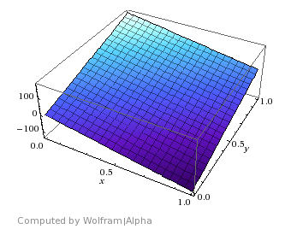
Monthly rent more than base household
AApercentED
AApercentWard
My theory for these results starts with the enumeration districts. I believe they all have such high positive coefficients because the neighborhoods with high percentages of African Americans were overcrowded as described by Alferdteen Harrison’s book mentioned in Section 2. This overcrowding was caused by the three causes of segregation that “The Rise and Decline of the American Ghetto” mentions, point of entry, collective action racism, and decentralized racism. The overcrowding in these neighborhoods led to an increase in demand without an equivalent increase in supply and thus led to higher rental prices. This is equivalent to Chart 4 in Section 6.
On the other hand, wards were significantly bigger than enumeration districts. This meant that unlike enumeration districts there were no ward for which the whole ward was designated as an African American area. This can be seen as there were very few wards for which African American households were the majority. This extra size means that wards with relatively large African American populations did not necessarily represent the overcrowding aspect because they were too large for the whole area to be overcrowded.
Instead, the coefficient of AApercentWard points to the demographics of enumeration districts affecting the enumeration districts around them. My theory is that the primarily white enumeration districts close to the majority black ones are cheaper than average. This is a natural result of white residents preferring segregation. This would then imply that in wards with a high percent of African Americans, the primarily white enumeration districts pay less.
This can be seen in Ward 5 in Chicago which is represented in Image 3 below. This ward includes the enumeration district with the highest rent in Chicago, Enumeration District 188. As would be expected from the empirical results, this enumeration district’s population is 100% African American. Furthermore, this enumeration district is directly on a black/white border, as none of the enumeration districts to the east of it have any African Americans, while all of the enumeration districts to the west of it within Ward 5 only have African Americans.
1930 Census
Ward 5
Enumeration Districts
Chicago, Illinois

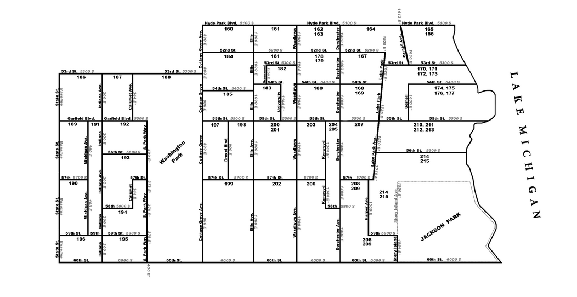
Image 3
(Image from http://www.alookatcook.com/1930/c1930wd01mapptif.gif)
A look at these enumeration districts’ average rents shows an interesting trend supporting the theory that white households prefer living further away from primarily black neighborhoods. This trend is that as the white enumeration districts get more expensive as they move further from the white/black border represented by Enumeration District 188. For example, the enumeration districts directly east of district 188, all of which are 100% white, have an average rent of $61.67, while the ones directly east of those have a 24% higher average rent $76.77. The rent steadily increases until you get to the enumeration districts next to Lake Michigan which have an average rent of $148.70. This ward is a perfect example of the idea that as white households get closer to the black/white border rent becomes less expensive. Thus wards with lower percentages of African Americans would have higher rents because white households prefer that.
The main takeaway is that economic discrimination did not mean African Americans would pay more than whites for the same property; instead it meant African Americans were not allowed to live in certain houses causing them to have a limited supply of housing. This, coupled with their increased demand, meant the enumeration districts where African Americans were allowed to live were overcrowded and thus charged higher rents. In general, however, white households preferred to be segregated from African Americans. The data and example of Chicago’s Ward 5 point to the idea that this preference led them to pay more money to be further away from African American enumeration districts. While the data is not conclusive, further research should continue down this path to see how the demographics of one enumeration district affected the others around it.

VIII. Conclusion
The data seems to tell a consistent story across the four cities I look at. This story is that economic discrimination increased rental prices in enumeration districts that are primarily black relative to those which are primarily white. However, within particular enumeration districts African Americans do not pay more than white residents for their rent. This implies that if an African American went to rent the same house as a white renter, he would not pay more if he were allowed to rent it; instead he would not have been allowed to rent many of those houses, causing the ones he can rent to have higher rental prices. The existing literature shows that the economic discrimination causes segregation among the races that led to overcrowding in African American neighborhoods. This gives context to this paper’s results, as the overcrowding would increase the demand in the primarily African American neighborhoods causing their monthly rental prices to be higher.
Another interesting result was that in wards, a larger geographic area than enumeration districts, the percent of the population that was African American had the opposite result. As the percent increases monthly rental prices actually decrease. My hypothesis for this is that white households preferred to live far away from African American areas. Thus, wards with higher percentages of African Americans had lower rental prices because the white enumeration districts within the wards, which usually outnumbered the African American ones within wards, had lower prices due to their proximity to the African American areas. The case study of Chicago’s Ward 5 supported this hypothesis, however the sample size was too small to make any definite conclusions. Additionally, if African Americans were limited to less desirable areas of towns then it would make sense that African American districts would have higher rents the closer they are to the black/white border. This, combined with the opposite effect that white households seem to have, would help explain why wards with high percents of African Americans have lower rents, as these would have more black enumeration districts further away from the border, and more white districts closer to it. I was not able to test these hypotheses but I believe they would be a great start for future research.
The main limitation of my data was the lack of information on household quality. While I did create some proxies based on the characteristics of the residents, they clearly left out important aspects such as household size. Creating a more comprehensive proxy for household quality would be another great avenue for further research; however I do not know how one would create this proxy. Another limitation to my data is that by only focusing on rental prices it did not take into account household owners. I do believe that rent is a better measure for this study’s goals then house prices because rent is a better measure of the use value of housing and not projected appreciation. But being able to incorporate household owners into the sample would get a more comprehensive look at the time period.
In spite of these limitations, this paper gives interesting results that fit into the existing literature and history of the time period. Additionally, understanding the driving forces of history can help illuminate current situations. For example, differences in costs of living can lead to wealth differences which can having lasting effects on descendents and can even be a reason for the current wealth gap between African American and white Americans.

Bibliography
- Corrigan v. Buckley, 271 U.S. 323 (1926).

- Cutler D. E. Glaeser and J. Vigdor (1999). “The Rise and Decline of the American Ghetto”, Journal of Political Economy, 107 (3), 455-506
- DiPasquale, D. (1995). Urban economics and real estate markets. (1 ed.). Upper Saddle River, NJ: Prentice Hall.
- Harrison, A. (1992). Black exodus: The great migration from the american south . Jackson, MS: Univ. Press of Mississippi.
- Hirsch, J. (2002). Riot and remembrance: The tulsa race war and its legacy. New York City: Mariner Books.
- Jones-Correa, Michael. (2000). "The Origins and Diffusion of Racial Restrictive Covenants." Academy of Political Science. 115.4: 541-568. Print.
- King, A Thomas & Mieszkowski, Peter, (1973)."Racial Discrimination, Segregation, and the Price of Housing," Journal of Political Economy, University of Chicago Press, vol. 81(3), pages 590-606, May-June.
- Lemann, N. (1992). The promised land: The great black migration and how it changed America . New York : Random House
- Miller, F. (1924, June). The black migration to philadelphia a 1924 profile. Pennsylvania Magazine of History and Biography,
- Mills, Edwin, and Peter Nijkamp (2002). "Advances in Urban Economics." Handbook of Regional and Urban Economics. Ed. Edwin Mills. 3rd. Netherlands: North-Holland, Print.
- Mintz, S (2007). The Great Migration. Digital History. Retrieved February 12, 2012 from http://www.digitalhistory.uh.edu/database/article_display.cfm?HHID=443
- Perman, Michael (2001). Struggle for Mastery: Disfranchisement in the South, 1888-1908. Chapel Hill: University of North Carolina Press, Introduction
- Ruggles, Steven, J. Trent Alexander, Katie Genadek, Ronald Goeken, Matthew B. Schroeder, and Matthew Sobek. (2010). Integrated Public Use Microdata Series: Version 5.0 [Machine-readable database]. Minneapolis: University of Minnesota.
- Taeuber, Karl and Alma Taeuber, (1965). Negroes in Cities: Residential Segregation and Neighborhood Change. Chicago: Aldine Publishing Company.
- Wienk, Ronald E., Clifford E. Reid, John C. Simonson, and Frederick J. Eggers. (1979). Measuring Discrimination in American Housing Markets: The Housing Market Practices Survey. Washington, D.C.: U.S. Department of Housing and Urban Development.
- Wilkerson, I. (2010). The Warmth of Other Suns. New York City: Vintage Books.

