**How do I add a flag to a patient chart (e.g. Refusal of blood products)?**

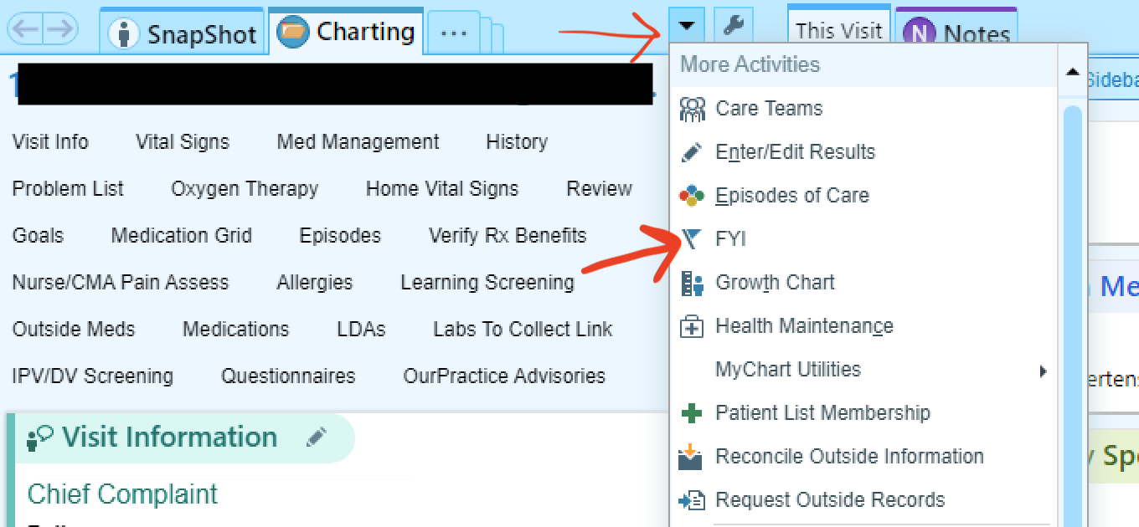

In a visit encounter, go to the small arrow on the right side of the top of your screen (see above), which opens a dropdown menu. Find "FYI" and click that.

This will open a screen where you can click "new flag", then choose from a drop down menu pictured above, including an option for blood product refusal. This should then show up as a banner or flag on a patient's chart going forward.