**DOC Pharmacy Services**

(See page 2 for a brief summary of the fully array of available DOC Pharmacy services)

Examples of most common reasons to refer to Holly for one-on-one pharmacy visits

* **HTN**: patient for which you are starting/adjusting anti-hypertensives and need follow up in 4-6 weeks for BP check and med adjustments
  + Holly can titrate, add, and discontinue medications, as well as order BMPs, etc.
* **DM**: patient for which you are adjusting diabetes meds and need short term follow up
  + Holly can titrate, add, and discontinue medications; order A1c, POC BG, UACR
  + She can also do one-on-one diabetes education and teaching, CGMs, etc.
* **Depression/anxiety:** starting a patient on an SSRI and need to see back to assess for changes in mood and side effects before uptitrating (not for starting/switching meds)
* **Anticoagulation:** patient on anti-coagulation has an upcoming procedure and you are unsure what to do with their anticoagulation or you don’t have time to address it
* **Obesity:** starting a GLP1 and want to assess for side effects, etc. before uptitrating

How to refer to Holly

**Step 1**: enter .doccheckoutnote in wrap up section

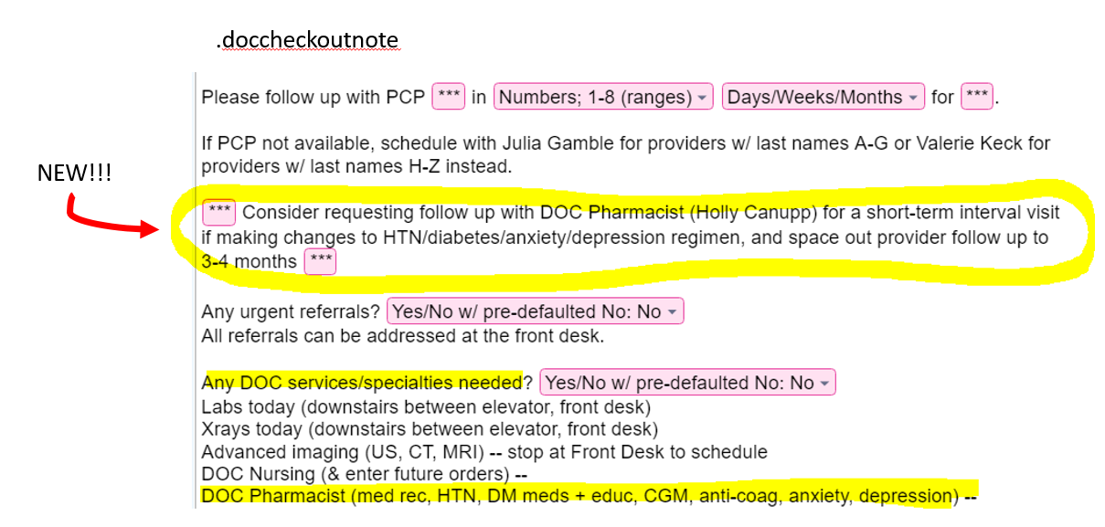

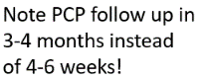 **Step 2**: fill out as such

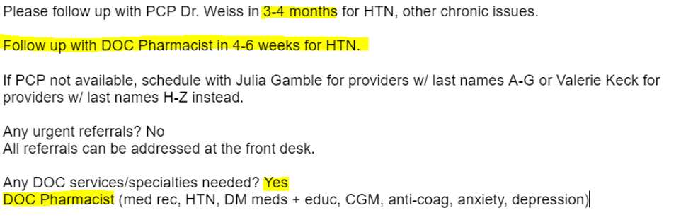

DOC Pharmacy Services

Brief summary of the fully array of available DOC Pharmacy services

* **One-on-one patient visits for medication management** (including *prescribing and titrating* all major classes of medications for):
  + **Hypertension**
  + **Diabetes**
  + **Anticoagulation**
  + **Asthma/COPD**
  + **Hyperlipidemia**
  + **Anxiety/depression**
  + **Heart failure**
  + **Obesity**
  + **Tobacco use disorder**
  + **HCV treatment (for specific cases, see attached handout as well)**
  + Hypomagnesemia
  + GERD
  + Contraception
  + Vitamin D deficiency
  + Osteoporosis/osteopenia
* Lab tests and monitoring
  + TSH/FT4
  + CBC
  + BMP/CMP, magnesium
  + Specific coagulation assays
  + BNP
  + Coags
  + Lipid panel
  + HCV tests, fibrosure
  + Vitamin D assays
  + A1c, UACR
* CGMs (refer all potential new CGM starts to Holly)
* Medication reconciliation (in person one-on-one visits)
* Patient education (in person one-on-one visits)
* Smoking cessation (including meds as above)
* Benefits investigation
* Manufacturer patient assistance programs (start with SW for med access concerns though)