Making Accessible Documents

The first rule of making documents accessible, is to try not to make PDF files. It is possible to make accessible PDF files, it just takes longer than other options.

Options for making accessible documents:

- Instead of PDF, can you make the information an accessible webpage? It might take less time than retrofitting accessibility to an old PDF. Accessible webpages usually produce more accessible results.

- Situations where a PDF might be required:
- If the PDF file is a Magazine or a Brochure that requires the layout and fonts be pixel perfect.
- If the PDF is a scan of text and requires Adobe Acrobat DC to use OCR (Optical Character Recognition) to convert the image of text into real text.

- A Word document is the best option if the file is simple text with images. It will probably be a more accessible and faster choice than PDF.
- If you have the original source document, try to make that accessible using Word’s “Accessibility Checker” and use it instead of a PDF.
- If you do not have the source document, try to export it from Acrobat DC to Word or PowerPoint instead. It will be easier to fix there.
- If it must be a PDF, fix the original source document first then convert it to a PDF following the instructions detailed in this document.

When all other options have been exhausted, and you must make or remediate a PDF file, open Acrobat DC and follow the instructions detailed in the “Acrobat DC Remediation” section of this document.

Table of contents:

Table of contents: 1
Microsoft Office 1
Office Part 1 - Creating Accessible Microsoft Office Documents: 1
1.1.0 – Making Accessible Documents in Word 1
1.2.0 – Run Accessibility Checker 1
Office Part – 2 Exporting Word document to PDF: 1
2.1.0 - Word 1
2.2.0 - Power Point 1
Office Part 3 – Convert a PDF file to Word: 1
3.1.0 – Export a PDF into a Word document from Acrobat 1
Office Part 4 – Read-only 1
4.1.0 – Mark document as “Read-only” 1
Acrobat DC Remediation 1
Acrobat Part 1 - Setting up Acrobat DC for Creating Accessible PDFs 1
1.1.0 - Add tools to the “navigation pane” 1
1.2.0 - Add Tools from the Tools tab to the right-side Panel 1
Acrobat Part 2 - Fixing PDF Files 1
2.1.0 - Action Wizard: 1
2.2.0 - Autotag Document: 1
2.3.0 - Tagging content using the Order pane: 1
2.4.0 - Touch Up Reading Order: 1
2.5.0 - Set Alternative Text: 1
2.6.0 - Check order by using the built-in screen reader to double check that things are working as expected. 1

Microsoft Office

Office Part 1 - Creating Accessible Microsoft Office Documents:

1.1.0 – Making Accessible Documents in Word

For Headings, do not use the font options in the ribbon directly. Always use the “Styles Pane” to modify styles.

1.1.1 - Click the “Styles Pane” button in the Ribbon.

1.1.2 – Hover over the Style you wish to edit, and click the dropdown area to click “Modify Style…”
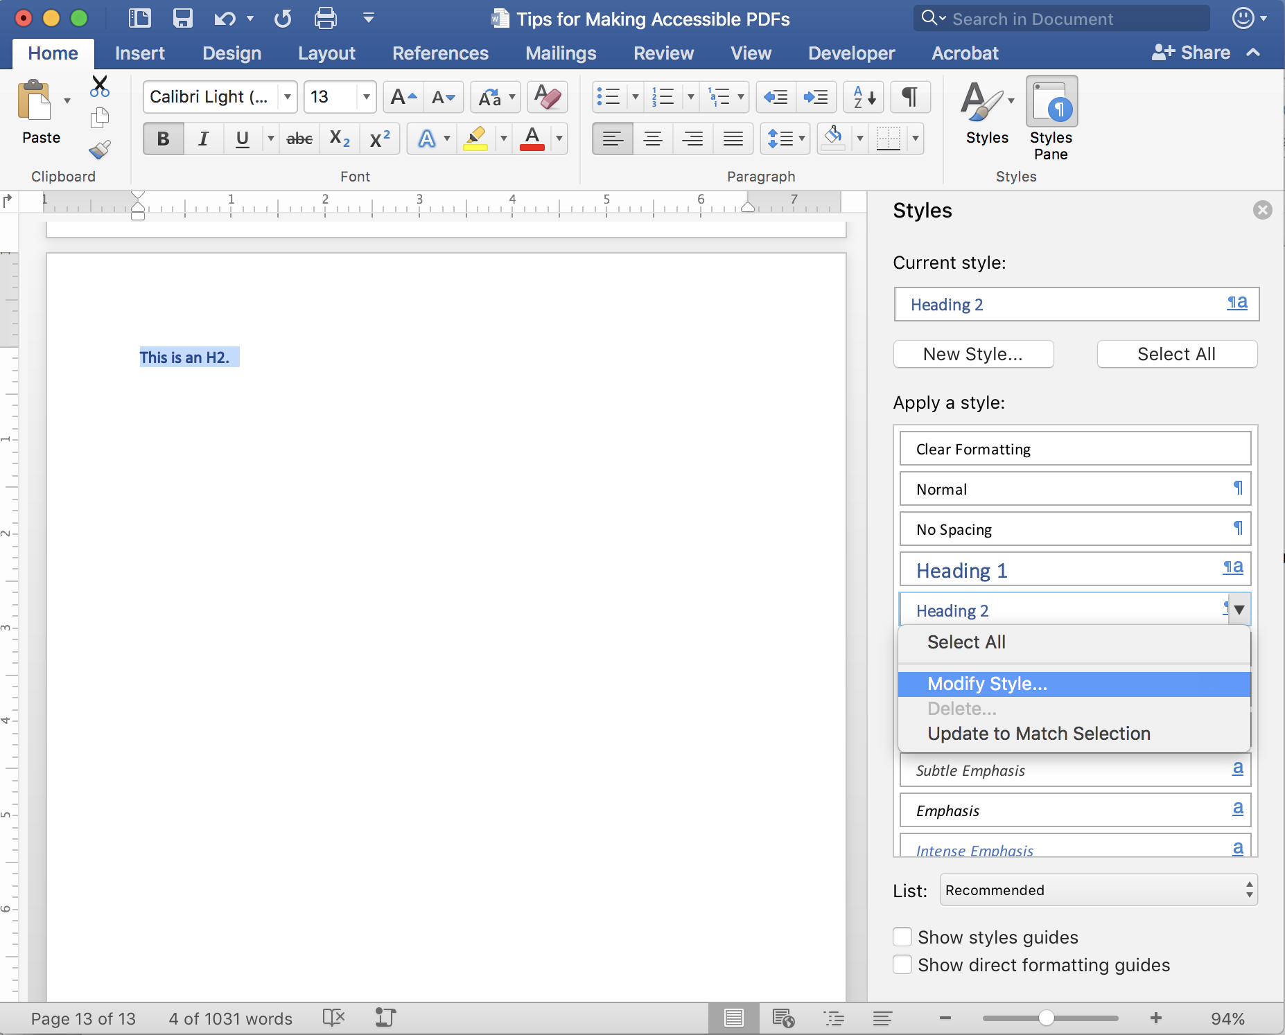

All of the options are still available in that dialog box:
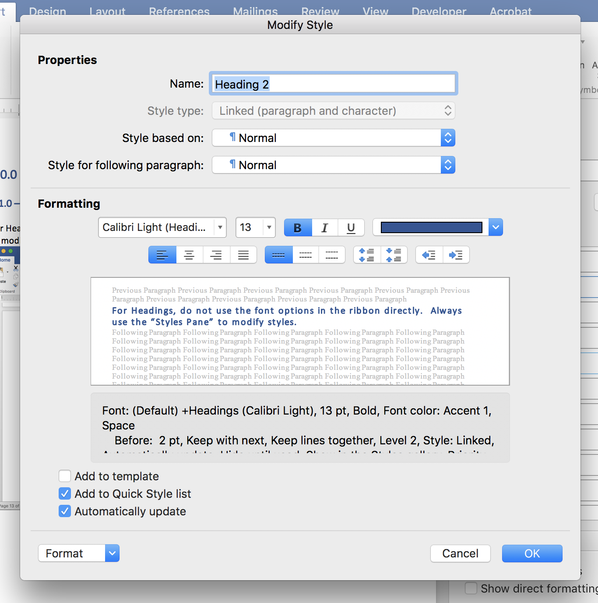

Note that you can retroactively “Automatically update” all the H2 at the same time.

TIP: The “Styles Pane” button may be missing from the Ribbon. Optionally, you can just right-click on the Heading and choose “Modify…” to open the same “Modify Style” dialog box.

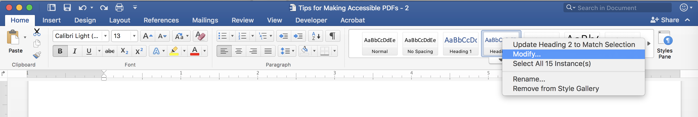

1.2.0 – Run Accessibility Checker

1.2.1 - Click the “Review” tab in the main menu.

1.2.2 - Click the “Accessibility Checker” button in the Ribbon.

1.2.3 – Click on an Error element and follow the “Steps To Fix” text.

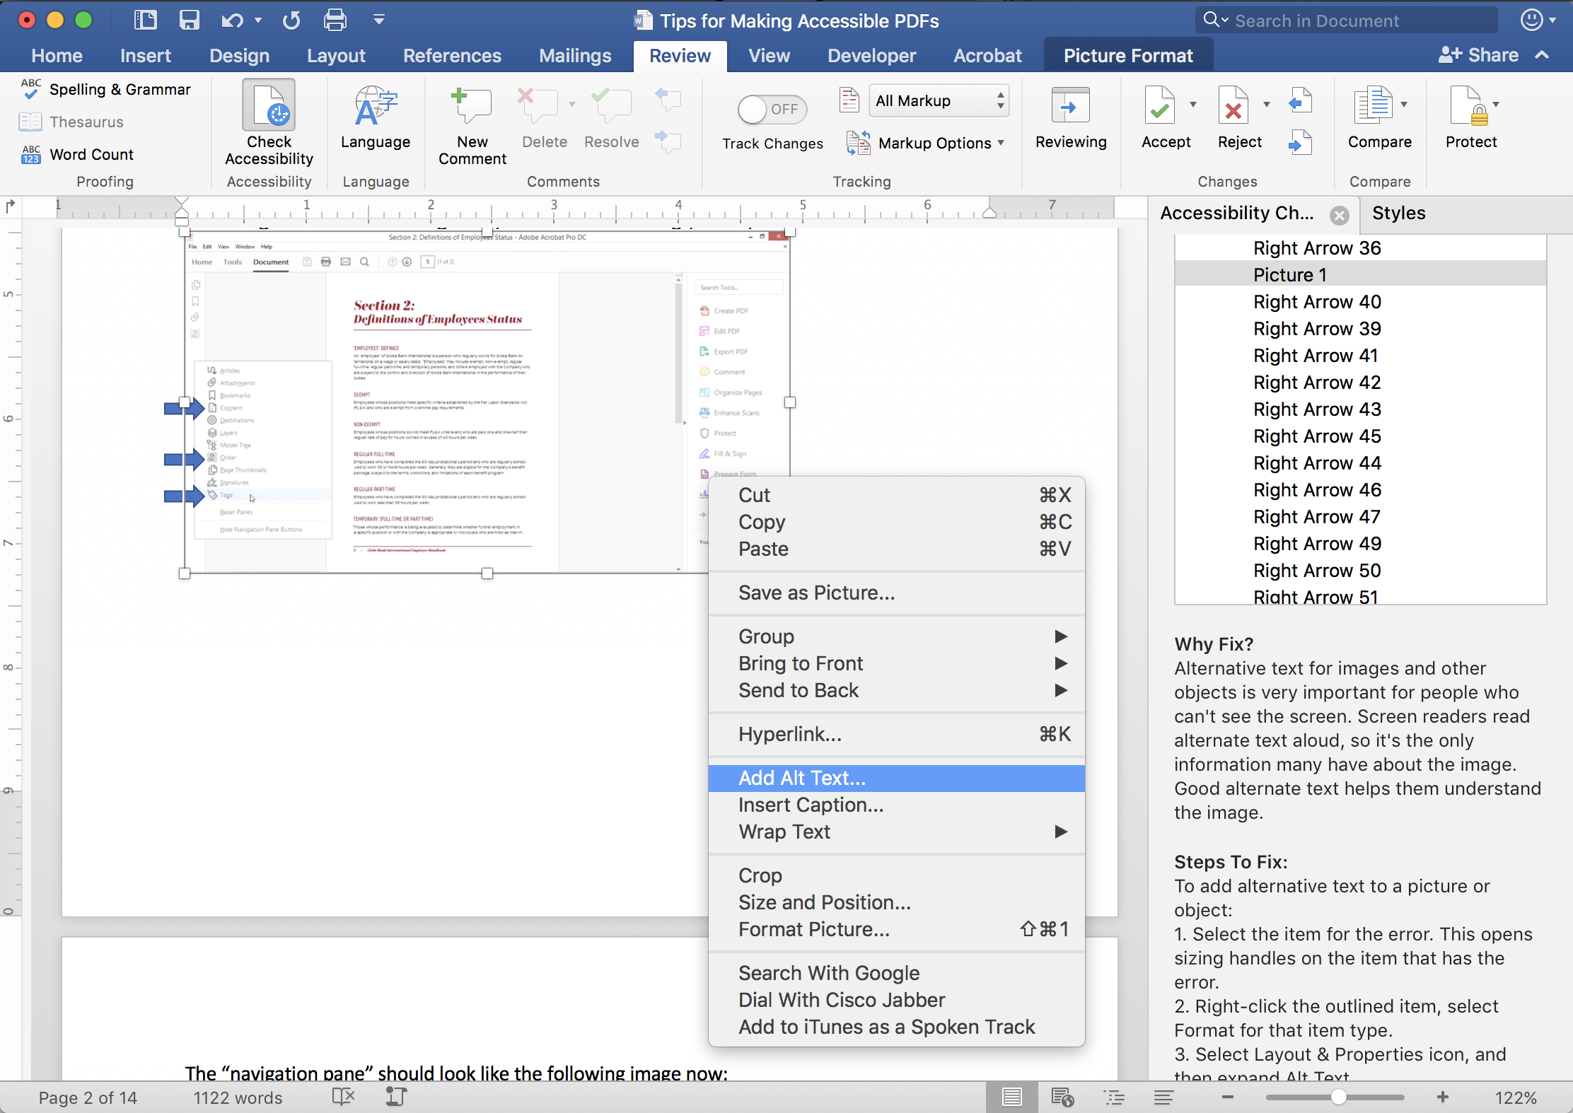

Office Part – 2 Exporting Word document to PDF:

2.1.0 - Word

Option A:
If you have Acrobat DC installed:

Click the “Acrobat” tab in the ribbon then click the “Create PDF” button. Saving it any other way will usually ignore all the work you have done.
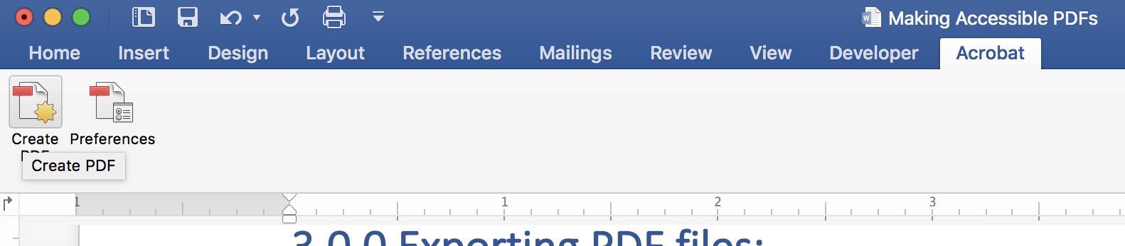

Option B:
If you do not have Acrobat DC installed:

Click “File > Save As…”
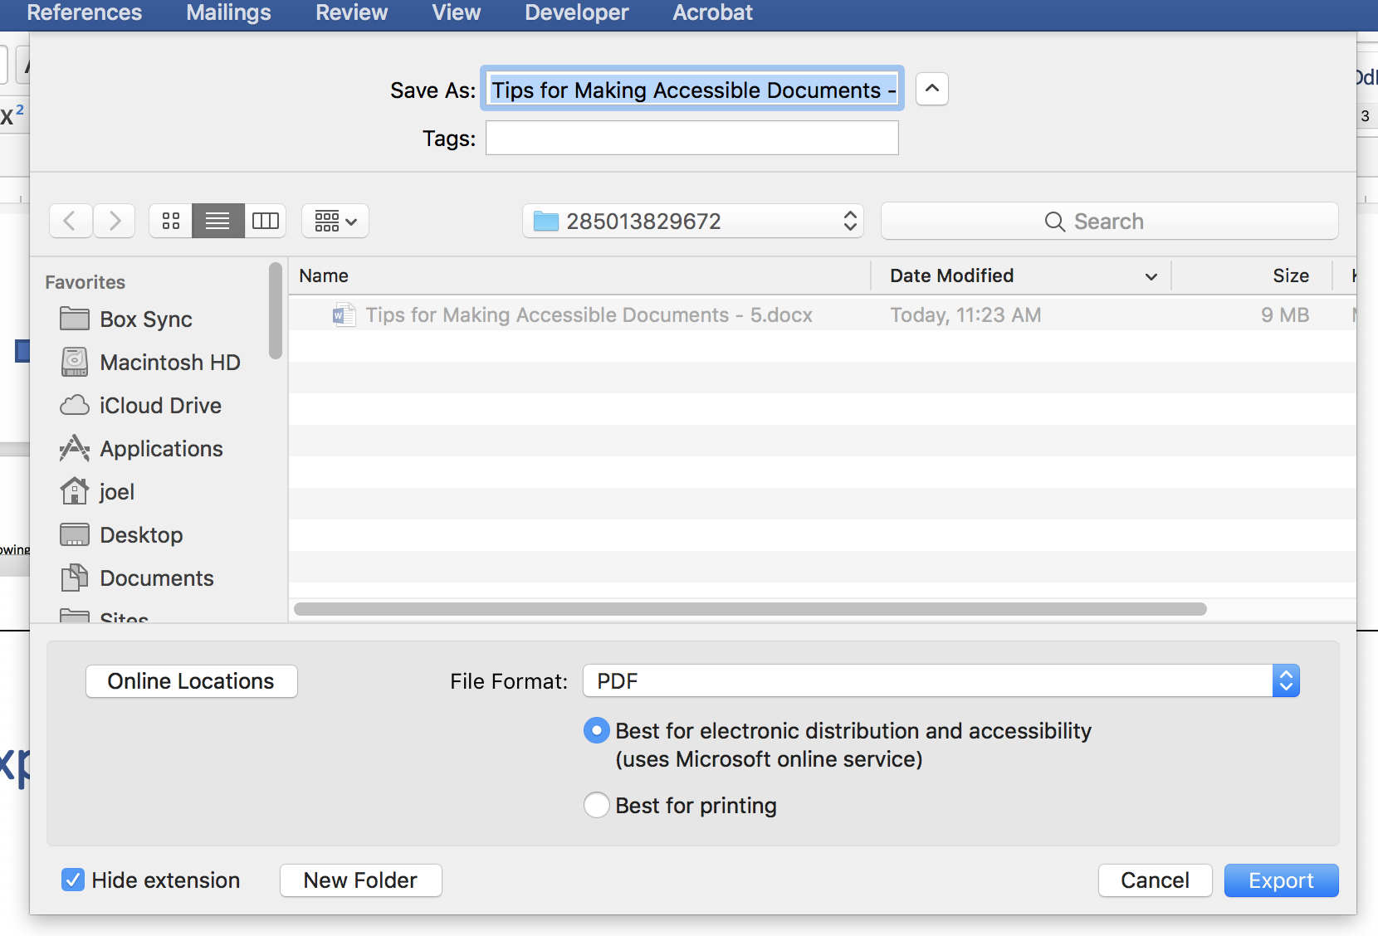

Choose “PDF” and leave the Radio Button set for “Best for electronic distribution and accessibility”

Option C:
Run the Word Document through our PDF conversion tool: https://www.robobraille.org/web3/duke/

2.2.0 - Power Point

Plan A: Click the “Acrobat” tab in the ribbon then click the “Create PDF” button. Saving it any other way will usually ignore all the work you have done.

Unfortunately, PowerPoint the “Acrobat” tab and ribbon is usually missing because Acrobat is terrible software.

Plan B: Run the PowerPoint through our PDF conversion tool: https://www.robobraille.org/web3/duke/

Office Part 3 – Convert a PDF file to Word:

3.1.0 – Export a PDF into a Word document from Acrobat

Fixing Word Documents is far easier that PDF files. You can use Acrobat DC to export the PDF to Word.

3.1.1 – Click “File > Export To > Microsoft Word > Word Document”

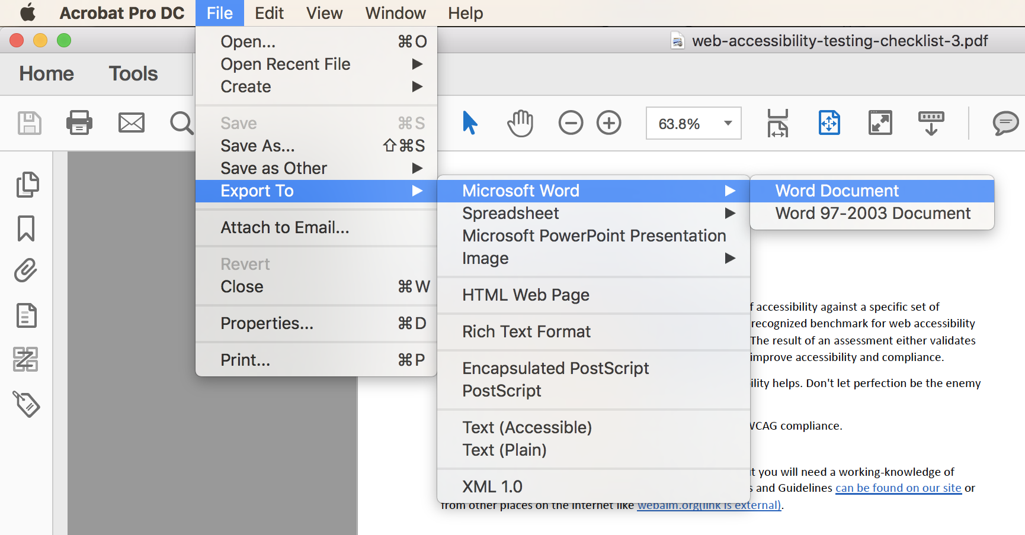

When you open it in Word, make sure that text that looks like headings are marked as headings, and run Words “Accessibility Checker”.

Note: If the PDF document was originally created in Word, you can try to open it directly in Word, but it generally does not work for documents created in other applications.

Office Part 4 – Read-only

4.1.0 – Mark document as “Read-only”

Word has many ways to mark a document as read-only. These methods are just as powerful as any method in Acrobat DC.

4.1.1 – Click on the “Review” tab

4.1.2 – Click the “Protect” button.

4.1.2 – Choose “Protect document for: Read only”

Tip: If you want multiple people to be able to edit the document, set a “Password” and share it with those people.
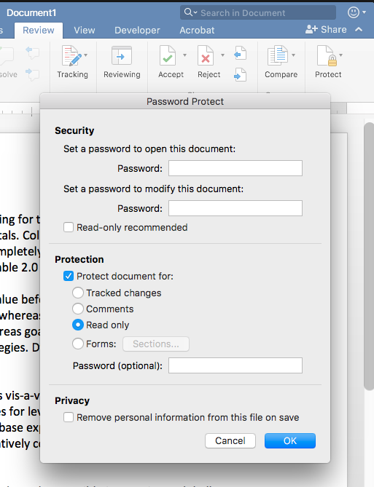

Note: Keep “Privacy” option unchecked. It is helpful to be able to know who created a document in-case a person needs to contact them or get the original source document.

Acrobat DC Remediation

Acrobat Part 1 - Setting up Acrobat DC for Creating Accessible PDFs

1.1.0 - Add tools to the “navigation pane”

1.1.1 - Click on the tiny arrow on the left side of the window.


1.1.2 - Right-click on the “navigation pane” and choose Tags, Order, and Content icons
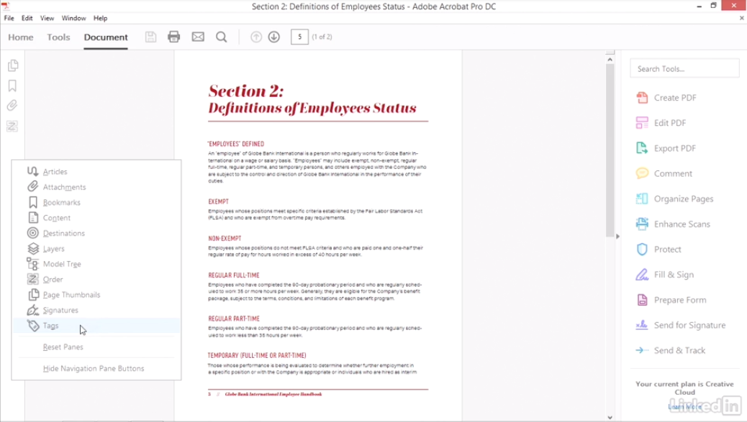

The “navigation pane” should look similar to the following image now:
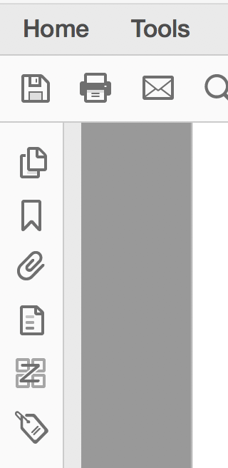

1.2.0 - Add Tools from the Tools tab to the right-side Panel

1.2.1 – Click on the “Tools” tab.
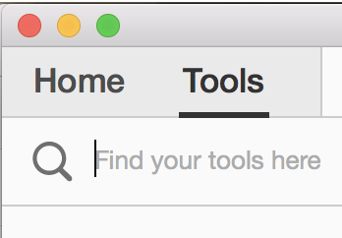

1.2.2 – Scroll down and find the following icons:

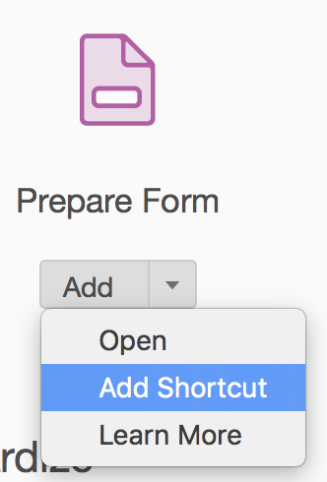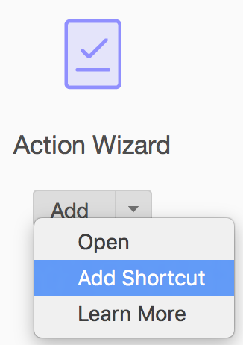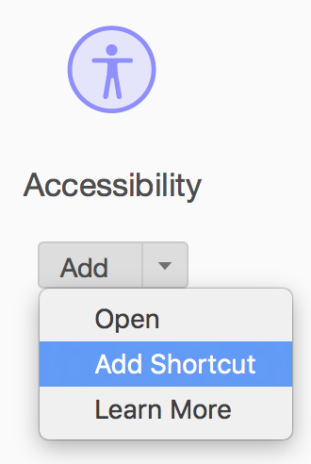

1.2.3 - Choose “Add Shortcut”. This will add them to the right-side bar as shortcuts.

Now you will see “Prepare Form”, “Action Wizard”, and “Accessibility” has been added to those three Shortcuts on the right column. It might look similar to the following image:

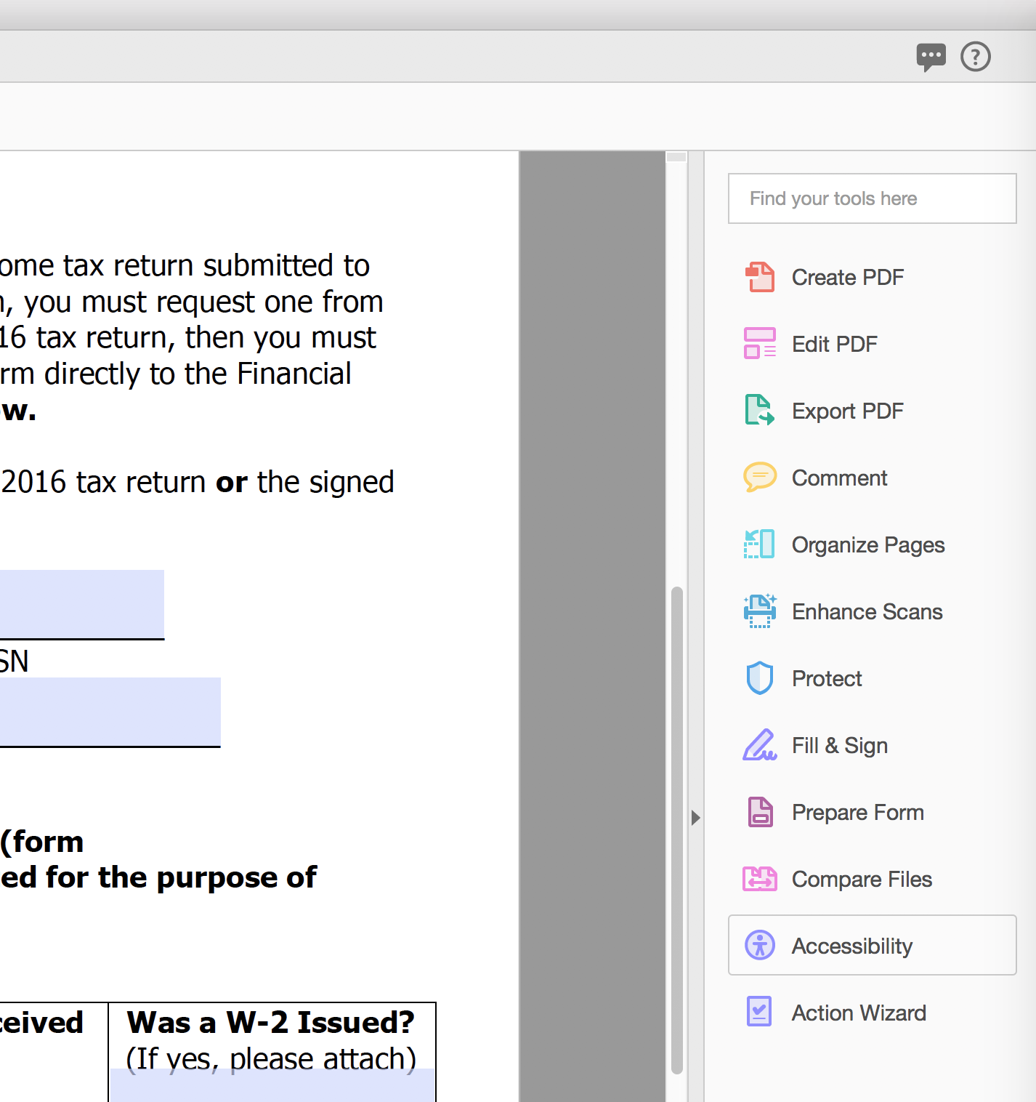

1.2.4 - Click on the “Action Wizard” button.

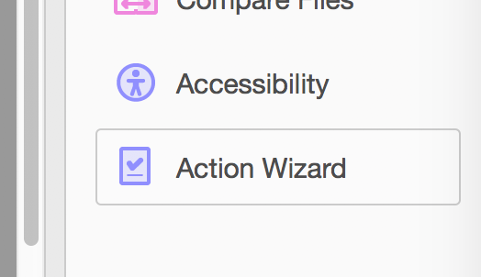

1.2.5 - Click the “Manage Actions” button in the contextual toolbar.

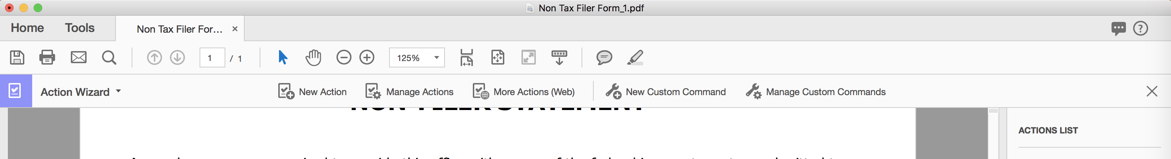

1.2.6 – Ensure the “Make Accessible” button is checked.
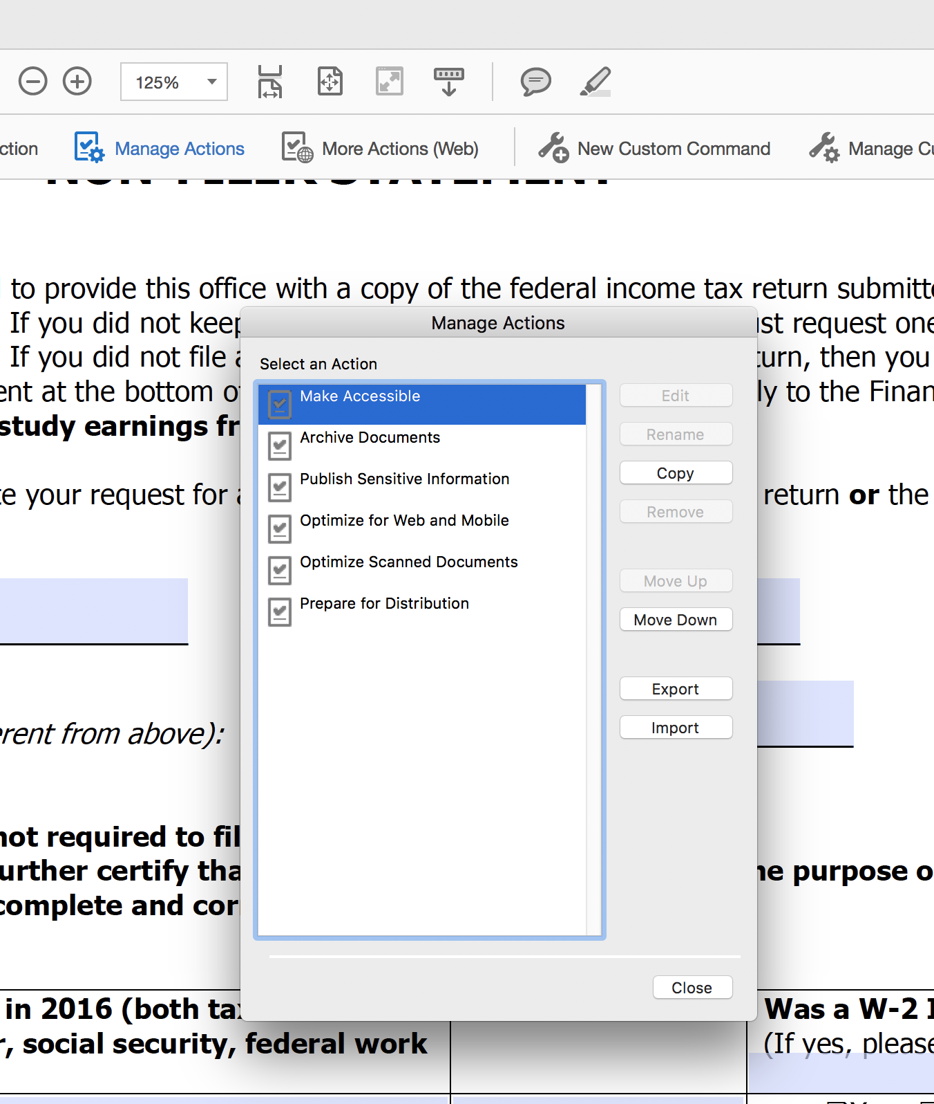

1.2.7 - Then click the “Close” button.

Acrobat Part 2 - Fixing PDF Files
Now that we have set Acrobat up with the right tools we can get to work.

2.1.0 - Action Wizard:

2.1.1 - Click “Action Wizard”.
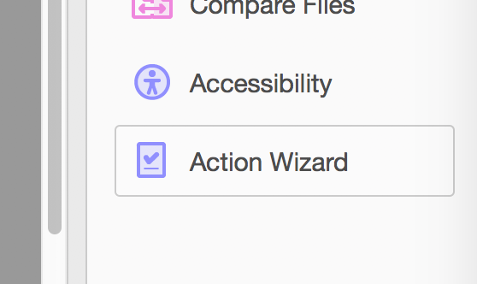

2.1.2 - Choose “Make Accessible”.
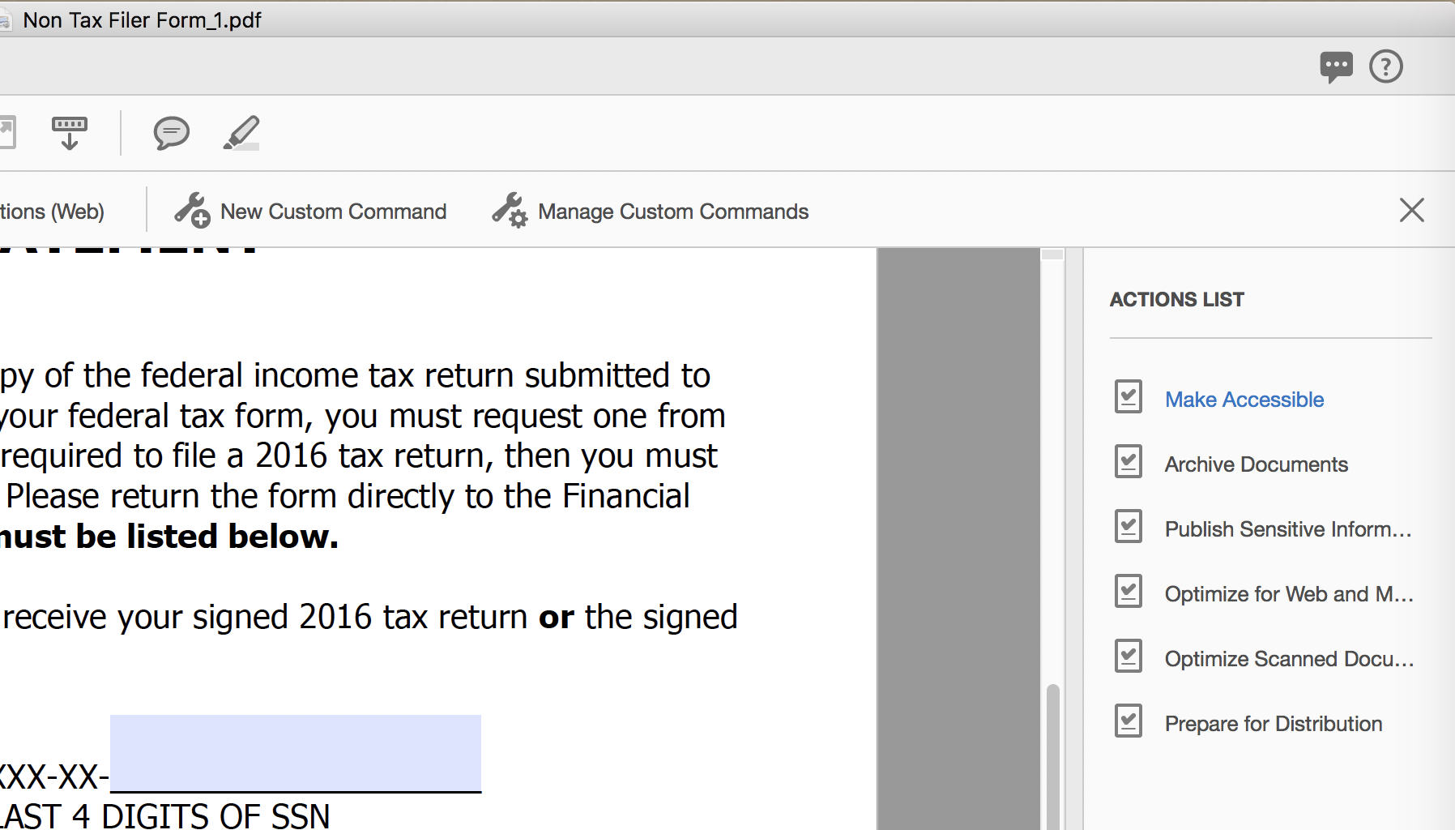
2.1.3 - Click “Start” button.
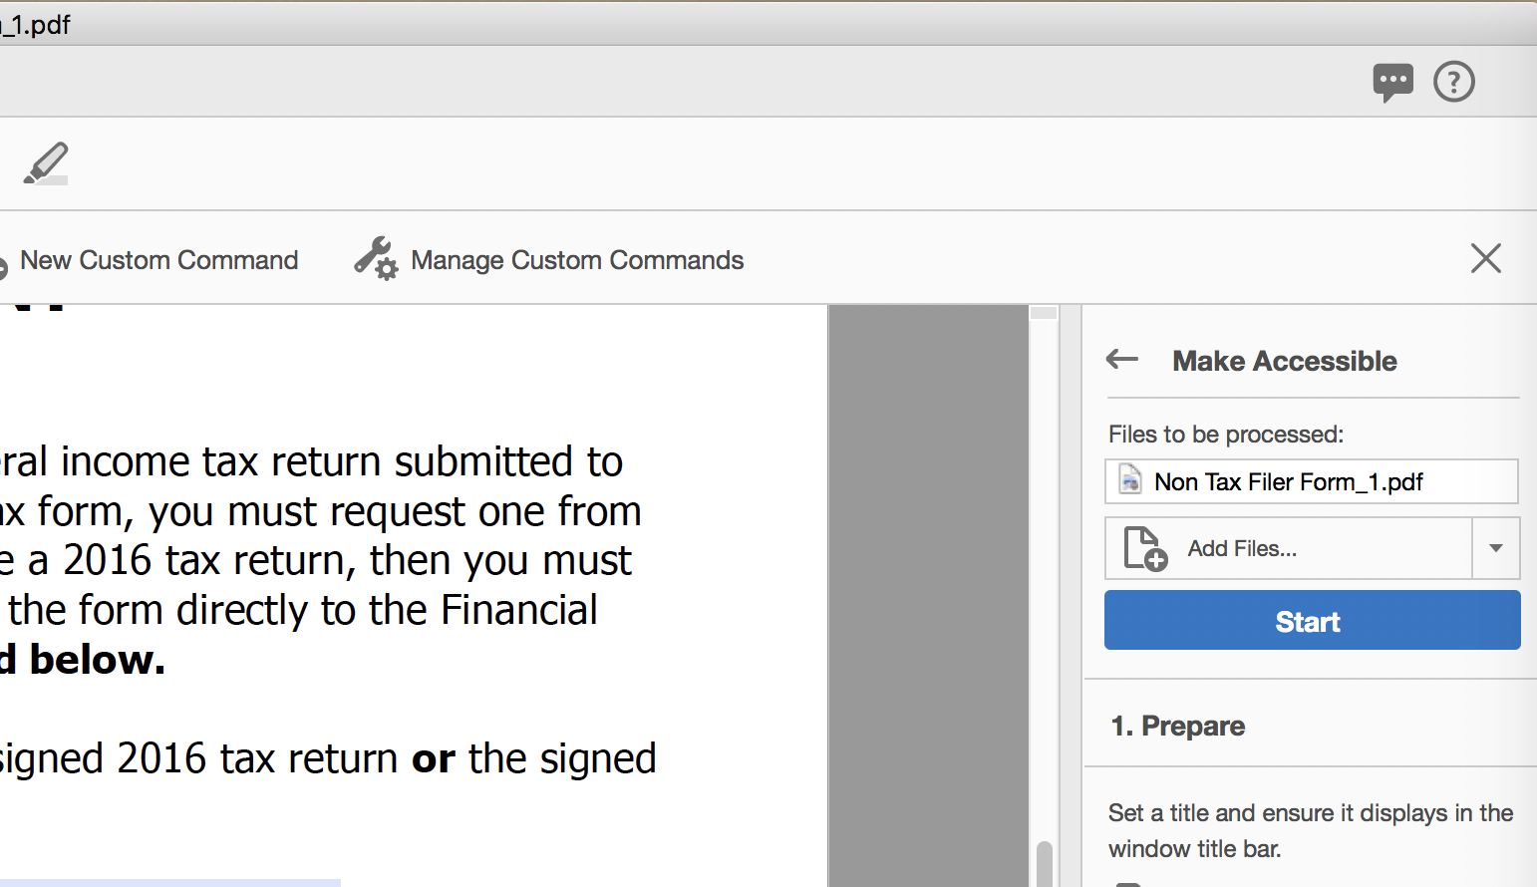

2.1.4 - Follow the Wizard.
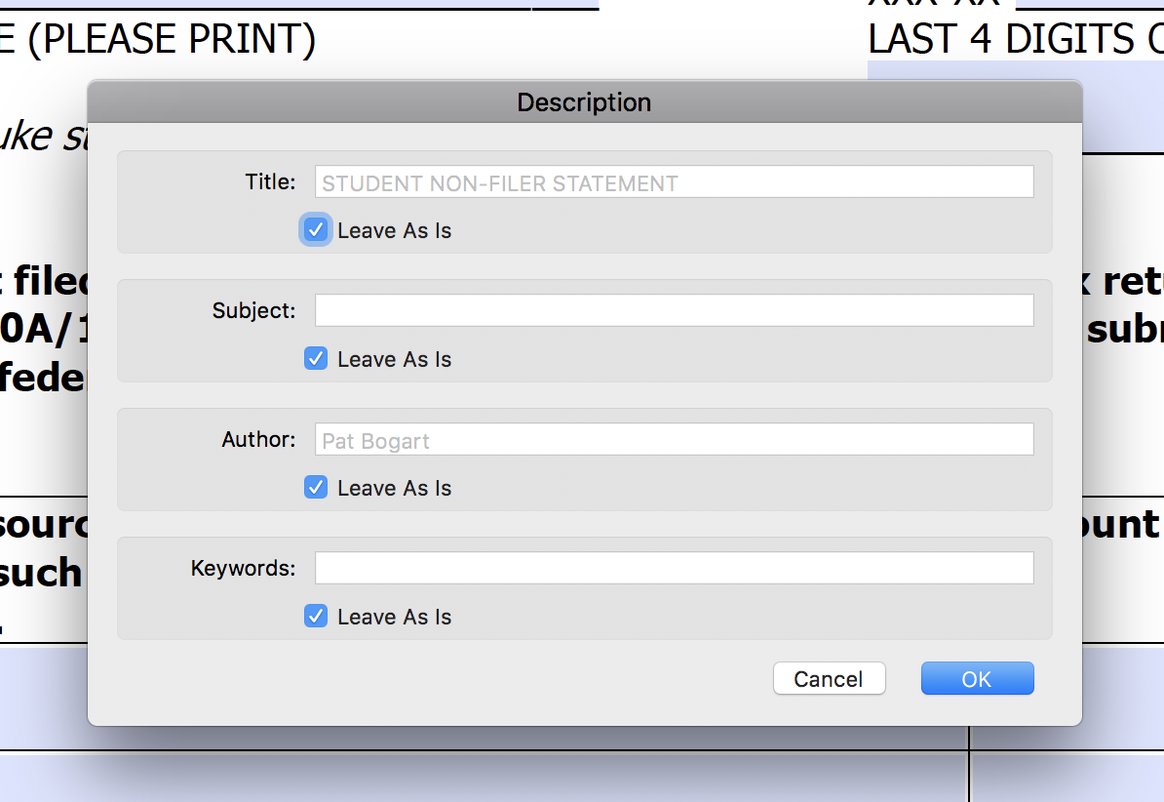
NOTE: Make sure the “Title” and “Subject” attributes are accurate and filled in.

2.1.5 - Close the Contextual toolbar.
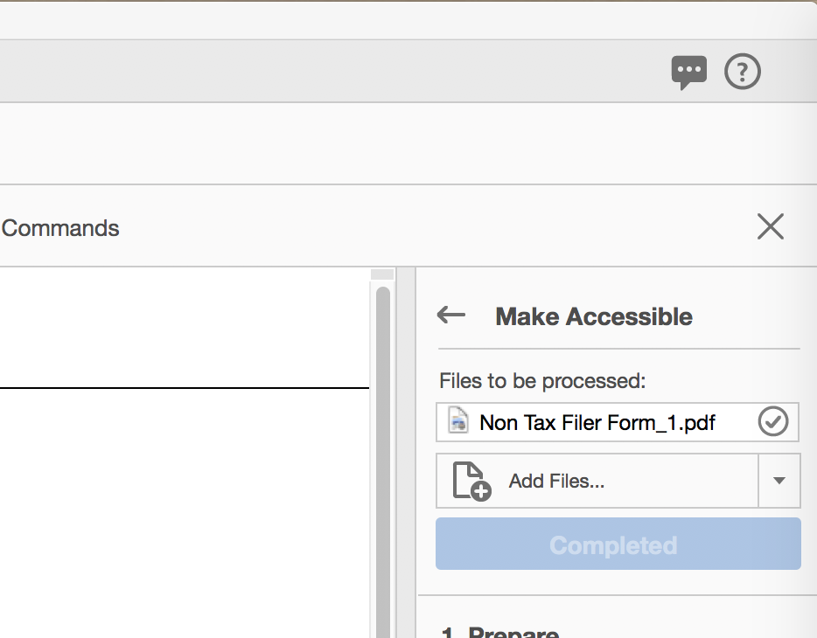

2.1.6 - Click the “Accessibility” button.
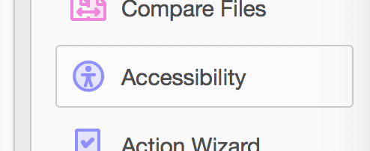

ENTER THE CHOOSE YOUR OWN ADVENTURE SECTION:
You can Autotag the document OR you can manual tag it with the “Touch Up Reading Order” dialog box. Let us try to Autotag it first.
TIP: ALWAYS, ALWAYS, ALWAYS, ALWAYS
SAVE THE DOCUMENT BEFORE AUTOTAGGING SO YOU CAN “FILE > REVERT” IF IT DOES NOT GO WELL.
Adobe Acrobat DC has no ctrl-z / undo in most of its operations.

2.2.0 - Autotag Document:

2.2.1 - Check if it has been tagged already by clicking on the Tag-pane on the left side:
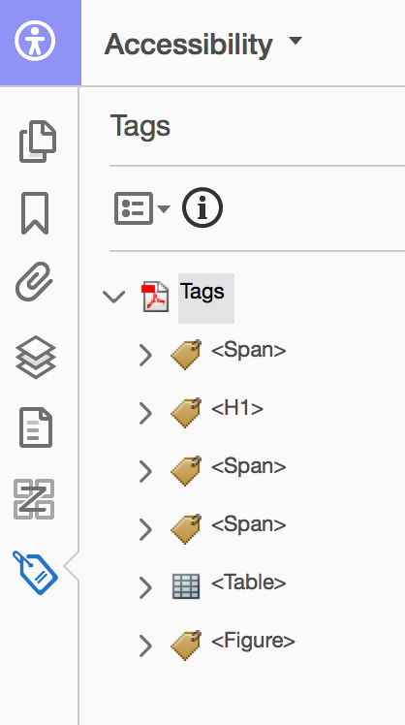
(Notice: In this example, it has already been tagged. If it wasn’t the expanded tags would be blank)

If there are not Tags we need to Tag it using 3.1.2 “Autotag Document” or 5.1.0 – “Touch-up Reading Order”:

2.2.2 - Click the “Autotag Document” button from the right side.
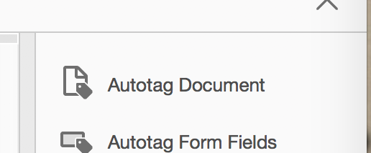

2.3.0 - Tagging content using the Order pane:

2.3.1 - You can drag items in the order pane to make them more logical.
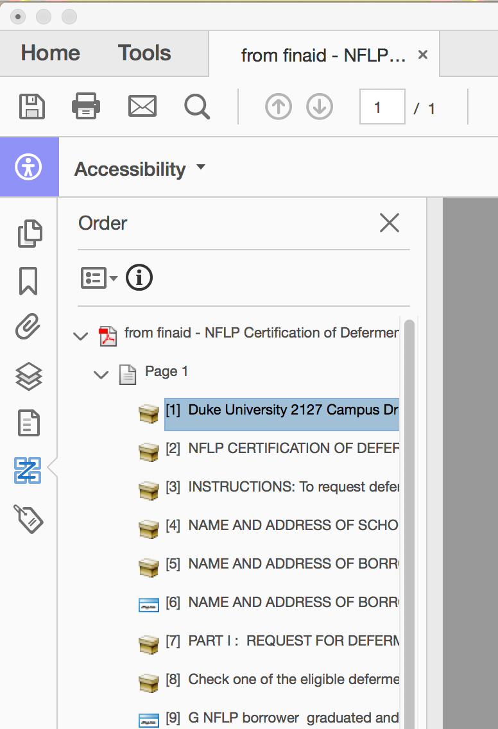

2.4.0 - Touch Up Reading Order:
This is a very poorly named tool. It is not for changing the reading order. It is for tagging text as paragraphs, headers, making tables, etc.

2.4.1 - Click the “Reading Order” button.
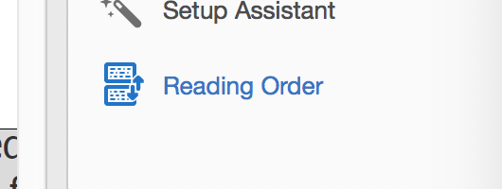

This will open the “Touch Up Reading Order” dialog box.

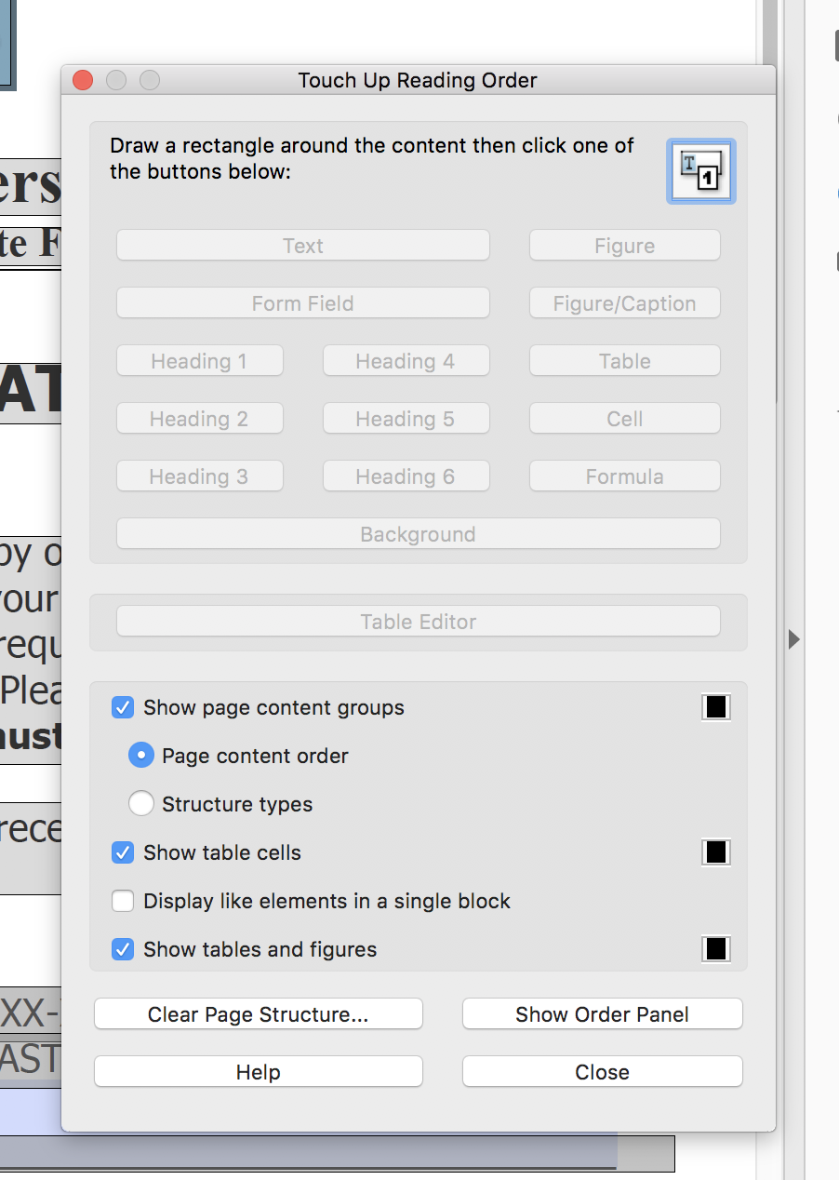
Notice “Display like elements in a single block” is unchecked.

2.4.2 - Start highlighting areas and tagging them.
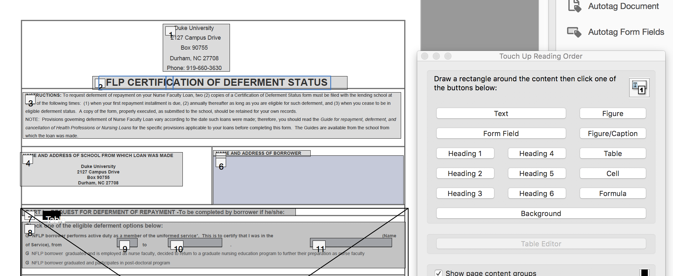

Adding Headings is important. This is a primary method people navigate content.

Try to mark decorative images as “Background”. Unless Acrobat DC it just deletes them.

Tip: If the “Touch Up Reading Order dialog” box is all greyed out, highlight the entire page, then click outside the page. It will start working again.

If this is a form with underlines like “Name:_____________” or other decorative non-content go to the “Order” pane items right-click and choose “Background”.

You can do this in the Reading Order pane too.
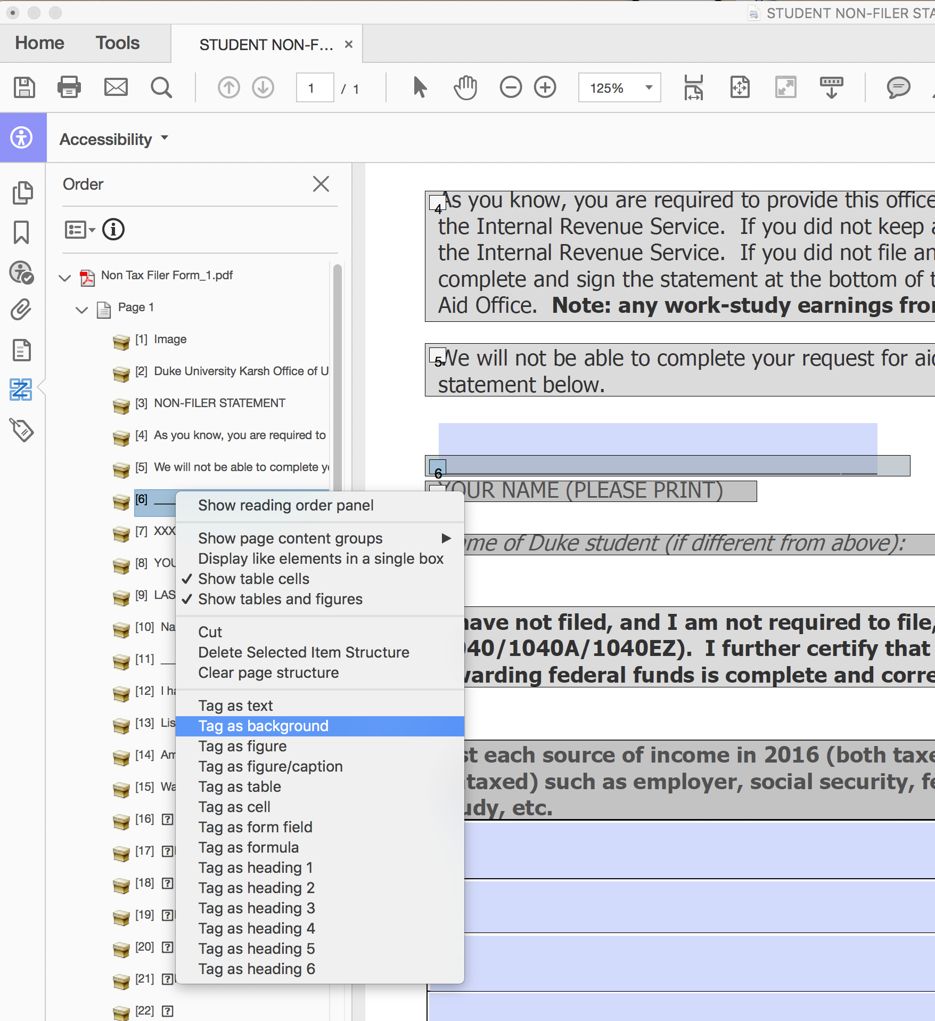

Tip: You can use the Order pane to find items in the document by highlighting them!
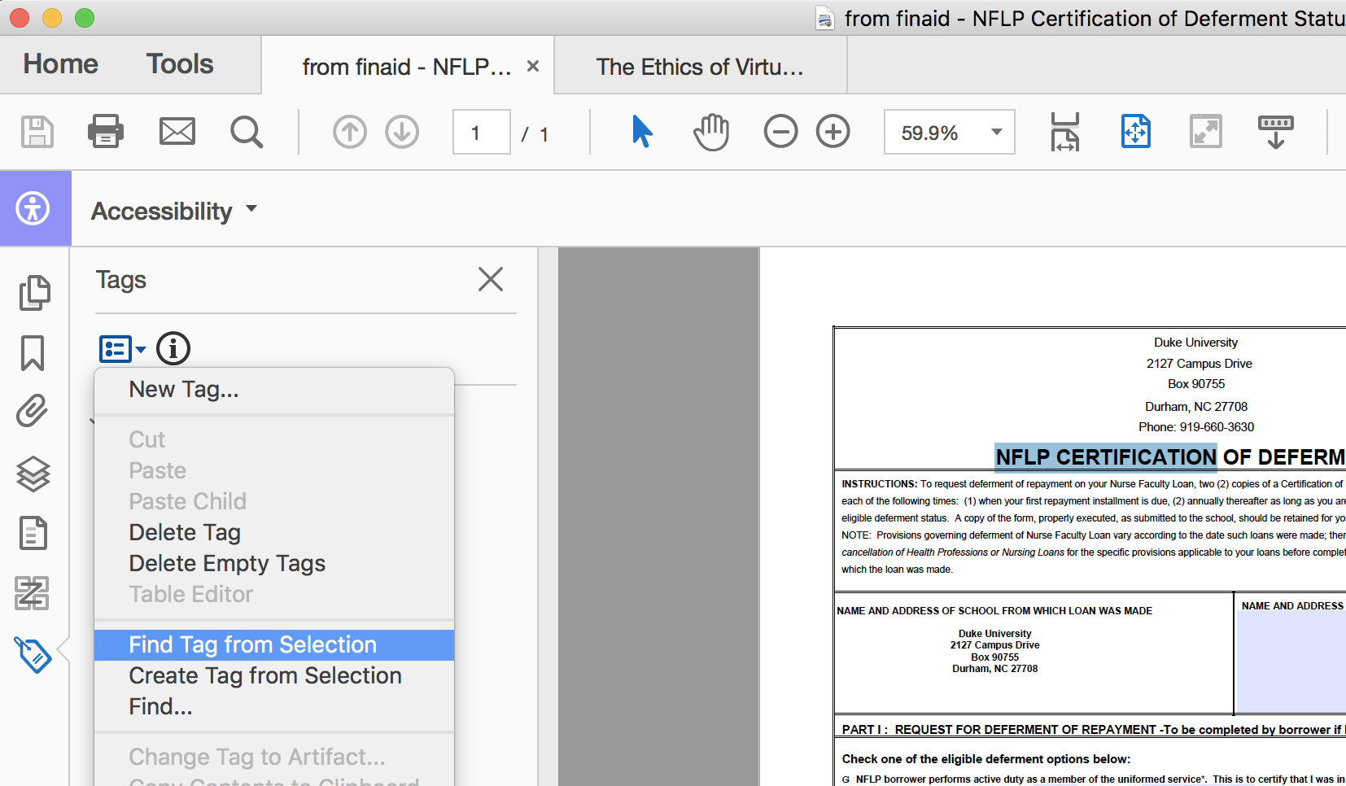

2.5.0 - Set Alternative Text:
We need to check if all the images all have “Alternate text” (or marked as “Decorative figure”).

2.5.1 - Click the “Set Alternate Text” button from the right side panel.
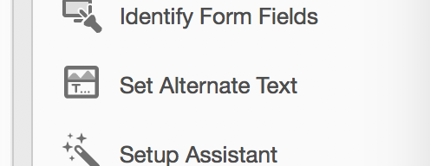

2.5.2 - Assign Alternate text to all images:
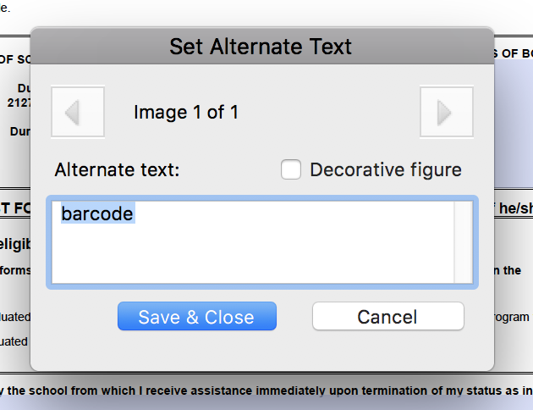

2.6.0 - Check order by using the built-in screen reader to double check that things are working as expected.

2.6.1 - Activate “Read Out Loud”.
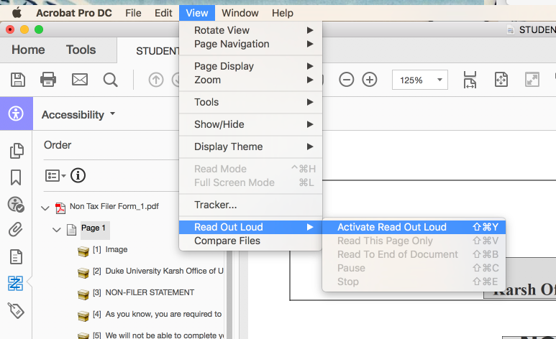

2.6.2 - Choose “Read Out Loud”.
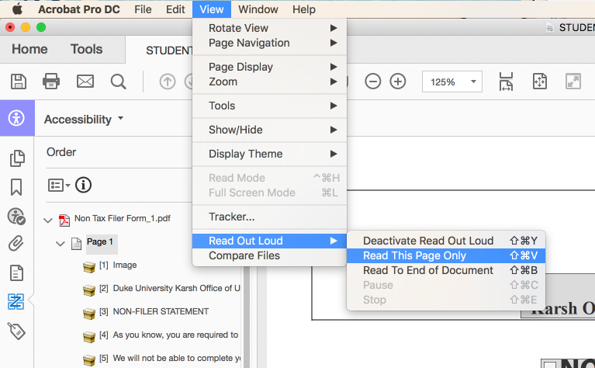

Tip: If it says “Warning Empty Page”. We need to go back and tag the document.

