QUICK TIP
Updating demographics and adding a preferred name
There are times when a provider receives demographic information from a patient or family that has not been documented by the front desk or scheduling team. Providers have the ability to update certain parts of the patient demographics. Here are the basic functions and some cautions:

Providers should update only patient phone numbers, patient email addresses, emergency contact and family contact information and the patient’s preferred name (or nickname)

Accessing: The Demographics function can be accessed from several places, but the easiest is by clicking on the patient’s name in Storyboard. This opens the Demographics Activity.

Updating: There are 4 sections that providers may update:
Patient phone numbers
Patient email address
Patient emergency contact/family contact information
Patient preferred name (Nickname)

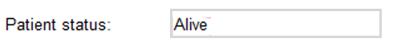
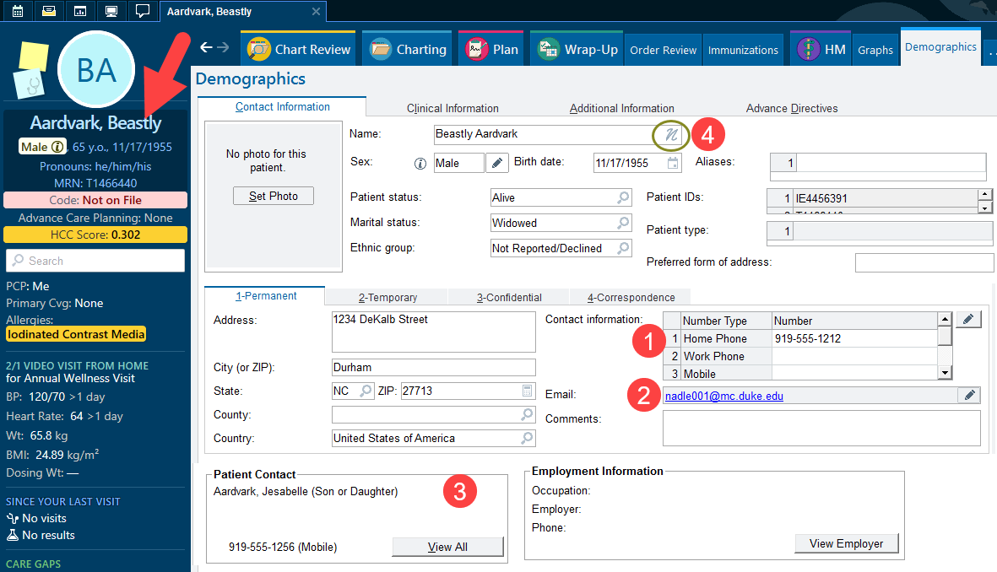

To add a preferred name or nickname:
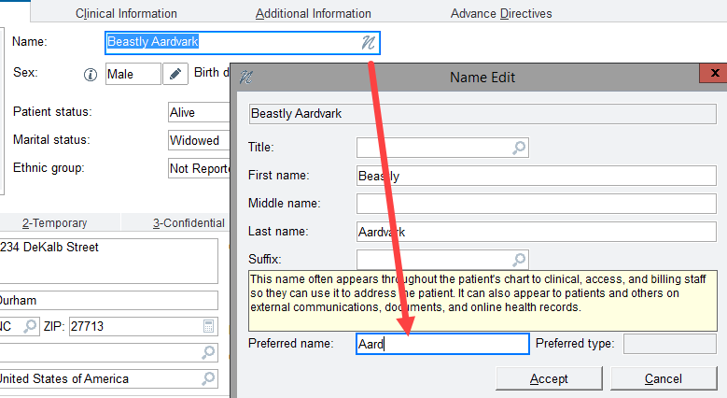

Caution: One field providers should NOT update is the Address field. Changing the address here does NOT change the patient’s address in the billing fields. Having discrepancies between addresses within the chart can cause billing and legal issues. Please ask your front desk/scheduling team to correct the address. If they are corrected through Cadence (the scheduling and registration) fields, they will flow INTO this section.

