Welcome to the 2019 Social Networks and Health workshop!

A folder for workshop materials has been set up on Dropbox: https://tinyurl.com/SNH-2019
For now, please check the 00_pre-workshop folder.

We will be using R Studio for almost all of our lab materials. To help you get the most out of the workshop, we ask that you install the software that we will be using during the workshop, and familiarize yourself with the RStudio environment by running code from one of the labs prior to the workshop. The following instructions will explain how to do that.

Install software
For the workshop, you will need to install R, RStudio, and Pajek on your computer:
- Install R: http://a-little-book-of-r-for-bioinformatics.readthedocs.io/en/latest/src/installr.html
- Install R Studio (after installing R): https://www.rstudio.com/products/rstudio/download2/
- Install Pajek:
  - Windows Pajek Install: http://mrvar.fdv.uni-lj.si/pajek/
  - Mac/Linux Pajek Install Guide-
    - Mac: http://vlado.fmf.uni-lj.si/pub/networks/pajek/howto/PajekOSX.pdf
    - Linux: http://vlado.fmf.uni-lj.si/pub/networks/pajek/howto/LinuxTut.pdf
    - Note: Pajek is not designed for Mac/Linux, and may be difficult to install on these machines. If it is too difficult to install, you may decide to watch the demonstration without following along on your own computer.

Update R and RStudio
Please follow the instructions found here, based on your operating system, to update R and RStudio: https://bioinfo.umassmed.edu/bootstrappers/bootstrappers-courses/courses/rCourse/Additional_Resources/Updating_R.html

Install R packages
Code from the workshop will rely on many R packages, which are bundles of contributed code that add additional functions to R. We created an R file that will install some of the packages we will use during the workshop for you. From the Dropbox folder, please download ‘Preparation Code – Installing Libraries.R’, which can also be accessed by clicking here:
https://www.dropbox.com/s/hy0au82krhbeh95/Preparation%20Code%20-%20Installing%20Libraries.R?dl=0
Open the file in RStudio, and run all of the lines of code in the file by clicking the “Source” button. It is highlighted in red in the screenshot below:
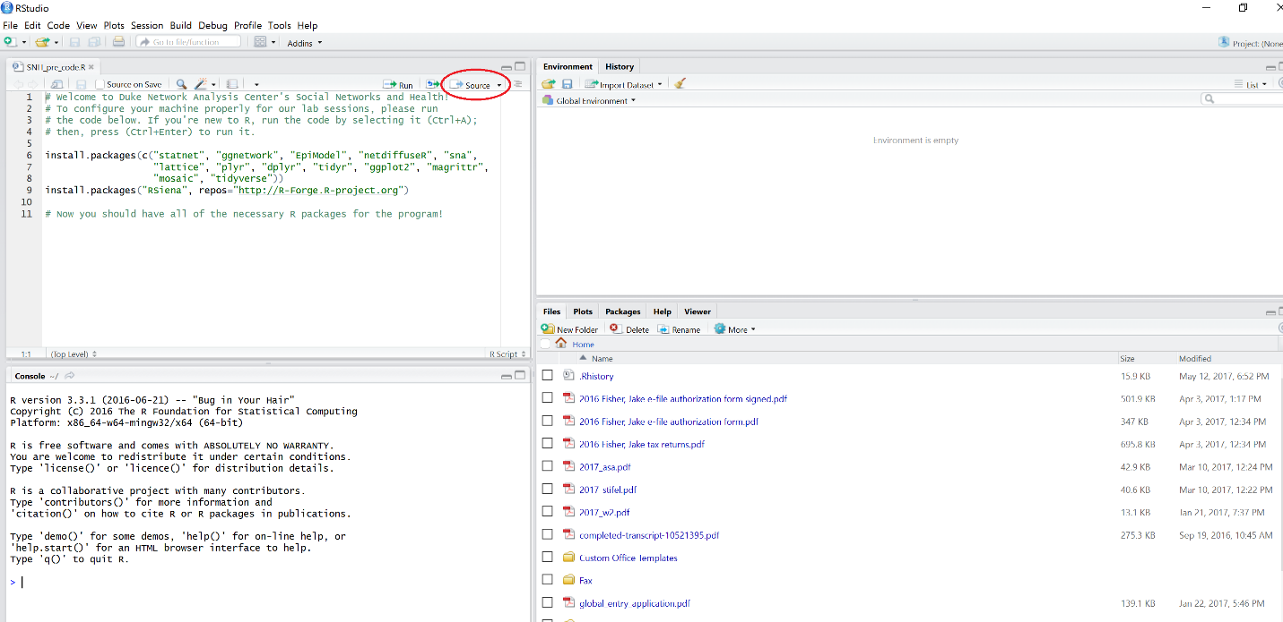
R may produce two pop-up menus. The first may ask you to select a mirror to download the packages from; choose a location that is close to you. The second may ask if you want to create a directory to install the packages into; click Yes. After this, a series of progress bars may pop up, and R will print a number of messages to the console, indicating that it is installing the packages.

Update all packages
Next, you must ensure that all packages are updated. You can do this through the R Studio interface.

Select the “Packages” tab.

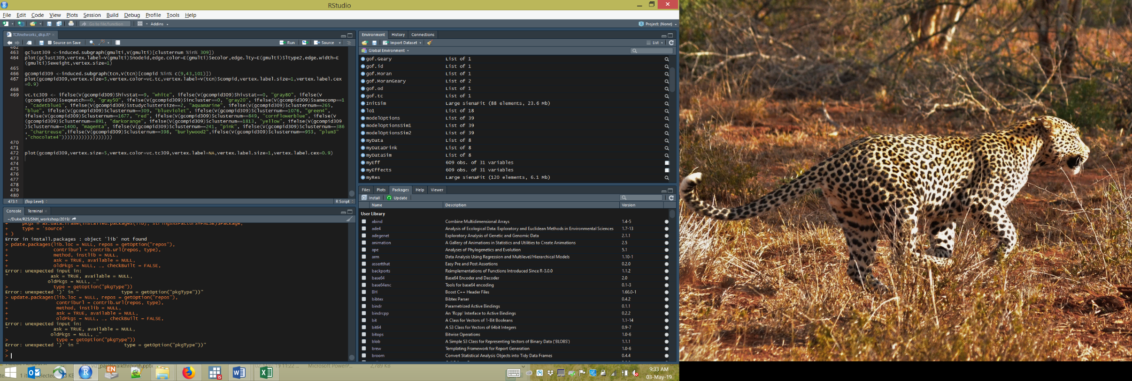
Next, click the “Update” button.

Check “Select All” in the pop-up box then click “Install Updates”.

This may take several minutes.

Run lab code
As a sample, we ask that you attempt to run an old version of the code for the Siena workshop, which will be updated for the Friday morning lab. You do not have to know what the code means, yet – we will cover that on Friday. Running the code successfully will confirm that you have installed R, RStudio, and the appropriate packages.
Download the code in the Dropbox folder called ‘test Lab – RSiena.R’, or access it by clicking here:
https://www.dropbox.com/s/zr1zuw716v662pe/test%20Lab%20-%20RSiena.R?dl=0
and open it in RStudio. Once it is open in RStudio, change the working directory on line 42 to a directory on your computer. *** Note the direction of the slashes in the file path ***
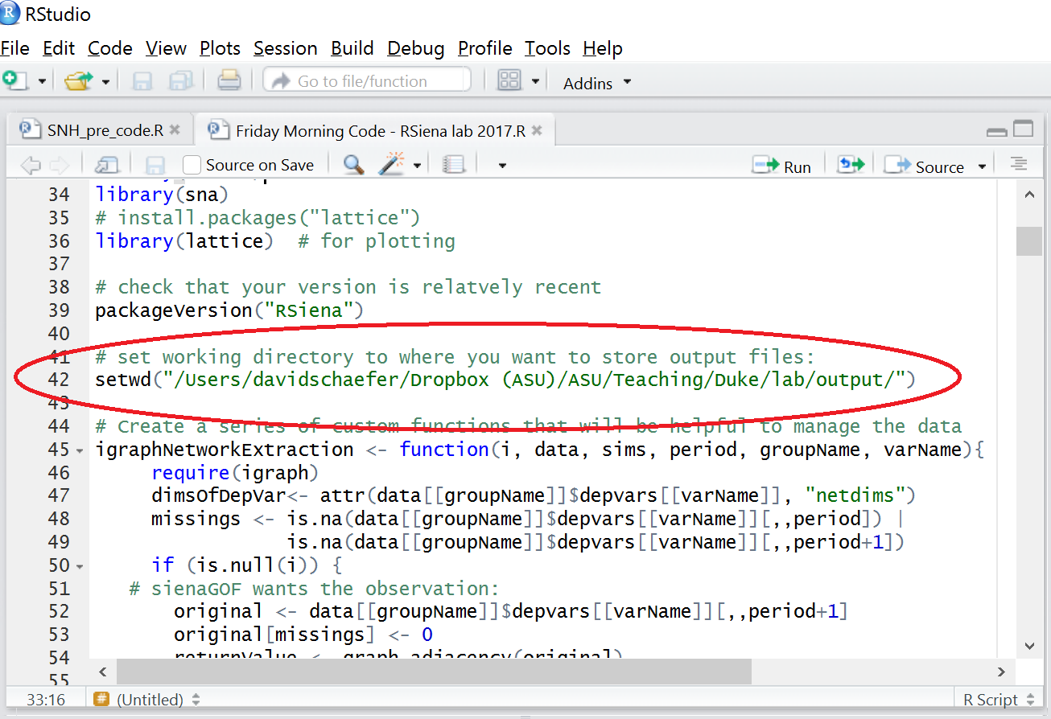
If you do not know how to find the path to a folder on your computer, follow the instructions here:
https://www.youtube.com/watch?v=LNw6hzGgyxM

or click Session > Set Working Directory > Choose Directory and pick a directory. R will print a command that begins with “setwd” to the console. Replace line 42 in the R script with the line that R printed to the console (beginning with setwd).

Once you have changed the working directory in the code, click “Source” as before. The code will take several minutes (up to 30) to run, and will cause several windows to pop up. If R does not stop with an error, congratulations! You successfully ran the test code.

If you have issues with any of these steps then please plan to attend the informal Sunday evening introductory session to seek assistance with completing them, held from 6-7:30p, location TBD.

