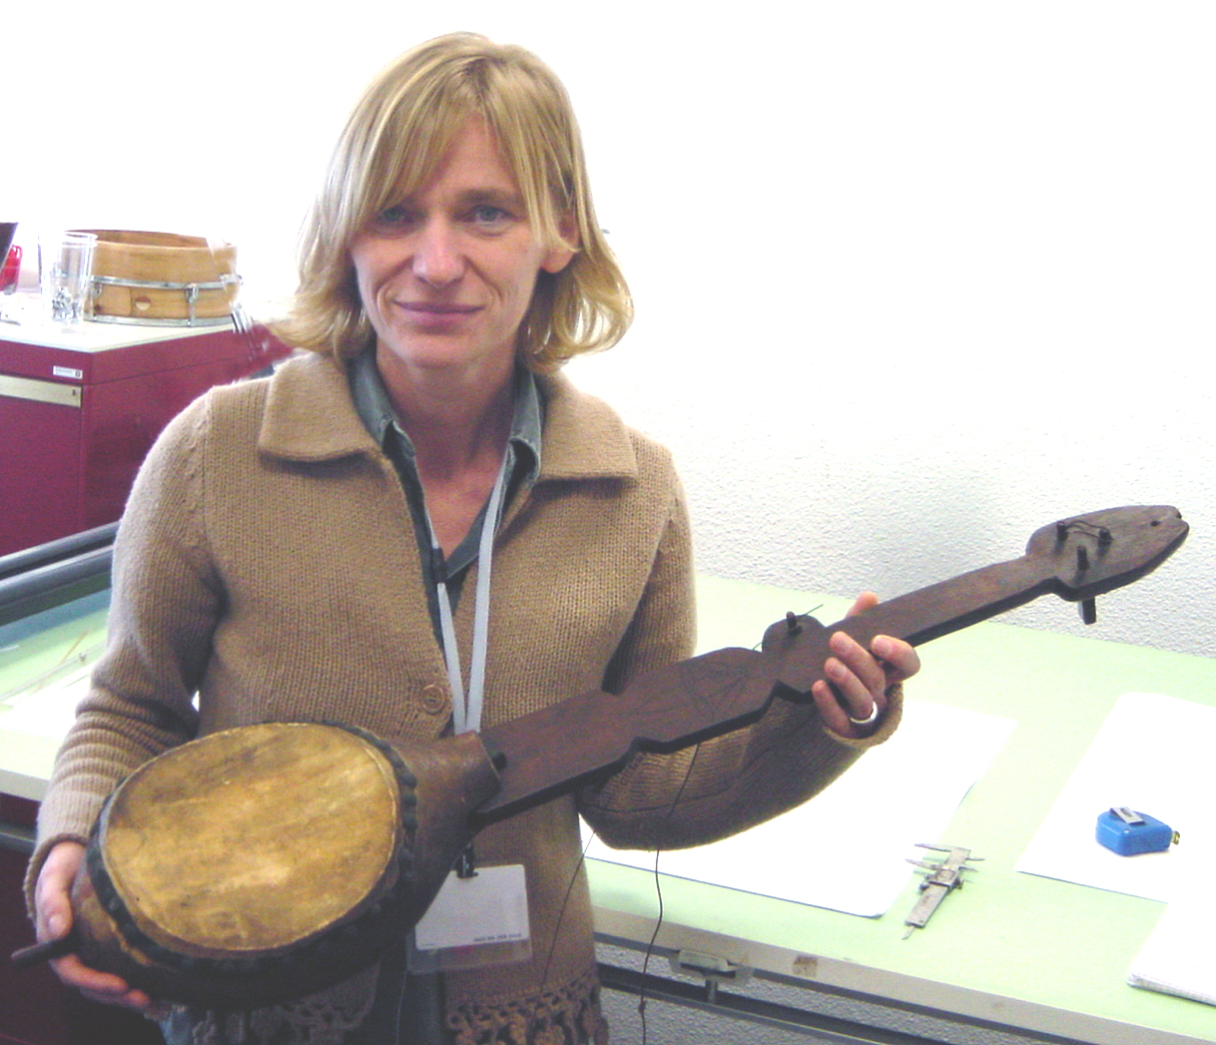 BNL cover picture: Saskia Willaert at the Musical Instrument Museum in Brussels with the Haitian Banza

The finding of the Haitian Banza
by Saskia Willaert
At the start of 2003 preparations were made to mount a banjo exhibition at the Museum of Musical Instruments in Brussels. Part of the exhibition was to be devoted to the African precursors of the American banjo. West-African lutes have a number of features which link them specifically to American banjos. They have a body over which a skin is stretched and into which a neck is fixed, and they sometimes have a short string –an open string that is plucked with the right hand thumb, thus allowing for a continuous high frequency drone.[1] Material was searched for which visualized the existence of African lute like instruments in the Caribbean region, the shores of which black slaves arrived at from the seventeenth century on. Contact was taken with the Paris colleagues of the Musée de la Musique to lend a ‘banza’, mentioned in their online inventory. The name of the instrument and its origin (Haiti) sounded promising. Its construction (gourd, with flat neck protruding the body) referred to the earliest known illustration of the banjo: an engraving of two ‘strum-strums’ and a harp-lute from Sir Hans Sloanes’ A Voyage to the Islands of Madeira, Barbados, Nieves, S. Christopher and Jamaica, written 1688 and published in London, 1707.[2]
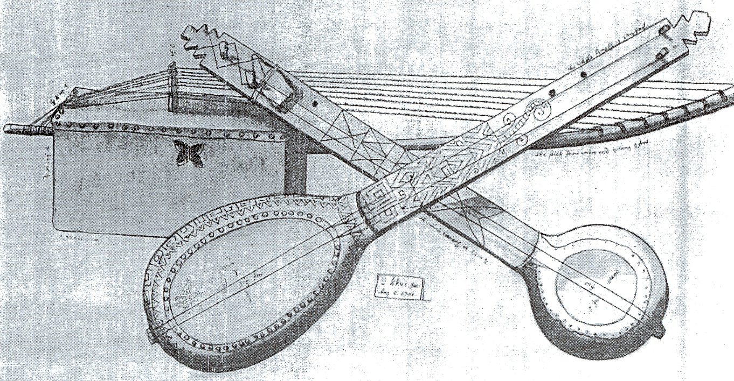Two dual string gourd “strum-strump” lutes and one eight string wooden crate bridge harp-lute from
Jamaica collected and depicted by Hans Sloan ca 1690-1700. The instruments should be in the possession of the British Museum but have so far not been located.

Not much was known about this Haitian lute. Philippe Bruguière, curator of the ethnic instruments in the Paris collection, remembered having put together the neck and the body which he had found in different boxes, thus completing an instrument which for decades had been dismembered. The banza is part of the Fonds Victor Schoelcher and entered the Paris museum on 11 November1872, together with 22 other African, Asian and American instruments.[3] On the vellum of the instrument is written in black ink, maybe by Schœlcher himself, translated to English: ‘Banza, imitation of an African instrument widely used by the black people of Haiti’.[4]
When announced to be on display at the Brussels banjo exhibition in October 2003, the banza caused quite a stir within the American banjo world, slightly to the amazement of the Brussels and Paris curators. Dr Allen Feldman, cultural anthropologist, professor at the New York University, and banjo aficionado, replied to the news: ‘before we all get lost in technical discussion, can we just take a minute and recognize that this is a bloody beautiful instrument, a work of art, I was very moved to see the pictures [from the Paris online catalogue]’.[5] Banjo researchers such as Ulf Jägfors, Bob Carlin and Pete Ross stressed the importance of the ‘discovery’ of the banza. The instrument was said to be a missing link in the history and evolution of the plucked lute from the guimbri at the Malinese court in the fourteenth century to nowadays North-American banjos.
The banza is the second eldest banjo artefact found so far. The oldest preserved banjo was made in the early 1770s in Netherlands Guyana. This creole bania was taken by the English captain John Gabriel Stedman to Holland after upheavals from local slaves and entered the Leyden Rijksmuseum voor Volkenkunde collection in 1777. The instrument may have been made on demand of Stedman to be taken to Europe as a decorative souvenir from black inhabitants amidst whom the captain had been living for years.[6] Small S-shaped sound holes meticulously cut in the underside of the gourd, a decorative peg scroll cut out in the tradition of a western violin and the absence of traces of finger placement suggest that this instrument was made to be looked at, not played.

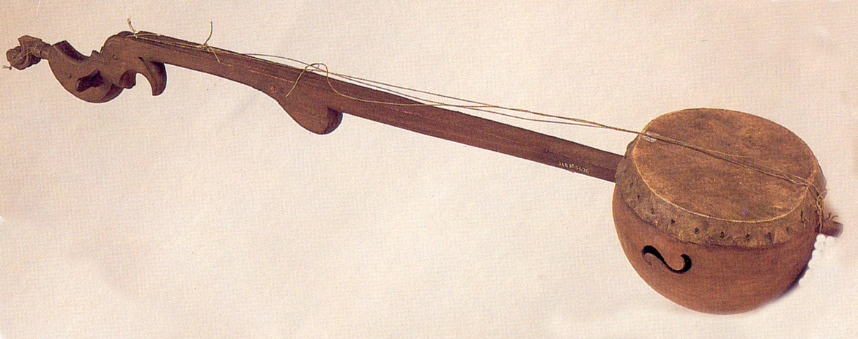
Four string Creole-Bania from Dutch Surinam. Collected by John Gabriel Stedman ca 1777

The Haiti banza on the other hand has clearly been played; traces of finger placements can be found in the lower registers of the neck.[7]
Victor Schœlcher (1804-1893), who had brought the banza to Europe, was a French politician, writer, traveller and collector. Smitten with the French Revolution ideas of liberty and equality, he became a tireless champion for the slaves of the French territories. Under-Secretary of State in 1848, he wrote, and succeeded in passing, the law abolishing slavery in the French colonies.[8] Apart from being a republican idealist, Schœlcher was also a music lover as well. Living in exile in London in the 1850s – he had been banned from France in 1851 by king Louis Napoléon Bonaparte – he published in 1857 his Life of Handel, a landmark in the history of Handel studies, being the first biography of the composer to be based upon solid documentary research.[9]
In 1840-41 Schœlcher travelled to the Caribbean to report on life conditions of black people. After having visited Guadeloupe, Martinique, Jamaica, and Dominique, he travelled to Haiti, from where he proceeded to Puerto Rico. He was back in Europe by the end of 1841, loaded with boxes filled with objects bought in the Caribbean from planters, in small villages and on local markets. Schœlcher carefully classified these witnesses of Caribbean daily life before handing them over to libraries and museums. On 11 November 1872 he donated his ethnic instruments to the Conservatoire de Musique.[10] Today these instruments are housed in the Musée de la Musique in Paris, still constituting the historical basis of the extra-European collections there.[11] According to Félix Raugel in the Musik in Geschichte und Gegenwart edition of 1965, ‘every sample of musical life as practiced by the black race is represented in [Schœlcher’s] collection, including the favourite instruments of the American Negro’.[12] One of the instruments given to the Conservatoire in 1872, was the four stringed banza. It dates before the end of 1841 (the time when Schœlcher came back from his Caribbean trip) and thus predates the first American banjos of William Boucher and Joel Walker Sweeny.[13]

[1] Especially the akonting (fr.ekonting) from Senegambia can be considered as the direct forerunner of the banjo. Apart from the round body over which a skin is stretched and the short string, the akonting has a neck that runs right through the body to protrude from its lower part, and a bridge with feet. Additionally, the neck of the akonting is made from a type of papyrus called bangoe in the local Mandinka language. See Ulf Jägfors, ‘The African Akonting and the origin of the banjo’, The Old-Time Herald 9 (2003-2004): 26-33.
[2] The harp-lute on this engraving is very similar to the aloko, a harp-lute from the Baule population in Ivory Coast. See, for example, Brussels Musical Instrument Museum, inv. 84.040.
[3] See online catalogue http://servsim.cite-musique.fr/museedelamusique/recherche.asp?ReturnList=1&Min. The inventory number of the banza is E.415.
[4] ‘Banza imitation d’un instrument africain / d’usage general [sic] parmi les no[irs?] d’Haiti [sic]’
[5] E-mail from Allen Feldman, sent on 28 September 2003 to Ulf Jägfors; George Gibson; Tony Trischka; Thornburg, Bob; Gérard de Smaele; Mike Seeger; Joseph Scott; Peter Roehling; Marc Perdue; Bruce Penner; Scott Odell; Walt Koken; Alan & Karen Jabbour; Hyatt, David; Ralf Fredblad; Bob Flesher; Ellis, Rex; Carrie Didlake; Conway, Cece; Pat v Conte; Eric Charry; Bob Carlin; Ed Britt; Banjo Collectors list; Paul Sedgwick; Saskia Willaert. For the pictures see http://servsim.cite-musique.fr/museedelamusique/recherche.asp?ReturnList=1&Min.
[6] See John G. Stedman, Narrative of a five-years’ expedition against te revolted negroes of Surinam from the year 1772 to 1777, London, 1796.
[7] See Banjo !, ed. Mia Awouters, catalogue of the banjo exhibition, MIM Brussels, 16 October 2003 – 15 February 2004, Brussels, [2003], 27.
[8] See Richard G. King, ‘Schoelcher, Victor’, The New Grove Dictionary of Music and Musicians, ed. Stanly Sadie, London, 2001, xxii.576-7.
[9] See Nelly Schmidt, Victor Schloecher en son temps. Images et Témoignages, Paris, 1998, 84.
[10] See Richard G. King, ‘Schoelcher, Victor’, The New Grove Dictionary of Music and Musicians, ed. Stanly Sadie, London, 2001, xxii.576-7, and Nelly Schmidt, Victor Schloecher en son temps. Images et Témoignabes, Paris, 1998, 33.
[11] See Nelly Schmidt, Victor Schloecher en son temps. Images et Témoignabes, Paris, 1998, 26, 33.
[12] Raugel, ‘Victor Schœlcher’, MGG xii, Kassel-Basel, 1965, ed. Friedrich Blume, pagina ??? (‘jede Art von Musikausübung der schwarzen Rasse ist in dieser S[amm]l[un]g vertreten, die auch die Lieblingsinstr[umenten] der amer[ikanischen] Neger enthält.’)
[13] Other Haitian instruments which Schœlcher brought with him from the Caribbeans and which he later gave to the Conservatoire were a rattle and a sanza. See the online catalogue of the Paris Musée de la Musique, E.432 and E.429.

