Art Statement  Over the past three decades, southern churches have been places of prejudice and fear for HIV+ people. This piece imagines what a service would look like if HIV+ and non-HIV+ Christians came together to address HIV/AIDs and amend the wrongs of years past, calling upon different elements from the Methodist, Baptist, and Presbyterian traditions. We borrow from the tradition of the reconciliation service; these services are generally performed during the Lenten season for members of the Church to repent and be reconciled to God. We bring together four voices--two pastors and two HIV positive people--interspersing their words to create a message of reconciliation between the church and those with HIV/AIDS. We hope this piece sparks a dialogue about the role of religion and HIV/AIDS in the South, from the past, to the present, and into the future.  Interpretation of the AIDs Cross  The AIDs cross is an adorned cross that provides an additional message. The color red symbolizes both AIDs and the blood of Jesus Christ, shed on the cross for our sins. In the 80s and 90s, some Christians acquired the naivety of biblical times, when folk shunned lepers and victims of the plague. They felt that HIV/AIDS was God's punishment for drug users and homosexuals. Ignorance breeds fear. Fear is a powerful motivator but a terrible adviser. We now know that HIV does not discriminate. The AIDs cross represents our prayer for the elimination of stigma, expression of support, and creation of dialogue within the church about HIV/AIDs. We seek to love HIV+ people within and without the Church and to be a powerful source of change in the world. |  |  | 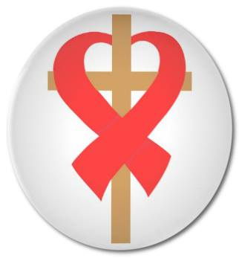  A Service of Reconciliation for the Church  October 9th, 2014  “Pursue peace with all men, and the sanctification without which no one will see the Lord. See to it that no one comes short of the grace of God; that no root of bitterness springing up causes trouble, and by it many be defiled.” –Hebrews 12:14-15

A Service of Reconciliation for the Church  This Church is a community of people seeking to be more human, knowing that we are created in the image of God.  October 9th, 2014  Song of Adoration*  How Great Thou Art  Invocation*  Prayers of Confession  Lord, we publicly confess and acknowledge that we have too often contributed to stigmatization and discrimination. Our churches have not always been welcome places for people living with HIV/AIDs. We confess that the church has rejected when it should have embraced and judged when it should have shown love and compassion. We therefore commit ourselves to a faithful and courageous response in breaking the silence, speaking openly and truthfully about human sexuality and HIV/AIDs. We lift the confessions of our hearts to you.  Assurance of Forgiveness* |  |  | Songs of Worship*  Great is Thy Faithfulness  Passing the Peace*  Leader: May the Peace of Christ be with you.  All: And also with you.  Scripture Readings  Romans 5:2-5, Romans 8:1  1 John 4:18-20  Proclamation of the Word  It is Well With My Soul  “In Our Own Words: A Reflection on HIV/AIDs and the Church”  John Paul Womble XVI, Wayne Smith, Alicia Diggs, Dianna Deaderick  Prayers of the People  Offering  Doxology*  Benediction  *all who are able, please stand

