Dear parent,

Welcome to FEMMES 2013! We are happy to inform you that your child has been accepted into the program. The capstone event will take place February 23, 2012 from 8:45 AM - 4:15 PM on Duke University's West Campus. We have included some further information about FEMMES 2013 that you may find helpful.

This packet includes:

- Driving Directions, with Drop-off and Pick-up Instructions (IMPORTANT!!)
- Schedule
This event is completely free for all participants and is suited for girls in 4th, 5th, or 6th grade. If you have registered your daughter and she is currently not a 4th, 5th, or 6th grader, please contact us immediately. We will be providing pizza for lunch, so a packed lunch is not necessary. However, if your daughter prefers having something other than pizza, please have her bring a sack lunch.
Please make sure that your daughter is dressed appropriately (comfortable clothes, long pants and closed-toed shoes). We suggest leaving purses at home, since your daughter will be receiving a free FEMMES drawstring bag at the beginning of the day. We will still be holding FEMMES rain or shine, so your daughter may want to bring an umbrella if rain is expected. Most of the day will be spent inside, but we will be walking outside between some of the activities.
Your daughter must be able to stay for the ENTIRE duration of the capstone event (8:45 AM – 4:15 PM). If you have reason to believe that she will miss any portion of the day, please let us know. In the case that something comes up and your daughter is unable to attend, we would like to know as soon as possible so that another girl on our waiting list may have the chance to participate.

If you have any questions, please email us at FEMMESatDUKE@gmail.com or contact your assigned Program Director (please see below). Feel free to visit our website at www.duke.edu/web/FEMMES to see pictures and to learn more about our faculty volunteers and their activities. We look forward to meeting your daughter!

Sincerely,
Alex Ong, Dayoung Ko, Salwa Zahalka, and Linda Cao
FEMMES Program Directors

Last Names A-F: Last Names G-N: Last Names O-R: Last Names S-Z:
Alex Ong Dayoung Ko Salwa Zahalka Linda Cao
(202) 550-9747 (703) 608 - 6040 (304) 276–1535 (425) 974-5205
ago5@duke.edu dk105@duke.edu salwa.zahalka@duke.edu yc103@duke.edu

FEMMES SCHEDULE

~ Saturday, February 23, 2013 ~

Tentative Schedule:

8:15-8:45 a.m. – Students arrive, meet groups, get schedules and bags
9:00-9:35 a.m. – Welcome speeches
9:35-9:45 a.m. – Break off into groups
9:45-10:00 a.m. – Travel to first activity
10:00-10:45 a.m. – Activity 1
10:45-11:00 a.m. – Travel to second activity
11:00-11:45 a.m. – Activity 2
11:45-12:00 p.m. – Travel to lunch
12:00-12:45 p.m. – Lunch
12:45-1:00 p.m. – Travel to third activity
1:00-1:45 p.m. – Activity 3
1:45-2:00 p.m. – Travel to fourth activity
2:00-2:45 p.m. – Activity 4
2:45-3:05 p.m. – Pass out and complete evaluations/questionnaires
3:05-3:20 p.m. – Return to Auditorium
3:20-3:50 p.m. – Closing remarks and raffle
4:00-4:45 p.m. – Pick-up

DRIVING DIRECTIONS

Drop-off and Pick-up:

IMPT: In order to facilitate the drop-off and pick-up process, please place a large sign with the first and last name of the child/children whom you are driving on the front right windshield of your car. If your daughter will be carpooling with others, you MUST let us know by email (FEMMESatDuke@gmail.com).

Drop-off and Pick-up for your child will be at the traffic circle off of Research Drive, next to the Levine Science Research Center (LSRC), shown on the map below. Volunteers will be waiting there to escort your child inside, where she will meet her student leaders and be placed with her group for the day. Breakfast will be provided in the morning. Drop-off is between 8:15-8:45 AM.

At the end of the day, students will be waiting with FEMMES volunteers at the traffic circle. (Please see the next few pages for a map and more detailed directions). Due to concerns with traffic flow, please try your best to pick up your child ON TIME: 4:00-4:45 pm.

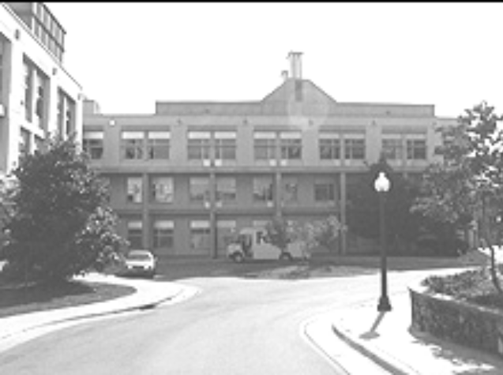

This is the view of the Levine Science Research Center building and the traffic circle where counselors will be waiting. (If you think you are at the traffic circle, but do not see this building, you are probably at the traffic circle in the middle of Research Drive and need to continue on and turn right in front of the LSRC sign. The traffic circle where you should wait has trees; the one on Research Drive does not.)

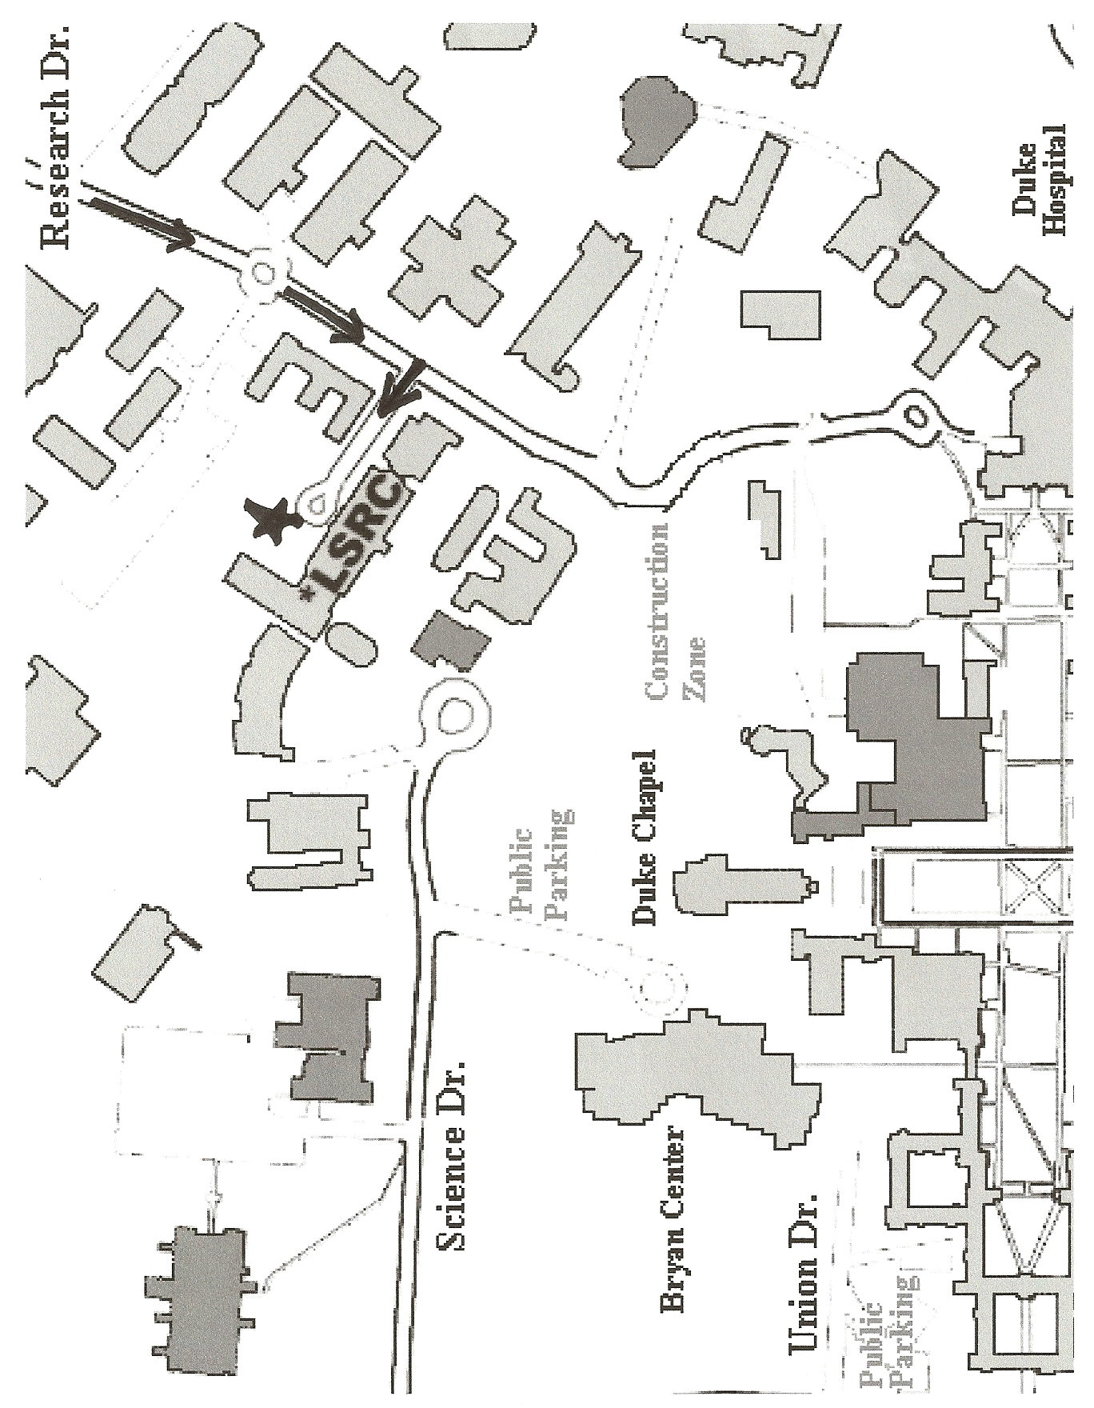
Erwin Rd.
Driving Directions to the LSRC building on Duke campus:

From RDU Airport, Raleigh, and Points East:
*Via I-40 West: Exit onto the Durham Freeway North (NC 147) towards Durham (Exit 279)
*Take Exit 15B (marked Fulton St., Hillendale Rd.)
*Make a left at the light at the end of the ramp onto Fulton St.
*At second light, make a right onto Erwin Rd (in front of Duke Hospital)
*At first light, make a left onto Research Drive.

From Chapel Hill
*Via US. 15-501 North:
*Take exit for N.C. 751 (#107) marked Duke University West Campus.
*Turn right onto N.C. 751 S.(Cameron Blvd.).
*At first traffic light, go left onto Erwin Rd.
*At third traffic light, go right onto Research Dr.

From Greensboro and Points West
*Via I-40 North: Exit onto US. 15-501 North:
*Take exit for N.C. 751 (#107) marked DukeUniversity West Campus.
*Turn right onto N.C. 751 S.(Cameron Blvd.).
*At first traffic light, go left onto Erwin Rd.
*At third traffic light, go right onto Research Dr.

From Richmond and Points North
*Via I-85 South: In Durham, take the exit (#174B) for US 15-501 South Bypass – Duke University/Chapel Hill.
*Continue on U.S. 15-501 to the fourth exit (#107), marked Duke Univ. West Campus, a right-lane exit for N.C.751.
*Turn LEFT onto N.C. 751 S. (Cameron Blvd.) go under the freeway.
*At second traffic light, go left onto Erwin Rd. At third traffic light, go right onto Research Dr.

*******Once On Research Drive*******
*Drive straight through traffic circle.
*The driveway to the LSRC will be the first right IMMEDIATELY after you go through the circle. (If you drive past the sign for the Levine Science Research Center, you’ve gone too far)
*Continue down the driveway to the very end. Wait in the traffic circle; one of our volunteers will meet you and bring your child inside.

If you accidentally end up on Science Drive (close to the Bryan Center) turn around and go back to Towerview (first light) and turn right. Then turn right again on Erwin Rd. From Erwin Rd, turn right on Research Dr.

If you accidentally end up near the chapel, continue back out to Duke University Rd and turn right. Continue on Duke University Rd (keeping to the right when it merges with Cameron Blvd) and turn right on Erwin Rd. From Erwin Rd, turn right on Research Drive.

If you would like to park and drop off your child, you can park in the Bryan Center Parking Garage. Please visit http://www.map.duke.edu/parking.php?pid=P002 for directions. Rates are $2/hr or $12/day

