Ruins of a Great House
By Derek Walcott

though our longest sun sets at right declensions and
makes but winter arches, it cannot be long before we
This poem begins with an epigraph, a short quote at the beginning of a passage or work. How does this epigraph fit with the rest of the passage? What kind of introduction does it provide?
lie down in darkness, and have our light in ashes . . .
-- BROWNE, Urn Burial

Stones only, the disjecta membra of this Great House,
Read the footnote for “disjecta membra.” What might Walcott be referencing here?
Whose moth-like girls are mixed with candledust,
Remain to file the lizard’s dragonish claws.
The mouths of those gate cherubs shriek with stain;
Axle and coach wheel silted under the muck
Of cattle droppings.
Three crows flap for the trees
And settle, creaking the eucalyptus boughs.
Walcott uses many strong examples of diction here. What words stand out to you? CIRCLE them. What effect do they have on you as a reader?
A smell of dead limes quickens in the nose
The leprosy of empire.
“Farewell, green fields,
Farewell, ye happy groves!”
Marble like Greece, like Faulkner’s South in stone,
Deciduous beauty prospered and is gone,
To whom or what is the speaker saying “farewell” here?
But where the lawn breaks in a rash of trees
A spade below dead leaves will ring the bone
Of some dead animal or human thing
Fall from evil days, from evil times.

It seems that the original crops were limes
Grown in the silt that clogs the river’s skirt;
Notice in line one of the first stanza “Great House” was capitalized, but in the second stanza it is not. Reflect on the importance of this detail.
The imperious rakes are gone, their bright girls gone,
The river flows, obliterating hurt.
I climbed a wall with the grille ironwork
Of exiled craftsmen protecting that great house
From guilt, perhaps, but not from the worm’s rent
Whose guilt are the craftsmen protecting the house from?

What does the speaker mean by “worm’s rent?”
Not from the padded cavalry of the mouse.
And when a wind shook in the limes I heard
What Kipling heard, the death of a great empire, the abuse
Of ignorance by Bible and by sword.

A green lawn, broken by low walls of stone,
Here the speaker alludes to several well-known English explorers. What is the speaker’s attitude towards these men? How do you know?
Dipped to the rivulet, and pacing, I thought next
Of men like Hawkins, Walter Raleigh, Drake,
Ancestral murderers and poets, more perplexed
In memory now by every ulcerous crime.
The world’s green age then was a rotting lime
Whose stench became the charnel galleon’s text.
The rot remains with us, the men are gone.
Consider the shift in the language of the poem from the beginning until now. How has it changed? How has this contributed to changes in tone?
But, as dead ash is lifted in a wind
That fans the blackening ember of the mind,
My eyes burned from the ashen prose of Donne.

Ablaze with rage I thought,
Some slave is rotting in this manorial lake,
But still the coal of my compassion fought
That Albion too was once
A colony like ours, “part of the continent, piece of the main,”
Nook-shotten, rook o’erblown, deranged
By foaming channels and the vain expense
Thoughts/feelings/reactions to the ending?
Of bitter faction.

All in compassion ends
So differently from what the heart arranged:
“as well as if a manor of thy friends . . .”

“Ruins of a Great House” Analysis
1. Think about the diction in this poem. What are the most important words?

2. How could you categorize this diction? (Think: the language of ____________)

3. Find 3 examples of striking imagery in the poem. What is the effect of each on the reader?
Example of Imagery #1 | Example of Imagery #2 | Example of Imagery #3
Effect | Effect | Effect

4. What is the subject(s) of the passage? What is the author’s attitude(s) toward this subject?
Subject(s) of poem | Attitude(s) toward the subject(s) (tone)

5. Find 3 examples of allusion from the passage. What might their effect be on the reader?
Example of Allusion #1 | Example of Allusion #2 | Example of Allusion #3
Effect | Effect | Effect
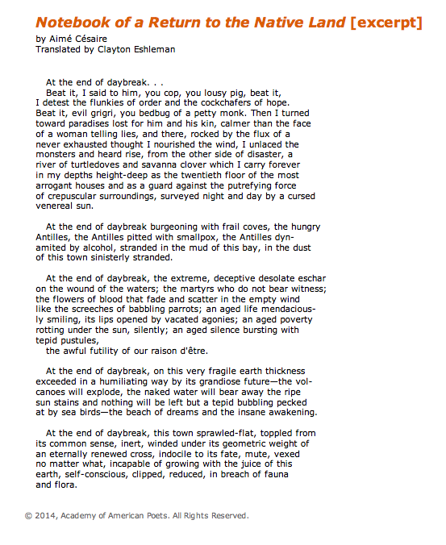

“Notebook of a Return to the Native Land” Analysis
1. What is the “plot” of this poem? In your group, explain in your own words what it is about.

2. Think about the diction in this poem. What are the most important words?

3. How could you categorize this diction? (Think: the language of ____________)

4. Find 3 examples of striking imagery in the poem. What is the effect of each on the reader?
Example of Imagery #1 | Example of Imagery #2 | Example of Imagery #3
Effect | Effect | Effect

5. What is the tone (author’s attitude toward the subject) in this poem? Is there one tone or multiple tones? If you see multiple tones, where does the tone shift?

Latin for “scattered limbs/members/remains.”
A disease known since biblical times; causes skin sores and nerve damage
An American author; received the Nobel Prize in literature
Referencing Rudyard Kipling, English writer and poet.
Sir Richard Hawkins: English sailor and explorer.
Sir Walter Raleigh: English aristocrat, writer, solider, and explorer.
Sir Francis Drake: English sea captain and slaver: completed 2nd circumnavigation of the world.
Building or chamber in which bones and remains are deposited
Referencing John Donne, a well-known English poet.
The oldest known name of the island of Great Britain

