Afro-Atlantic Music as Archive
Laurent Dubois
(Paper for Africa N’Ko: La bibliothèque coloniale en débat)

From the very beginnings of the colonization of the Americas, African and African-American individuals and communities produced their own forms of interpretation and representation meant to analyze, depict, and survive what they were experiencing. One of the most powerful and consistent of these was that of music, which through form and content, thought and performance, offered a way of understanding and confronting the colonial situation. This paper argues that Afro-Atlantic music represents a critical, alternative, archive through which to tell the history of African individuals and communities in the Americas during the 16th through the 18th centuries. This archive has the powerful advantage of being largely the production of these communities, a space in which and through which they articulated their vision of the past, their experience of the present, and their aspirations for the future. It is extremely rich and diverse, and in its musical forms, instruments, and sung lyrics both condenses and reflects on the experiences of exile, struggle, and emancipation. Developed in critical spheres of social life – religious practice, social dancing, funerary rites, carnival, and other spaces – it provides a record of the visions and ideals cultivated within the interstices of plantation life.
This archive, however, also presents profound challenges. It is, first of all, extremely fragmented, and has to be reconstituted out of bits and pieces of observations by outsiders and the exploration of more recent musical traditions. The question becomes what types of method and theory are best suited to offer a history written from within this archive. I begin with a discussion of some of the ways three pivotal scholars – W.E.B. DuBois, Paul Gilroy, and Ronald Radano – have grappled with Afro-Atlantic music as a historical archive. I then offer some reflections based on two research projects I am currently carrying out. The first is a project of collecting and analyzing the songs of Haitian Vodou; the second a history of the banjo, tracing its development during the 17th through the early 19th centuries (with a focus on the Caribbean and Louisiana). I attempt to illustrate the possibilities of constituting a history of this music by bringing together fragments. These fragments can be gleaned from text, from visual and material culture, and from within the music itself. Because they are often quite scattered, the process of gathering requires a geographically and chronological adventurous and omnivorous approach that ranges across regions and periods in the Atlantic world during it’s formative period of the 16th through the 18th centuries.
The early archive of Afro-Atlantic music, the examples I showcase here show, offers us a fascinating and vital archive through which to tell alternative histories that may allow us to speak back to, and perhaps even bypass, the “Colonial Library.” That is because music offers not only accounts and reflections of historical experience and political aspiration, but also in many cases of narration and critical interpretation of the very cultural processes that produced it. Embedded within the songs and objects of that music are reflections on precisely what it has meant to continually reconstitute, often out of fragments, a sense both of rooted history and of an alternative future in the face of spirals of dispossession and refusal.

*

For the past several decades, writes music scholar Ronald Radano, the “listening public” in the United States has “remained remarkably committed to a particular story about black music.” “It is a good one,” he admits, “so good, in fact, that it has more or less determined the way we hear performances across a range of genres, from blues to jazz to hip-hop.”
The story goes something like this. Black music garners it strength and power from the integrity of a greater African-American culture forged under circumstances of enduring racial oppression. The qualities so often affiliated with black music – its soulfulness, its depth of feeling or “realness,” its emotional and rhythmic energy, its vocally informed instrument inflections – grow directly out of the depths of social tragedy only to rise up miraculously in the voice of racial uplift. This generative background, in turn, determines the aesthetic value of modern forms. Black music of real worth speaks with certitude and conviction of the rightness of blackness against the wrongness of white supremacy. At its best, black music expresses a kind of cultural exceptionalism, a racially informed distinctiveness and moral integrity that reflects its ground in traditions of Africa and an intimately linked slave era.

One of the earliest and most powerful formulations of this “story” came in a chapter of The Souls of Black Folk in which W.E.B. DuBois famously turned to what he called “The Sorrow Songs” in African-American music – those “weird old songs in which the soul of the black slave spoke to men.” When he first heard these songs, DuBois wrote, “at once I knew them as of me and of mine.” These songs were not just “voices of the past.” They, were, he argued, “the sole American music”: “the most beautiful expression of human experience born this side of the seas. . . the singular spiritual heritage of the nation and the greatest gift of the Negro people.” The purest and most important form of American culture, DuBois insisted, was African-American culture. This interpretation of music was the culmination of his broader argument: just as slavery had laid the foundation for the country’s economic development, and the struggle for freedom had expanded and perfected its political culture, it was African-American music that ultimately best voiced and embodied what America should be.
The soaring universalism of DuBois’ claim about music, however, gained its power from the way it was expressed through a very particular, and rooted, story about family memory and the transmission of culture. In fact, having addressed America, DuBois then rapidly turns to a much older history, looking across the Atlantic to Africa. Contemporary African-American songs were “indeed the siftings of centuries,” the music “far more ancient than the words.”
My grandfather’s grandfather’s grandmother was seized by an evil Dutch trader two centuries ago; and coming to the valleys of the Hudson and Housatonic, black, little, and lithe, she shivered and shrank in the harsh north winds, looked longingly at the hills, and often crooned a heathen melody to the child between her knees, thus:

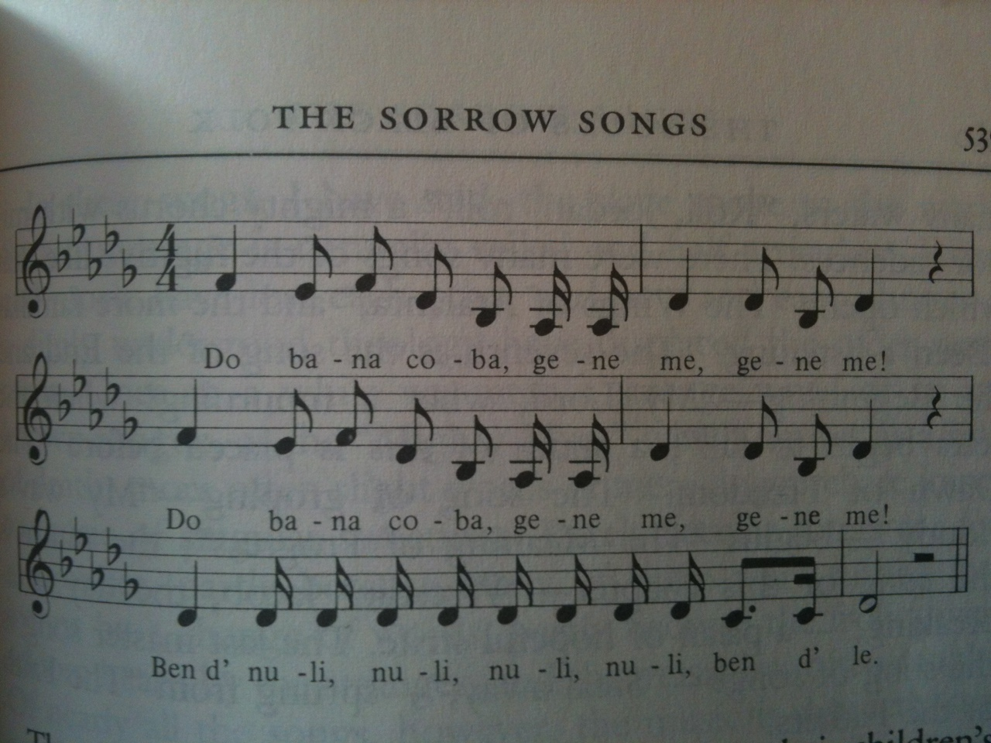

The child sang it to his children and they to their children’s children, and so two hundred years it has traveled down to us and we sing it to our children, knowing as little as our fathers what its words may mean, but knowing well the meaning of its music.

DuBois’ attempt to grapple with the power and meaning of music was, Paul Gilroy has argued, at the center of his entire project in The Souls of Black Folk. It was the inspiration for the “polyphonic montage technique” he developed in writing the work. “Black music,” writes Gilroy, was for DuBois “the central sign of black cultural value, integrity, and autonomy.” Each chapter in The Souls of Black Folk begins with a counterpoint between “a fragment of slave song which both accompanied and signified on the Euro-American romantic poetry that comprised the other part of these double epigraphs.” We might say that DuBois’ was trying to find a way to make words speak as powerfully about the African-American experience as the music did.
DuBois’ thoughts on music embody and illuminate a set of contradictions. Was black music fundamentally American, therefore a kind of universal heritage, “the singular spiritual experience of the nation”? Or was it something transmitted within community, particular to it, linked to the powerful familial memory that he described? Could it be both at once? Scholars grappling with the history of African-American music have long struggled with this question. But in what has probably been the most influential reflection on the problem, Paul Gilroy expressed a certain frustration with the existing interpretive avenues available to him, and a longing for something different.
Gilroy identified two equally problematic poles in the analysis of black music. One the one had was a tradition that identifies “music with tradition and cultural continuity.” This approach has, in fact, long been a dominant one – the one Radano identifies as still guiding much of the conversation about music in the United States. But Gilroy argues that it is fundamentally, and problematically, conservative. This fact, he admits, “is sometimes disguised by the radical nature of its affirmative political rhetoric and by its laudable concern with the relationship between music and the memory of the past.” But as a framework it is unable to effectively confront the complexity and “fragmentation” of musical production in the Black Atlantic. Instead of really dealing with this diversity, it effectively denies it, arguing that it is “only apparent rather than real and cannot therefore forestall the power of the underlying racial aesthetic.” The approach is to know in advance that all black music is based in and therefore vehicles a common set of aesthetic and performative approaches. The goal becomes to track and trace those common principles which are assumed, a priori, to always be latent even if hidden.
That, Gilroy asserts, is a failure of analysis and imagination. But Gilroy is as withering in his view of the “would-be postmodern pragmatism which routinely and inadequately opposes” arguments about tradition and continuity. He finds risible an approach that simply celebrates the multiplication and profusion of fragmented forms – taking “the white noise of Washington, D.C.’s Rasta thrash punk band the Bad Brains as the last work in black cultural expression” – as an expression of a desire to “abandon the ground of the black vernacular entirely.” A playful celebration of endless multiplicity, he suggests, represents a dangerous surrender of the terrain of interpretation to “racial conservationists” and “misty-eyed sentimentality.” It also is risky, ignoring the “undiminished power of racism itself” and the ways it shapes the very terms of cultural production and expression.
Gilroy worries that “the opposition between these rigid perspectives has become an obstacle to critical theorising.” What bothers him most, however, is that he sees in most interpretation of music an “elitism and contempt for black popular culture.” Ironically “given the importance to music in the habitus of diaspora blacks,” he insists that “neither pole in this tense conversation takes the music very seriously,” forsaking “discussion of music and its attendant dramaturgy, performance, ritual and gesture.”
Gilroy’s subtle and searching critique, along with his exemplary forays – both in The Black Atlantic and in his earlier work There Ain’t No Black in the Union Jack – into the situated interpretation of music as simultaneously lived and thought have been a key inspiration for a range of new work during the past two decades. And yet it is not so clear that we have necessarily escaped the bind he identified. Writing a decade later, for instance, Radano finds himself struggling against what he argues is a dominant view that sees “black music as the last bastion of authenticity in a postmodern age.” Trying to offer an alternative to the “hero’s tale” of black music turns out to be a difficult task. “If we begin to argue that black music is not stable, is not culturally pure, concerns mount, for this would seemingly lead to the conclusion that the music is not specifically black. And if that is the case, the argument continues, we are just a small step away from an even older tale, namely that black music is simply a version of (white) American music, a story that, at its root, presumes that African-Americans are incapable of creative expression.” “How,” he wonders, “do we affirm distinctiveness while also allowing black music some breathing room, some possibility of taking public form according to another tale?”
Radano’s solution is a genealogical one: he tells the story of how the very idea of “black music” has emerged and been sustained over the past centuries of American history. This genealogy allows him to deconstruct the broader “racial logic” which he argues has burdened interpretations of “black music” for centuries in the United States. “The qualities that define black music grow out of a cultural ground that is more common than many may realize,” he writes, “and this commonality is all the more so in musical circumstances, where practices literally exist in the air and are thus accessed more easily than other forms of cultural expression.” But the powerful, rooted belief that “racial differences are real” has meant that people have “sought to enact those differences in sound.” “As a result, black music, as the defining expression of race, has been shaped and reshaped within a peculiar interracial conversation whose participants simultaneously deny that the conversation has ever taken place.” Radano’s work shows brilliantly how the conversation about black music in the United States is inescapably bound up with – and in many cases generative of – conversations about race. It is a cautionary tale, seeking to warn us away from reading too broadly and generally, of taking the specific as a sign of the general. Radano’s work leaves us wondering, in fact, whether it is actually possible (or desirable) to tell a larger story about music without falling into the kinds of reification he critiques.
I would argue, though, that we should not abandon the task of telling a story of what ultimately remains of the greatest and most important cultural achievements of the modern world: the formation of the vast set of traditions of Afro-Atlantic music, to which much of the world has moved and dreamed for at least the past century. The impulses Radano and Gilroy identify and critique are probably inevitable in this process. Precisely because of it’s incredible multiplicity, its constant reproduction and motion, and the fact that at least for earlier periods (especially before the emergence of recording technologies in the early 20th century) we have an extremely and frustratingly fragmentary record, there is a powerful pull to seek recourse in a narrative of continuity and connection. That is especially true because the music itself so powerfully reflects and refracts a history of exile, scattering, and dispossession, alongside a will to overcome that experience.
Part of the beginnings of a solution, I would argue, is an expansion in both the chronological and geographical scope of the conversation. The work by Radano and Gilroy, for instance, remains entirely Anglophone and essentially North Atlantic in its scope. And the discussions on the topic tend to revolve around the 19th and 20th centuries, which offer a much larger archive of both writing and sound with which to work. But the history of the Black Atlantic is, of course, a much older one. Any properly historical investigation of music in this zone needs to start at least in the 16th century – and in fact needs to delve much further back into the intertwined musical histories of different regions of Africa and of Africa and Iberia. Changing our temporal frame also means changing our geographical one, since until the 19th century North America was one of the more marginal regions of the Atlantic world, with the Caribbean and Brazil the centers of economic – and, I would argue, cultural – dynamism. If we adventurously begin to link diverse imperial histories, drawing texts, archives, images and music from multiple sites in the Atlantic, the play of research and interpretation grows exponentially in both material and interpretive terms. What we have to work with remains, of course, limited. But the task is to find meaning within refracted traces and evanescent fragments. And, as I hope to show here, it is a possible journey, and one worth taking. For in delving into the earlier trans-Atlantic movement and constitution of musical forms, whose spectral presence continues to both contemporary music and the debates about it, we may find a way to move beyond some of the critical impasses that have frustrated scholars such as Gilroy and Radano.

*

The songs of Haitian Vodou number in the tens of thousands, and combine long-transmitted texts with frequently combination, transformation, and invention. They are sung in ritual contexts but also have, over the centuries, become part of a number of other Haitian musical traditions – notably the “trabadour” music played mostly in rural areas and sometimes at Vodou ceremonies themselves. Among other things, they can be considered probably the largest corpus of Creole-language literature in existence. Recent collections and studies on song have brought increasing attention to the importance of this group of texts. And in their work on Vodou, scholars Colin Dayan, Karen McCarthy Brown, and Karen Richman have all offered examples of how such songs both condense historical experience and allow for the articulation of current social and political conflicts. Several songs, for instance, relate to the complex and contradictory place of Dessalines during the Haitian war for independence, evoking both his heroism and his internal oppression of certain groups – particularly the Ibo – during the conflict.
Vodou songs include a many kinds of references to Africa, both in the form of an ancestral Guinen to which the dead return, and in the evocation of specific place names within West and Central Africa. One funerary song, for instance, calls: “M’ap ale Upemba!” – “I’m going to Upemba!” There are many references more broadly to the “Congo” both as a place and a broader category of Africanness. In one particular powerful song, for instance, a slave pleads across the Atlantic to the “roua-yo” – the kings – of the Congo: “Look at what they are doing to me!” These songs also at times take up the complex cultural and social interplay between creoles (born in the colony) and African-born. But, interestingly, in contrast to academic interpretations which sometimes reify this into a set of relatively fixed and dichotomous social positions, these songs also offer them as more mutable and shifting categories. “I’m a Creole-Congo,” one song offers simply, and potently.
Some songs also offer broader historical narratives, tracing the history of Haiti’s population from Africa through struggles in the new world.
That is the case for the following song, which was sung by Erol Josué in February of 2011. He is a Haitian musician, choreographer, houngan (Vodou priest), and current Director of the Bureau d’Ethnologie in Haiti with whom I have collaborated since meeting him in Paris in the late 1990s.
Depi m soti nan Ginen
Depi m soti nan Ginen, moun y ape sonde mwen
Se mwen-menm (w osin o) rasin o
Depi m soti nan Ginen, moun y ape sonde mwen
O se mwen-menm, o gwo wòch o!
M soti an ba dlo, mwen vole “dans les airs” dan lèzè (an lè)
Kou yo kwè yo pran mwen, m tounen lafimen o
Jou yo konnen sa m sèvi, latè va tranble
Jou yo konnen non vanyan mwen, loray va gwonde
O se mwen-menm, o rasin o!
Depi m soti nan ginen, moun y ape sonde mwen
O se mwen-menm, O rasin o !
M soti an ba dlo, mwen vole “dans les airs” dan lèzè (an lè)
Kou yo kwè yo pran mwen, m tounen lafimen o
Jou yo konnen non vanyan m, latè va tranble, ey
Jou yo konnen sa m sèvi, loray va gwonde
Se mwen-menm, O rasin o!
M di se mwen-menm, o gwo wòch o.
Since I left Africa, people have been testing me
I am the root
Since I left Africa, people have been testing me
I am a great rock
I came from under the water, I fly up into the sky
When they thought they captured me, I turned to smoke
When they find out who I serve, the earth will tremble
When they learn my real name, the storm will thunder
I am the root
Since I left Africa, people have been testing me
I am the root
Since I left Africa, people have been testing me
I am a great rock
I came from under the water, I fly up into the sky
When they thought they captured me, I turned to smoke
When they find out who I serve, the earth will tremble
When they learn my real name, the storm will thunder
I am the root
I am a great rock
The song is powerful in part for it’s complex engagement with a longue-durée history: “Since I left Africa” evokes a distant time in such a way as to make it recent, even personal in scope. It also identifies this moment as the beginning of a set of trials and tests, all of which have been confronted in part because the “I” is at once a “root” and a “great rock.” The fact that this “I” comes from “under the water” taps into another web of symbols. In Haitian Vodou, the lwa (variously translated as either “saints” or “gods”) live under the water and are called on and out during ceremonies. But that layers onto another set of symbols: the Atlantic Ocean as giant graveyard for those lost on the middle passage, as a site of ancestral death and memory. In this song, though, an origin in the depths of the water doesn’t preclude a soaring present, uncaptured.
The song makes an elliptical reference – though one easily recognized in the Haitian context – to a historical figure, that of the rebel Makandal who sowed terror among masters in the 1750s through the use of poison. According to contemporary accounts, when he was captured and set to be burned at the stake in the main plaza of Le Cap in front of a crowd in 1758, he burst open the ropes tying him. The written archive tells that the plaza was then cleared, and Makandal re-tied and burned to death. Yet it is another outcome that is more remembered: that Makandal, using an ability to transform into an insect, flew away to lurk and haunt Saint-Domingue from then on. The latter story, in a sense, captures the truth of the matter, since Makandal’s spectral presence had a profound political and social impact in the colony, both among slaves and masters.
In the song, Makandal’s story takes a slightly different form that also makes it into the story of everyone, of all those who, when masters sought to capture them, “turned to smoke” in one way or another. Finally, the song turns towards a powerful future: when “they” learn the “real name” and the truth of who the singer serves – that is the lwa of Vodou – the earth will tremble. The song condenses history while also issuing a future prophesy, simultaneously sending those who sing the song backwards into the past and propelling them into a future of overcoming and transformation.
Something similar happens in another Vodou song that evokes the Middle Passage as a foundation for a long set of ongoing struggles. In this song, the experience of the passage itself, described in detail, becomes a metaphor for the creation of a new culture.
Sou Lan Me

Sou lan me a n’ap navige On the ocean we are sailing
Agwét a woyo Agwé in Oyo
Gen yon tan ya we nou There will come a time when they’ll see us
Sou lan me a n’ap navige On the ocean we are sailing

Yo pran de pyé-nou They took our feet
Yo enchéné dè ponyet-nou They chained our two wrists
Yo lagè’n anba kal They dropped us in the bottom

Negriyé sou dlo Slave ship under the water
Lanmè move The ocean is bad
Batimen krévé The ship is broken
Li prèt pou’l koulé It’s ready to sink

Negriyé sou dlo Slave ship under the water
Na fon lanmè At the bottom of the ocean
Li fè vwal dlo It’s covered in water
Li prèt pou’l koulé It’s ready to sink

Anba kal batiman In the bottom of the ship
Nou tout se youn’n o We are all one

Anba kal negriyé In the bottom of the slave ship
Sin kité’l koulé If it sinks

Peson p’ap sové No one will be saved
Agwét a woyo Agwé in Oyo
Nou tout abo We’re all on board
W’pa wè nou angagé Don’t you see we’re trapped

Nou angagé papa, nou angagé We’re trapped, papa, trapped
Nou angagé Lasirèn, nou angagé We’re trapped Lasirèn, trapped

Sung in the present tense by an oungan or an assembly in a ceremony, the song places the group back on the slave ship itself. That historical experience becomes the place from which entreaties are issued to the lwa Agwé and Lasirèn. These two control the ocean, ocean crossings, and more broadly travel – in more recent decades they are often invoked by those embarking on the dangerous trip across the ocean to Miami or other parts of the Caribbean. In this song, though, Agwé is also given a specific home in Africa – Oyo. And the song is offered to him, as a plea of sorts, but also as a promise. For in the first verse, from the bottom of the slave ship, comes a kind of threat about the future: “There will come a time when they see us,” which I read as a suggestion that at one point the tables will be turned, and the enslaved will be rising up against their masters. In the context in which the song is sung in today’s Haiti, of course, such a rebellion is established as past rather than future hope. In that sense the singers connect back to ancestors on the slave ship, acknowledging that they were looking ahead to a day of liberation.
“In the bottom of the ship/ We are all one,” the song announces, summing up in one potent phrase the process of interaction and creolization that would ultimately produce Haiti’s culture – a process archived itself in the very structures of Vodou, which organize the lwa according to “nations” of origin, including Congo and Nago nations. But the most powerful and complex symbolism in the song involves the fact that the ship is sinking. It is with the image of being on this doomed ship, one in which the singers are “trapped.” In fact, though, the term angagé is quite polysemic. It may also be a way of saying “enslaved” or “indentured,” as in the “engagés” or indentured laborers of early colonial times. But it also can be a way of saying “we are committed.” and asking for help from those who command the sea into which they are sinking. If there is one final twist to the song, however, it is that as they are singing it those in the slave ship are decidedly alive, in the present, perpetually trapped and sinking perhaps in new types of subjection, but also still unstoppably present. Nou led, Nou la, goes one common Haitian saying: “We may be ugly, but we’re (still) here.” In singing such a song, a return to a long history of trials is also an assertion not just of survival but of power.
As in Depi m soti nan Ginen, this song also evokes specific historical experiences as a way of capturing broader cultural processes. The image of the slave ship – central to the theorization of contemporary theorists like Gilroy – becomes a way of capturing how fragmentation became unity through a certain form of oppression. The mixing of past, future, and present in the song emphasizes certain kinds of connections and continuities in the face of the fundamental rupture of the slave voyage itself. As such, the complexities and dynamics of this experience – of a break with African that was never complete, of a process of cultural invention which involves, in part, the invention of a new Africa in the Americas – come through precisely thanks to the ambiguities and multivalent symbolism that the form of the song allows.
These two songs, fragments from a larger and ever-evolving corpus, suggest some of the ways in which music itself might be approached not just as a historical or ethnographic object but also as an ongoing site of reflection about the broader processes of Afro-Atlantic history. This means, however, also thinking differently about what we consider as theorization or historicity. In an essay about “court songs” in Porto-Novo and Abomey, Gilbert Rouget grapples with the question of whether these texts can be considered “historical.” But he falls back on a rather limited definition of what historical discourse might entail. Some songs, he notes, “are not of the historical kind, but of the religious kind,” as if these two modes of reflection and representation are antithetical. He explains that many songs recount stories of the past in a “particular style” which is “deliberatively allusive, even hermetic,” again suggesting that this somehow removes them from the realm of historical reflection. Yet one might well describe many works of history – academic, literary, sung, or spoken – as “allusive” texts, “mainly using images and proverbs, often referring to historical data, and sometimes having an anecdotal content.” In the end, Rouget perhaps unwittingly invites us to precisely the kind of reflection I think is necessary. “Songs, chants, psalmodies, and historical recitations indeed provide the historian of Dahomey with many useful pieces of information,” he notes. “One is tempted to say, however, that in the actual state of things they create more problems than they solve.” If the “actual state of things” is one in which the colonial library still haunts us, and we continue to search for ways to upend and re-write it, then music perhaps provides precisely the kinds of productive problems that may hold the key to new theorizing.

*

The interpretation of songs presents an ever-present historical problem, which is that generally we have to work back from a present or at least recent iteration of a song towards the past. Dating songs is extremely difficult. So, too, is tracking the ways in which older songs might be layered and transformed with new words and new meanings. We can struggle against these limitations, finding older traces of songs, or finding clues within songs about when they were first created. (Some Haitian Vodou songs include highly specific historical information, for instance, that suggest their composition at a particular moment, in some cases going back to the period of the Haitian Revolution). But if we want to understand the place of music within the history of the Afro-Atlantic world in the period of the slave trade, from the 16th through the 19th centuries, we need to also turn to other approaches and methods. Because textual production about music is both limited and almost exclusively produced by outside – and often quite hostile – observers, visual and material culture takes on a particularly important place in this work.
I am currently working on a project that takes one particular object – the instrument known as the banjo – and attempts to track its emergence and motion through the space of the Atlantic world. The banjo was, in the nineteenth century, famously dubbed “America’s Instrument.” Like DuBois’ “Sorrow Songs,” it is an example of the ways in which the context of slavery ultimately produced the core arteries of “American” culture. That the banjo is generally thought of today in the U.S. as one of the most potent symbols of “white” rural America adds a layer of irony to the story, one which makes telling it all the more critical. I can think of no other instrument that has had so much symbolic weight placed upon it, for at least since the mid eighteenth century the banjo has been at the crossroads of literary, visual, and performative representations grappling with the problem of race, slavery, tradition, and Americanness. But while banjo’s history has largely been written in relation to it’s place in North America – whether in the 19th century Minstrel show, early jazz, folk, or bluegrass – I argue that this story is incomplete if it is not connected to a broader Afro-Atlantic world. It is, in fact, in the Caribbean that we first find traces of the banjo, a half century before it appears in the archives of North America, and only from that space that we can begin to reconstruct it’s history as object and symbol.
Part of the puzzle I am trying to assemble is a deceptively simple one: how, exactly, did this instrument emerge and consolidate as a specific type of object in a variety of settings in the Americas? Though the banjo is clearly based on African prototypes, it was a new instrument, perhaps one of the most vivid material examples of the process of creolization. It was the result of the condensation and combination of various African influences, shaped by the very particular contexts of Atlantic plantation slavery. Not surprisingly given it’s central place within the broader Atlantic imperial world, Haiti occupied an important place in this broader cultural history. It’s material and textual archives turn out to hold the key to understanding the banjo’s story.
For several decades, scholars working on the history of the banjo depended upon a small number of images to understand what the construction of the early banjo looked like. The earliest of these is from the naturalist Hans Sloane’s early 18th century travel account, and depicts an instrument he saw in Jamaica. (It is the second instrument from the front in the image below, with an Indian instrument in front of it and an African harp behind it for comparison).

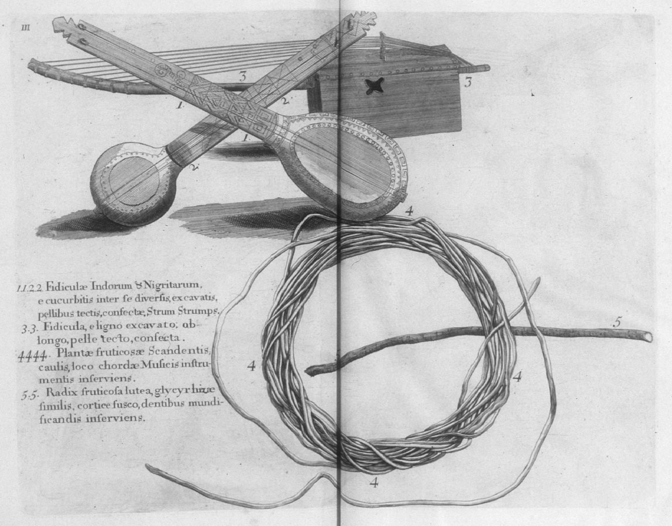

A second pivotal image of the banjo is part of a late 18th century watercolor painted in South Carolina, known as the “Old Plantation,” which shows a dance on a plantation with a drummer and banjo player providing the entertainment.
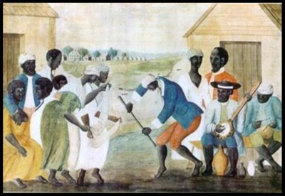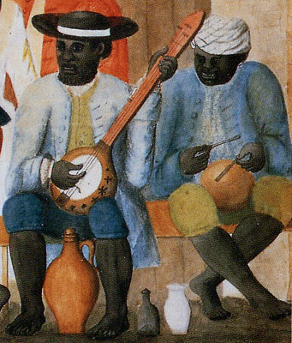
“The Old Plantation,” Abby Aldrich Rockefeller Folk Art Museum, Colonial Williamsburg, Virginia.

Finally, there is one other key image drawn in a journal by Henry Latrobe after a visit to Congo Square in New Orleans in 1818.
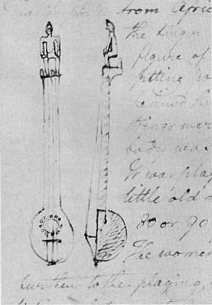

Though textual and visual sources make clear the banjo was popular and widespread throughout the Caribbean and North America during the 17th and 18th centuries, these older instruments have essentially all disappeared. None has surfaced in the United States, for instance, despite much searching by a very active and large group of banjo collectors. This is perhaps not surprising: these were hand-crafted and built around fragile gourds, and in contexts of slavery in which it was difficult to preserve such materials from generation to generation. For the past decades, there has only been one exception: a banjo-like instrument collected by John Stedman among the maroons of Guiana, preserved in The Netherlands, whose construction parallels that of the banjo but also has some important differences. The lack of a physical relic posed a serious limitation for scholars of music: an image, after all, doesn’t really communicate the precise construction of an instrument, its hidden interior structure, or its sound.
In fact, however, the solution was just waiting to be found, hidden away – as such things often seem to be – in Paris. In 1841, French abolitionist Victor Schoelcher travelled to Haiti. An avid collector of musical instruments, he left the country carrying several which became part of his personal collection in Paris. Decades later, he donated these instruments to the Musée du Conservatoire de Musique in Paris. This collection was, at some point in the late nineteenth century, boxed up and put into storage, where many of these instruments stayed until 1997, when they were shipped to the new Museum of Music at La Villette.
Though this museum devotes only one room out of its vast space to non-European music, it does at least have a curator of “non-European” instruments, Philippe Bruguière. Part of his job was to go through the crates from the old Musée du Conservatoire that were relocated to the museum. In 1997, while carrying out this work, he found a gourd covered with an animal skin, upon which was written an inscription describing it as a “banza,” the instrument of the “nègres of Haiti.” Soon afterwards, he found the neck of an instrument in another box, and realized the two pieces fit together. The instrument he had re-assembled, he soon realized, was one of a series brought from Haiti by Schoelcher in 1841. What he didn’t realize at the time, however, was how important this object would turn out to be for researchers from across the Atlantic. But news of the discovery soon spread – via a curator in Belgium – to banjo-philes across the Atlantic. The Haitian banza offered, for the first time, a physical, palpable example of how early gourd banjo were actually constructed: the most complete trace of the history of “America’s instrument. A leading banjo-maker named Pete Ross, who had been making gourd banjos based on the “Old Plantation” image, travelled to Europe to see the instrument and began making exact replicas for museums and private collections in the U.S.
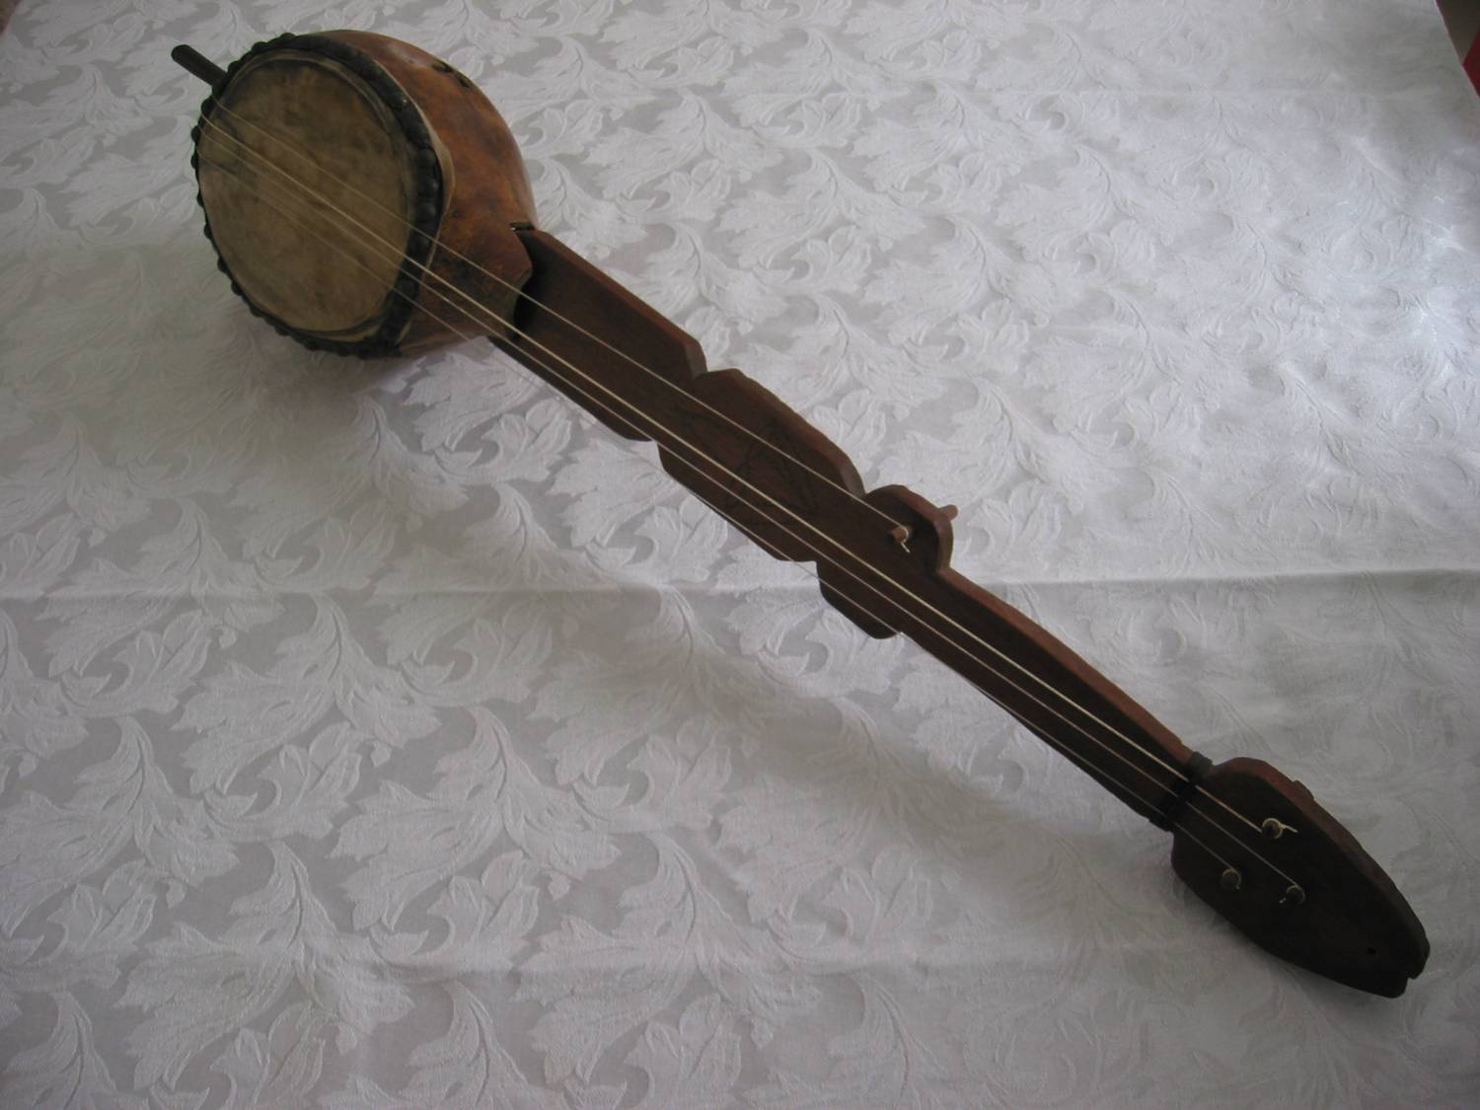
Haitian Banza, Reproduction par Pete Ross (http://www.banjopete.com/haitibanza.html)

Based on the various images from New Orleans, Jamaica and South Carolina and the example of the Haitian banza, we can conclude that by the late 18th and early 19th century a certain kind of construction had been established and consolidated across a fairly large region in the Americas. That is striking: all these banjos were constructed locally, by individual artisans using the gourds and wood available to them in different regions. It was not until the 1820s and 1830s that a larger-scale industrial production of the instrument began. But the techniques of building the object seem to have been widely shared, presumably through the same routes of transmission through which slave communities in and around the Greater Caribbean shared news, political projects, and other cultural forms.
The comparative homogeneity of the banjo also presents a striking contrast to the situation in Africa out of which it had emerged. In both West and Central Africa, we can gather both from contemporary sources and from later traditions and musical instrument collections, there was a tremendous diversity of instruments. Simply within the family of what are known in musicological language as “chordophones” were a profusion of different body shapes – some elongated, some round – and types of necks, though these were almost exclusively “spike” necks made of rounded poles rather than the flat necks seen on banjos. That variety corresponded to a very complex set of arrangements surrounding musical education and performance that have been explored in detail in several excellent studies. Though scholars of African-American musical forms, and of the banjo, tend to focus on West African sources for the instrument there were also many chordophones in Central Africa that could have served as an inspiration for the banjo in the Americas. An extensive catalogue of such instruments, held in the Tervuren Museum outside Brussels, makes this clear.
What explains the difference between the great diversity of construction in Africa, and the relative homogeneity in the Americas? We should answer with caution: obviously there may be a bias in visual sources, for instance, towards instruments that seemed familiar, and there likely was continued diversity in the kinds of instruments built in various communities in the Americas. Nevertheless there is a divergence here that is worth exploring. And in trying to explain it, we might also be able to answer a set of larger questions about precisely what music meant, and what roles it served, in the context of plantation slavery and the broader Atlantic world that surrounded it. The banjo was, it seems to me, partly a response to the specific problem of mass dislocation and constant movement posed by the experience of the slave trade and plantation life. A musician in the Atlantic world, if he was to be able to fall in and participate in various performances, needed something that could travel, something recognizable. The Atlantic space was a world of ports and ships, and the music of that space had to be able to travel. The banjo as a consolidated instrument, one that began to look the same in Haiti and South Carolina and New York, seems to have responded to that need.
A number of written traces about the banza in Haiti allow us to get a better sense of how the instrument was built – as both an object and a social and artistic resource – in one particular context. In an irony familiar to those who study slave societies, in which hostile and repressive observers often offer us key testimony about the lives of the enslaved, the most detailed description of how banjos were made comes to us from a committed defender of slavery. In a long 1810 book called « Le Cri des Colons, » an ex-planter from Saint-Domingue named Richard de Tussac passionately attacked the l’Abbé Grégoire, whose De la Littérature des Nègres had issued a detailed defense of the cultural and intellectual capacities of blacks. Among other things, Grégoire celebrated their musical achievements, to which Tussac scoffed that theirs was the music of “barbarians.” (The quote below maintains the original spelling).
Quant aux guitares, que les nègres nomment banza, voici en quoi elles consistent : Ils coupent dans sa longueur, et par le milieu, une callebasse franche (c’est le fruit d’un arbre que l’on nomme callebassier). Ce fruit a quelquefois huit pouces et plus de diamètre. Ils étendent dessus une peau de cabrit, qu’ils assujettisent autour des bords avec des petits cloux; ils font deux petits trous sur cette surface, ensuite une espèce de latte ou morceau de bois grossièrement aplati, constitue la manche de la guittarre ; ils tendent dessus trois cordes de pitre (espèce de filasse tirée de l’agave, vulgairement pitre); l‘instrument construit. Ils jouent sur cet instrument des airs composés de trois ou quatre notes, qu’ils répètent sans cesse ; voici ce que l’évêque Grégoire appelle une musique sentimentale, mélancolique ; et ce que nous appelons une musique de sauvages.

Tussac offers about the most detailed account of the precise creativity and use of resources that went into creating the banzas of the Caribbean. Another contemporary, the naturalist Michel-Etienne Descourtilz, offered details about the instrument in his work Flore pittoresque des Antilles, published in 1833 but based on a visit to Haiti during the early 1800s. His description of the banjo shows up as part of his examination of the « courge calebasse ». From these calabashes, he notes, « les Créoles et les Noirs » of the Caribbean created « des soupières, des gobelets et des banza, instrument nègre, que les Noirs préparent en sciant une de ces Calebasses ou une grosse Gourde dans toute sa longueur, et à laquelle ils ajustent un manche et des cordes sonores faites avec la filasse » from aloe plants. Though, like Tussac, Descourtilz doesn’t seem to like the banjo very much, he does recognize its cultural importance: « Cet instrument, quoique peu harmonieux, plait aux Noirs qui en font une espèce de mandoline avec laquelle ils charment leurs ennuis en accompagnant leurs voix pendant la paix des nuits, ou en faisant danser leurs camarades aux fêtes joyeuses, et à celles plus lugubres des calendas, cérémonies funéraires suivies de festins. On a coutume d’associer au son du banza celui plus bruyant du bamboula, espèce de tambour qu’ils font résonner avec leurs doigts et les poignets, en se mettant à cheval dessus. Ce tambour est fait avec une tige de Bambou recouvert des deux côtés d’une peau. »
Such sources give us valuable details about how certain hands were able to construct an instrument that allowed them to constitute or re-constitute sound and music in the midst of the plantation world. But of course music is not only sound: it is also both produced by and a producer of social worlds. If the banjo meant something it is also because, as an object, it created moments of connection, remembrance, solidarity, and imagination. It is because it spurred on motion through dance, the recalling and composition of melodies and song. Reconstructing that world, and its meanings for those who inhabited it is a major but critical challenge. Here, too, however, there are fragmentary clues to be found.
Out of the thousands of advertisements for maroons published in the Saint-Domingue newspaper Les Affiches Américaines, for instance, there are two that mention the banza. In 1772, a man named Pompée, it announces « étampé NGDP, âgé d'environ 30 ans, taille de 5 pieds 4 pouces, d'une assez jolie figure, ayant une cicatrice au haut du front, d'une grosse corpulence, se berçant un peu des hanches en marchant, est parti marron depuis un mois du bord d'un Passager au Fort-Dauphin; on l'a vu depuis à Ouanaminthe, & on croit qu'il pourroit bien se dire libre; le dit Nègre joue très-bien d'un instrument appelé Banza. »
Advertisements like this are remarkable capsule biographies. For masters, the important thing was to share the maximum of information about the individual in order to recapture their property. The irony was that, in order to do so, they produced the most detailed – and even human – description of slaves that we ever get from masters. They likely often didn’t even know much about these maroons before they escaped, and had to gather information about them from other slaves, probably depending on the enslaved drivers who oversaw much activity on the plantations. So the process of escape itself forced masters to piece together fragmentary information, creating traces of lives that otherwise would have remained invisible. Among the information they garnered was tremendous detail about specific African ethnicities: a collaborative research project on the advertisements has turned up over two hundred different descriptors of African groups. The details were important, because they were destined not only for other masters, but also probably for enslaved people and free people of African descent who could also collect a reward for turning in a maroon. For Pompée, as for many other maroons, music was probably an aid in flight, giving him an entry into certain urban communities and also a possible source of livelihood. Identifying these skills was also a good way of trying to track him down. The fact that the banza playing is described in the advertisement as “good” raises another question: Did the master miss the music?
Twelve years later, another banza player was listed in the runaway advertisements of the Affiches Américaines. His name was Cahouet, he lived in the economic capital of he colony, Le Cap, and worked as a coach-man: « âgé de 24 à 26 ans, taille de 5 pieds 1 pouce, la face grosse, trapu & cambré, grand joueur de bansa, chansonnier, & engoleur de Nègres, courant toutes les danses des habitations appartenant ci-devant à M. Roquefort. »
Identified as a « grand » banza player and « chansonnier, » he seems to have had a particular zone – a particular set of inter-connected plantations – in which he worked. But his performance style is also described with what seems to be an interesting neologism: « engoleur. » It is possible that this is in fact a typo, and the word was meant to be « enjoleur ». But it is also conceivable that this was a term, like some of the African ethnicities named in the advertisements, passed on by slaves in Le Cap who were interrogated. If so, the term might well have been a way of capturing the ways in which Cahouet’s music functioned socially, animating dances, inciting call-and-response. The idea of song as « shouting » appears in other musical traditions of the Caribbean, notably in Trinidad. And there, it is also linked to religious practice, which the work of Cahouet may also well have been in Haiti. After all, the “dances” on plantations were often in fact religious ceremonies, and the music of the banza could well have been linked to the music of drums and song aimed at accessing other plains than that of the sugar plantation covered Plaine du Cap – those of the lwa, and Guinée.
The link between the banza and religious practice seems even more likely given one final fragment taken from the archives of Saint-Domingue. Several decades after the Haitian Revolution, a former resident of the colony named Gaspard-Théodore Mollien wrote a manuscript, part history and part memoir, with many descriptions of the vanished live of the planter class. In it he briefly describes a rather remarkable party that took place in the years before the Revolution: « On avait même vu une esclave de l’habitation Lefeuve, maîtresse du procureur, donner à la Saint-Louis un repas de 400 couverts, servi en vaisselle plate et égayé par les chants des chanteurs publics, Trois-Feuilles et Grand Simone, dont les banzas (guitares) étaient garnis de doublons. »
Packed into this one sentence are scintillating details. There is a clue about the banza itself, “garnished” with “doubloons” whose role could have been decorative but also sonic, creating a metallic buzz such as that prized in many West African chordophones that are hung with metallic plates. There is the designation of the musicians as “public singers,” suggesting – like the advertisement for Cahouet – that there was a kind of profession of enslaved musicians who were paid to play not for masters but for other slaves. But the most important detail of all is the name of one of the musicians: Trois-Feuilles.
That is also the name of a central Vodou song – really an anthem of Haitian music:
Twa fey Three leaves
Twa rasin Three roots
Jeté blyé If I throw down I forget
ranmassé songé If I gather them I remember
Mwen gen basin lwa I’ve got a basin lwa
Mwen twa fey tonbé ladan’n My three leaves fell in it

The song, in a few short words and images, captures the power and necessity of connection and memory. The “three leaves” are the knowledge of medicine cultivated in Haitian Vodou, but also more broadly the spiritual practice and tradition that is maintained if it is gathered, as people gather around it. Too much, of course, has been lost for us to know exactly what all these connections might mean. But it is reasonable to conclude that the fact that this long-gone musician from Saint-Domingue had taken the name “Trois-Feuilles” was a message about what his music was for.
The Haitian banza collected by Schoelcher has several symbols on it. On the gourd is a carved cross – not unlike those in the “Old Plantation” image – whose sonic purpose is to let sound out of the gourd, but whose form obviously resonates with the deep symbolism surrounding crosses in the Black Atlantic that Robert Farris Thompson has explored in such detail. And, on the neck of the instrument is carved a symbol. It looks a bit like a face, or a mask. But it can also easily be read as a particular kind of face: one constructed out of Trois-Feuilles.

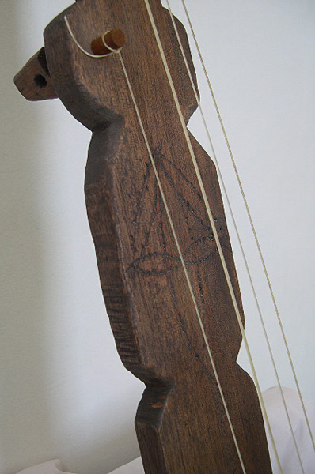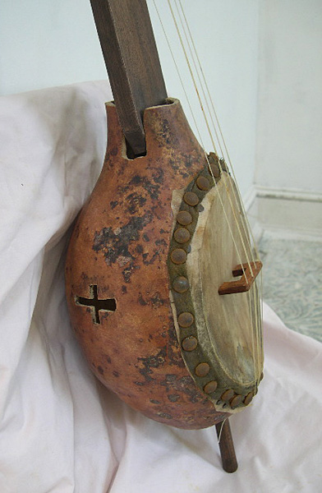

Banza Haïtien, Reproduction par Pete Ross (http://www.banjopete.com/haitibanza.html)

If this were a novel, which is perhaps what it should be, I would write a story in which this banza collected by Schoelcher was none other than instrument once played upon in the pre-revolutionary plantation world of Saint-Domingue by Trois-Feuilles. And he might become the original composer of the song by the same name, handed down from that time to our own. Such a story would be true to the extent that it condensed and personalized a broader story that I think we can tell through these fragments: one in which Haitian music, born through exile and slavery, transformed through the process of revolution and the creation of a new society in the midst of independence, constituted at once a source of inspiration, a locus of encounter and conviviality, and a way of telling and reflecting on this broader historical experience. In this sense, like the Vodou songs I discussed earlier, we can think of the banza as part of the crossroads between the living and the dead, humans and the lwa, the here and the beyond. And if this story only comes to us in the form of such evanescent fragments, that should only incite us to continue to search for and reconstitute what we can of this story.
The fact that it will always be partial, with much of it forever beyond us, should incite us to caution and humility in our interpretations, to instruct us to avoid making leaps and connections that are too easy. That is so not only because we need to be wary of reifying certain tales, but also because in the end such simple stories don’t do justice to the historical multiplicity and divergences that we are called upon to analyze and interpret. But as I hope I have suggested here, the material of music itself also constantly pushes back against easy certainties, reminding us that any perception of Afro-Atlantic history has to confront the multiplying of temporalities, the sedimentation of contradictions, and the fact that the desire for freedom and escape should also always guide are confrontation with categories and modes of thought.

Ronald Michael Radano, Lying up a Nation: Race and Black Music (Chicago: University of Chicago Press, 2003), xii.
William Edward Burghardt DuBois, Writings (New York: Library of America, 1986), 536.
Ibid., 538–539.
Paul Gilroy, The Black Atlantic: Modernity and Double Consciousness (Cambridge: Harvard University Press, 1993), 89–91.
Ibid., 100.
Ibid., 100–101.
Ibid., 101.
Radano, Lying up a Nation, xii–xiii.
Ibid., xiii–xiv. For another recent analysis of the way racial ideas have structured both musical production and academic work in the U.S. see Karl Hagstrom Miller, Segregating Sound: Inventing Folk and Pop Music in the Age of Jim Crow (Durham: Duke University Press,, 2010).
I find inspiration for this work in a series of historically rich reflections on African and Afro-Atlantic music, particularly Tal Tamari, Les Castes De l’Afrique Occidentale: Artisans Et Musiciens Endogames (Nanterre: Société d’ethnologie, 1997); Eric S. Charry, Mande Music: Traditional and Modern Music of the Maninka and Mandinka of Western Africa (Chicago: University of Chicago Press, 2000); Robert Farris Thompson, Tango: The Art History of Love (New York: Pantheon Books, 2005); Ned Sublette, Cuba and Its Music: From the First Drums to the Mambo (Chicago: Chicago Review Press,, 2004).
Max G. Beauvoir, Le Grand Receuil Sacré, Ou Répertoire Des Chansons Du Vodou Haïtien (Port-au-Prince: Edisyon Près Nasyonal d’Ayiti, 2008); Benjamin Hebblethwaite, Vodou Songs in Haitian Creole and English (Philadelphia: Temple University Press, 2012). I am currently involved in a large collaborative project (supported by the National Endowment for Humanities) called the “Vodou Archive” whose goal is to document many of these songs in audio, video, and textual format. The beginnings of the project can be viewed here: http://www.dloc.com/vodou.
Joan Dayan, Haiti, History, and the Gods (Berkeley: University of California Press, 1995); Karen McCarthy Brown, Mama Lola: A Vodou Priestess in Brooklyn (Berkeley: University of California Press, 1991); Karen E Richman, Migration and Vodou (Gainesville: University Press of Florida, 2005).
Laurent Dubois, “Dessalines Toro d’Haïti,” William and Mary Quarterly 3d ser., 69, no. 3 (July 2012): 541–548.
I draw these examples both from fieldwork ceremonies in Haiti and France and from a remarkable collection of songs gathered by the French ethnographer Odette Mennesson-Rigaud, and held in the Bibliothèque Haïtienne des Pères du Saint-Esprit in Port-au-Prince. Some of this collection is available online: http://fondspatrimoniauxhaiti.org/fonds-omr/index.htm.
I recorded Josué singing the song and worked on the translation and transcription with him during a residency at Duke University on February 3, 2011. The video of the song is available here: http://vimeo.com/19707817. Josué and I offer an interpretation of Vodou song in a conversation published here: Laurent Dubois and Erol Josué, “Le Vodou, Miroir De L’histoire: Dialogue,” Tabou: Revue Du Musée d’Ethnologie De Genève 5 (2007): 325–340.
On Makandal see Laurent Dubois, Avengers of the New World: The Story of the Haitian Revolution (Cambridge, Mass: Belknap Press of Harvard University Press, 2004) chapter 1.
This transcription, done in collaboration with Erol Josué, is from a version recorded by Wawa and Rasin Ganga on The Haitian Roots: Volume 1 (2005) part of a series of CDs released by Geronimo offered ceremonial songs to the Haitian diaspora.
Gilbert Rouget, “Court Songs of Porto-Novo and Abomey,” in Essays on Music and History in Africa, ed. Klaus P. Wachsmann (Evanston: Northwestern University Press, 1971), 32, 43–44.
The foundational study on the history of the banjo is Dena J. Polacheck Epstein, Sinful Tunes and Spirituals: Black Folk Music to the Civil War (Urbana: University of Illinois Press, 1977); a more detailed examination of African connections is Cecelia Conway, African Banjo Echoes in Appalachia: A Study of Folk Traditions (Knoxville: The University of Tennessee Press, 1995); and an excellent overview of the early history of the instrument is provided in Philip F Gura and James F Bollman, America’s Instrument: The Banjo in the Nineteenth Century (Chapel Hill: University of North Carolina Press, 1999).
Hans Sloane, A Voyage to the Islands Madera, Barbados, Nieves, S. Christophers and Jamaica, vol. 1 (London: B.M., 1707).
For a detailed study of the painting and it’s production see Susan P. Shames, The Old Plantation: The Artist Revealed (Williamsburg, Va: Colonial Williamsburg Foundation, 2010).
Benjamin Henry Boneval Latrobe, Impressions Respecting New Orleans, Diary and Sketches, 1818-1820 (New York: Columbia University Press, 1951).
He wrote about his journey in Victor Schoelcher, Colonies Étrangères Et Haiti: Résultats De L’’emancipation Anglaise, vol. 2 (Paris: Pagnerre, 1843).
I first heard about the banza at the “Black Banjo Gathering” held at Appalachia State University in March 2005, during a presentation by independent researcher Ulf Jagfors. I later met with Philippe Bruguière in Paris in June 2006, where I saw the original banza and talked to Bruguière about his discovery.
For a collection of essays reflecting on circulation in the Atlantic world see Laurent Dubois and Julius Sherrard Scott, eds., Origins of the Black Atlantic (New York: Routledge,, 2010).
Tamari, Les Castes; Charry, Mande Music.
Jean-Sébastien Laurenty, Les Cordophones du Congo Belge et du Ruanda-Urundi. (Tervuren: Annales du Musee Royale du Congo Belge, 1960).
Michel Etienne Descourtilz, Flore Pittoresque Et Médicale Des Antilles, vol. 5 (Paris: Imprimerie de J. Tastu, 1833), 85–86.
The entire archive of runaway advertisements from this newspaper have been digitized by a group at Sherbrooke University in Canada. For this advertisement, from Affiches Américaines, 14 December 1772, see http://www.marronnage.info/fr/lire.php?type=annonce&id=3464.
L’annonce, publié dans les Affiches Américaines le 15 Decembre 1784, est en ligne ici: http://www.marronnage.info/fr/lire.php?type=annonce&id=7199.
Gaspard-Théodore Mollien, Histoire Et Mœurs d’Haïti: De Christophe Colomb á La Révolte Des Esclaves, ed. François Arzalier, vol. 1 (Paris: Le Serpent de Mer, 2001), 84.
Robert Farris Thompson, Flash of the Spirit: African and Afro-American Art and Philosophy (New York: Random House, 1983).

