Chapter 8
One D is Not Enough: Measuring Conditional Party Government, 1887-2002

John H. Aldrich, David W. Rohde and Michael W. Tofias

Special thanks goes to Jorge Bravo, Scott de Marchi, Giacomo Chiozza, Claire Kramer, Olga Shvetsova and participants of the Micro-Incentives Research Center Brownbag Lunch Group and the participants at the two History of Conferences. Of course, this work would not have been possible without the generous lengths that Keith Poole goes to in making the DW-NOMINATE data available. All analysis here used Stata8.

Introduction
The purpose of this paper is to develop a general, multidimensional extension of the original cpg measure (Aldrich, Berger and Rohde 2002) and apply it to the same historical period as the earlier measure. In doing so we also modify the specific measurement techniques employed. Substantively, this period, 1877 to date, covers the Democratic-Republican period from the full reentry of white southern Democrats at the end of Reconstruction through the most recent available date. We hope to show that there is real value in considering partisan politics as basically (or at least often enough) multidimensional and that doing so yields a measure of conditional party government that reflects not only the one “big” historical dynamic (giving justification to W.E.B. DuBois’ claim that the twentieth century indeed was the century of race, at least in partisan congressional politics), but also other important historical aspects of the Congress. We also offer a theoretical exposition of CPG to aid understanding of what the model implies by suggesting that a majority party will “act in ways to empower its leadership” when the conditions are met.
Conditional Party Government
The basic notion underlying conditional party government begins with the emergence of candidates for a legislative office (whether voluntarily choosing to run purely on their own instigation or being recruited by parties or others), the screening of primaries or conventions that select a single party nominee, and the general election that chooses between the two resulting party nominees. This set of electoral mechanisms, we assume, selects members and induces in them policy preferences that they bring with them to the Congress and which they would choose to reveal in voting and other policy-making actions. These preferences may be shaped by legislators' personal views as well as the consequences flowing from the reelection incentive. Members’ behavior, we further assume, may also be shaped to a considerable degree by the legislative party. While parties as electoral institutions likely have the larger impact on behavior, we do assume that the parties may have considerable effect on members’ behavior through their partisan legislative institutions. Further, the relative importance of the party as a legislative institution is a consequence of the degree to which the "condition" in conditional party government is satisfied. By satisfaction of the condition, we mean the degree to which the preferences of party members are similar within each party (particularly the majority), and different between the parties. Because the degree of satisfaction is partially due to electoral forces, the electoral party and the internal legislative party are closely related.
Three sets of consequences flow from the increasing degree to which the condition is satisfied. First, members of a party are increasingly likely to choose to provide their legislative party institutions and party leadership with stronger powers and with greater resources, the greater the degree to which the condition is met. Second, the party will be expected to employ those powers and resources more often, the greater the satisfaction of the condition. Third, provided that the majority party has (by virtue of its being the party that organizes the legislature) more powers and resources to employ than the minority party, then legislation should reveal that fact. In particular, the greater the degree of satisfaction of the condition in conditional party government, the farther or more frequently the policy outcomes should be skewed from the center of the whole Congress toward the center of opinion in the majority party. This policy consequence can be seen as a tug-of-war between the chamber and the majority party within it, contesting over the pull of the policy center of the legislature and the push toward the center of the majority party.

Historical Variability of Conditional Party Government
Poole and Rosenthal (1997a) are correct when they argue that most congresses are able to be estimated in a unidimensional manner since it is a relative handful where the overall fit of the model is greatly improved with the addition of a second dimension in the ideal point estimation analysis. However, this view becomes problematic if one is interested in studying Congress across time. Longitudinal analysis will typically include at least one period of Congresses when the second dimension “matters.” Instead of ad hoc fixes to deal with this problem, we develop a single-scored latent measurement of conditional party government from two-dimensional estimates of ideal points (and develop it for the general, n-dimensional data input case). Our technique allows for a more textured understanding of Congress compared to the previous one-dimensional measurement, one that is more congruent with the inherited explanations of the history Congress.
The Use of Voting Data and Scaling
Scaling as Data Reduction: All scaling procedures end up having the (intended) consequence of “data reduction.” That is, they yield a small number of dimensions, or end up using fewer parameters to describe a portion of the information originally available. In general, of course, this is a good thing and emphasizes that which is common and general over that which is unique and idiosyncratic.
One of the key differences between majoratarian and partisan theories of Congress is the way that each deals with the shape of members’ preferences that make up a given session. These differences are not merely theoretic in nature; they each imply that different information be considered when describing a Congress. In fact, the theories each imply a different data reduction scheme in aggregating from 435 members to a single Congress in order to study such things such as historical variability. In Krehbiel’s majoratarian theory (see Krehbiel 1998), Congress can be described by studying the preferences of the pivotal members, the median voter, the two-thirds or veto-override voter, etc. Furthermore, one of the assumptions of Krehbiel’s models is unidimensionality of the preference space potentially making certain questions or eras difficult to study.
Both partisan and ideological models (including most forms of informational models) anticipate there will be a major space of policy action of low dimensionality. Indeed, in our case, we believe that the space in which actual partisan policy voting takes place is of low dimensionality precisely because of partisan influence over the agenda. The Cox-McCubbins-Kiewiet account (see Cox and McCubbins, 1993; Kiewiet and McCubbins, 1991), for example, is that the majority party exerts great control over the agenda, whether positive (on cpg-like occasions) or negative (at all times). While they do not develop this particular point, it seems likely that they would expect a space of low dimensionality for most policy purposes. Our account also anticipates a small dimensional space over which parties contest (plus being at least consistent with a lot of “small” dimensions, akin to distributive policy).
We expect that actual policy is fought over both what is shared in common (e.g., partisan reputations and publicly discussed policies) and what is unique to the needs of particular members and their districts and constituents. Thus, while some information is lost when using lower dimensionality spaces, we will be picking out the areas over which partisan competition is most keen – and over which public dialogue is most intense. It is, however, our contention that important information is lost when reducing the space from two to one dimensions.
The conditional party government variant of partisan theory implies knowledge of the entire shape of preferences of a Congress. Specifically CPG uses the heterogeneity of the two parties and the homogeneity of the majority party. CPG theory assumes an n-dimensional preference space. However, one cannot proceed with 435 pieces of information even if members of Congress were to arrive in Washington with their ideal points stamped on their foreheads. Like many other studies of Congress we are forced to use roll call data estimated ideal points to describe the members of Congress. The question for the measurement of the conditions of conditional party government becomes how to measure inter-part heterogeneity and intra-party homogeneity. This measurement is a theoretically required data reduction from the estimated ideal points.
We proceed in a second level data reduction, the data reduction of a data reduction. The cpg measure is a data reduction of size M members’ estimated ideal points to a single cpg measure per Congress from a data reduction on a roll vote matrix of M members by N votes. Both data reductions (our cpg measure and the DW-NOMINATE reduction) take advantage of changes (and the lack thereof) over time. Poole and Rosenthal use it to anchor each Congress to a common space, we use to time to exploit the commonality of the components of measured cpg. This process allows us to assign values to the shape of preferences in a Congress. While the value for a given Congress may mean nothing in absolute terms, when we compare the historical variability of the cpg measure we are able to get a better handle on the changing nature of Congress. Furthermore, we have developed a measurement technique that is extensible to n-dimensions. Conditional party government as a theory is not limited to a single dimension or even to two dimensions. Therefore we have thought to extend our measurement theory to be flexible in case researchers someday, for some Congress, recover a third or more dimensions. It is not clear what happens to majoratarian theory in a multi-dimensional space.

Data and Measurement
In earlier work, Aldrich and Rohde used a mixture of D-NOMINATE and W-NOMINATE ideal point estimates in order to develop a number of measures used to analyze the structure of both the House and Senate (in this paper, we look only at the analysis of the House for purposes of clarity and exposition). After constructing their four measures of partisan ideal point structures they ran a principal component analysis and found support for the thesis of a single underlying variable. In engaging the two-dimensional Congress we wed ourselves to the original methodology, but consider the four aspects that are changing in the new analysis:
- Extending the time series used to include the 107th Congress.
- Utilizing two estimated dimensions, with input data from:
- The DW-NOMINATE procedure, and
- Developing new component measures in order to accommodate two-dimensional ideal point estimates.
The first three changes are straightforward as item 2 is the focus of our current analysis and DW-NOMINATE has supplanted the D-NOMINATE and W-NOMINATE procedures. Item 4 demands some understanding of the original component measures.
To tap different aspects of CPG four separate measures were developed previously (in the 1998 and 1999 papers, descriptions taken from the 1999 paper): the difference between the location of the Democratic and Republican Party medians; the ratio of the majority party to floor standard deviations in ideal points; the extent of overlap between ideal points in the two parties; and the R-sqd. of the ideal point location of all Members and their party affiliation.

These measures had to be reconceived in order to truly account for the two-dimensional nature of the DW-NOMINATE ideal point estimates. The concept of “median” becomes problematic, as there is not likely to be a median in all directions for the majority party. Similarly the score based on the standard deviation was measured as deviations about this same median. Overlap becomes similarly problematic to calculate, as overlapping area in two-dimensions becomes difficult to identify. Perhaps the most puzzling would be the OLS regression used to calculate R-sqd. In order to proceed we faced a research decision on how to incorporate the 2nd dimension, we chose to develop truly two-dimensional measures as opposed to creating 8 separate measures by merely carrying out on the 2nd dimension what had already been done on the first. The new measures, based on both dimensions of DW-NOMINATE (with the 2nd dimension weighted by .3 per Keith Poole’s instructions, see http://voteview.uh.edu) are as follows:
- Inter-party Heterogeneity: Inter-party Heterogeneity was calculated by finding the
Euclidian distance between the intersection of both party “medians.” For each party the intersection of the two medians in DW-NOMINATE space (dwnom1, dwnom2) was identified. The Euclidian distance between the “median point” of each party was calculated.
- Intra-party Homogeneity: is a measure of dispersion. Intra-party Homogeneity
was calculated by measuring the spread of the majority party around its “median” (using the same intersection technique as described above for identification). The Euclidian distances are calculated for each MC in the majority party to this “median” point. We take the median distance to get a measure of “majority spread,” which is used for the factor analysis. For graphical purposes we calculate a measure of intra-party homogeneity by subtracting “majority spread” from 1. (This measure of spread has been checked against a similar measure where the central tendency statistic of distance from the “median” is the mean distance, it is quite similar and the correlation coefficient between the two measures is around .94.)
- Party Separation: Separation is measured by the percent of MCs correctly
predicted by a discriminate function analysis preformed with party affiliation as the group variable with both dimensional scores of DW-NOMINATE used as predictors. As the percent of MCs correctly predicted increases, overlap decreases, making this really a measure of party separation.
- Party Label Fitness: We use the (pseudo) R² from the discriminate function
analysis described above as a measure of party label fit. We interpret a higher R² to be associated with a goodness-of-fit between the party label of an MC and his or her two-dimensional DW-NOMINATE scores.
We will discuss the nature of these changes later.

CPG as a Latent Factor
As the earlier papers held, we consider the four component measures to be generated by an underlying latent cpg variable. This variable is generated by conditions in the electorate, but should be observable in the actions (voting records) of Members of Congress since there voting records are being used to further their reelection goals. Therefore, we engage in a principal factor analysis in order to perform a confirmatory factor analysis.
Using an Eigenvalue of 1 as the standard for accepting a factor, the first factor should be clearly accepted and the 2nd factor discarded as not having the information contained in even one variable. Roughly speaking, the first factor accounts for nearly 90% of the variation in the matrix. We regard this as being strongly suggestive of the existence of a single latent factor that can be used to describe our four component measures of the underlying ideal point structure of the House. The factor loadings on the first two dimensions further support this view.
We find that all four component measures of conditional party government load on to the first factor, but do not load on to a second factor, further suggesting the appropriateness of the first factor. Also, each of the four strongly loads on the dimension (rather than it being asymmetrically dominated by one or two variables). Therefore we consider the first component to be our estimate of cpg. We think that the ability of the four measures to load onto a common factor suggests that there is some latent variable that drives the components in the predicted directions. Without such a variable, there is no good reason to expect that inter-party heterogeneity and intra-party homogeneity would move in similar directions. Second, we are less concerned with the specific values of cpg; instead we are concerned with its variation over time. Therefore we present a standardized factor (mean=0, SD=1) to facilitate analysis and comprehension of the variation in cpg over this time period.
Two Dimensional CPG
If we examine the estimated cpg measure based on two-dimensional distributions of Poole-Rosenthal ideal points we can see that the cpg measure was high in most Congresses from 1877 through about 1910, where by “high” we mean in comparison to other Congresses in this historical period, since these have been normed to have mean zero, variance one over the full set of Congresses included. The measure appears to have declined around that time to a moderately high level (above the mean or zero) through the 1920s. While there was fluctuation, the cpg level was at a below average level from the 1930s through about 1970. At that point, it declined sharply until about 1980, before rising to above average levels similar to those around 1920 or so in the last four Congresses. When we compare this two-dimensional measure to that which arises from using only the first dimension estimates of ideal points we can see there that the one dimensional measure overstates the level of cpg around 1980, in comparison to the two dimensional version, while understating the level of cpg around 1960. The single-dimensional measure also overstates the level of cpg during the New Deal and WWII eras. It is interesting to note the differences between the two versions of cpg scores. They seem to be different in a predictable way, one that is not “normally distributed errors around zero,” or, in short, i.i.d. Rather they seem to form a pattern based on the ebb and flow of partisan strength and how it relates to the effect of the second DW-NOMINATE dimension. We therefore turn first to examine why, in the “cross section” the two dimensional results are more informative. We then return to the time series to provide a second argument about the value of this two-dimensional version, and conclude with a consideration of the relationship between this measure and well-known historical cases.
Why Two Dimensional Ideal Points are Needed
What we hope to show in this section is that there are cases in which ideal points in two dimensions reveal much more of the nature of the partisan structuring of estimated congressional preferences, that there seems to be two different reasons for this, and finally that there are important, systematic occurrences of these reasons in the historical period under consideration. Consider first the distribution of Poole-Rosenthal estimated ideal points in one and two dimensions for the 107th Congress, a Congress that is relatively high on the cpg measure. In this case, one dimension appears to capture the single most important “fact,” that affiliates of the two parties stand for very different things and, thus, that there is very little overlap between the two parties. To be sure, the second dimension reveals a great deal of nuance to this story, and it shows considerable spread within each party (with each party roughly comparable in that spread) on the second dimension, but one can hardly miss the degree of partisan polarization in either version.
Compare those figures to the comparable ones for the 96th Congress, one quite low in cpg score. Here, the one-dimensional distribution of ideal points illustrates a great deal of overlap. Looking at the two-dimensional distribution, however, one can see that there is uniqueness to the two parties. Both have their own, nearly non-overlapping “clouds” of ideal points. Still, one can see that, in many respects they do overlap on both dimensions. Thus, we would say that the two parties are (still) quite similar and highly dispersed on the second dimension. There is more separation between the two parties on the first dimension, but there is a reasonably high degree of variation within each party and there are conservative Democrats (compared to the most liberal Republicans) on it, and vice versa. The line of division between the two parties appears to go at more or less 45 degrees, or more accurately, at something clearly in between 0 and 90 degrees. Thus, how important polarization versus overlap is depends upon the way in which the two dimensions are invoked in any given alternative and whether preferences between the two dimensions are separable or non-separable.
From the above, it appears that we might be interested in the relative balance of the two dimensions in distinguishing between the two parties. The discriminant function analysis used in defining cpg provides relevant information. In particular, it estimates coefficients for each dimension in the discriminant analysis. The ratio of, say, the second to the first dimension will vary from 0, when the second dimension does not contribute at all to the categorization, to |1| when its coefficient has the same effect (relative to the Poole- Rosenthal scales, which, by their advice, are set at .3 for the second dimension, when the first is set at 1), and exceeds |1| when its effect is larger than the first dimension. Note that this analysis differs from comparing the first and second dimensions of the ideal point estimates themselves. Here, the question is how strongly does each dimension help us distinguish Republicans from Democrats? The answer helps us see whether partisan affiliation is unidimensional (when the ratio is near zero) or it requires at least two dimensions to characterize well.
The data are quite clear. For the latter part of the nineteenth and the early part of the twentieth century, the second dimension is relatively unimportant, with a ratio of discrimination less than 20% that of the first dimension. Beginning in the late 1930s, the ratio climbs smoothly and continuously until it reaches half the size of the first dimensional effect at the beginning of the 1970s. After persisting at that level for a few Congresses, it begins to decline steadily and smoothly, dropping back in the 107th Congress to approximately the range of values it achieved in the nineteenth century.
This makes it apparent that what we had described in our earlier paper as the civil rights era’s impact on the division of Democratic party in one dimension is less the failure of the condition in cpg to be satisfied as it is to a substantial degree the importance of viewing party affiliation as combining two dimensional preferences, with the second dimension reaching historical highs in relative importance in distinguishing between the two parties’ members. It is this dynamic that made the one-dimensional view so regular in its “v-shape” decline and return of one-dimensional cpg. Correcting for this fact by inclusion of the two dimensional nature of preferences makes the divisions within the Democratic party less severe than by viewing only a part of apparently relevant preferences. There is a decline in the cpg measure in the 1950s and 1960s, but a less severe one. The collapse of the measure of cpg therefore was particularly stark only in the late 1970s, especially during the Carter and first couple of years of the Reagan administrations.
Conclusion
One way of summarizing these data is to look at the two-dimensional-based measure of cpg over the full time period, overlaid with speakership tenures (see Figure 1). This helps us observe that this measure of cpg does provide a richer and more nuanced account. For example, many of the eras we think of as relative highs in party “strength,” seem to be reflected as relatively high in cpg, too. Perhaps most notable are the highest scores being concentrated in the “Czar” speakerships (especially the dramatic jump in the first Reed Congress), and the decline and partial resurgence at the revolt in 1910 and then coming of the short party caucus era. Thus, unlike the one-dimensional case, the measure based on two dimensions of preferences seems to reflect a cpg that appears at least broadly and perhaps quite closely reflective of the usual story about party and division at the turn of the century.
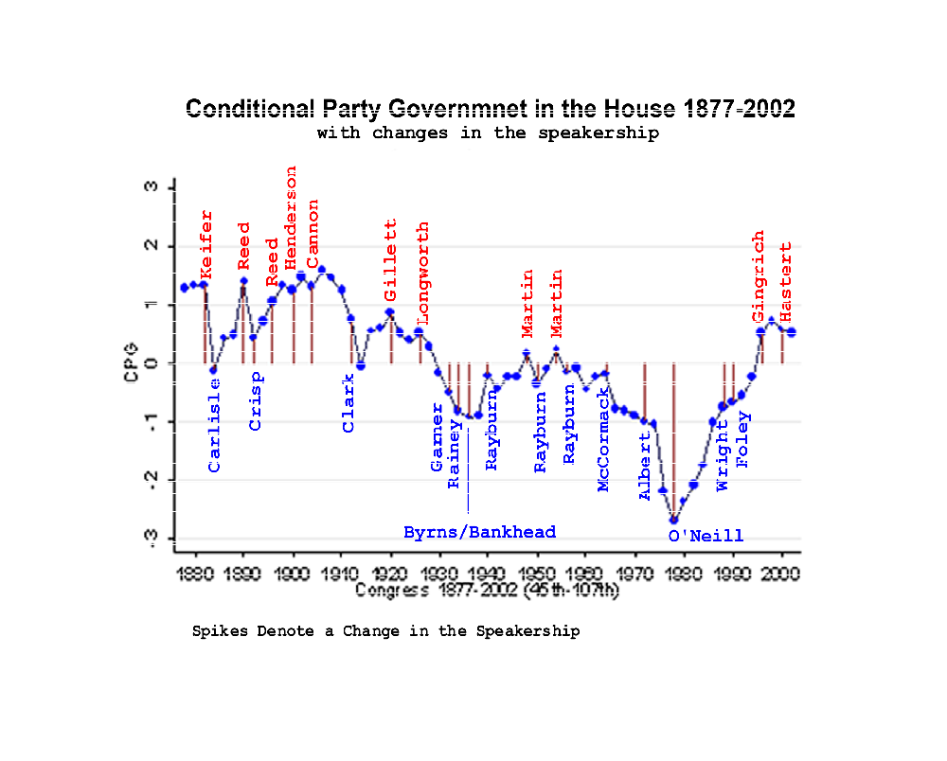

This and the following few paragraphs are based on Aldrich and Rohde (2000a).
These one-dimensional measures differ from those reported in the earlier papers, because they are based on DW-NOMINATE, use the new measurement techniques described above, and are extended through the 107th Congress.

